ALI SETHI ADDS FOUR UK DATES TO HIS AUTUMN 2023 WORLD TOUR

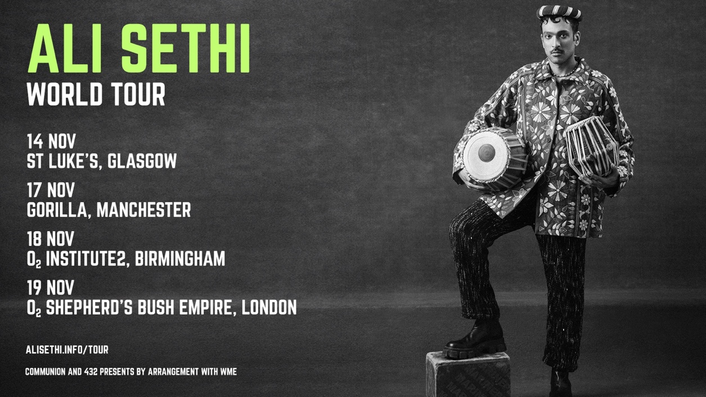

ON SALE NOW
tickets.lnk.to/AliSethi

Following a tour of North America earlier this year that included sold-out shows in New York City, Los Angeles and Toronto, Pakistani-American star ALI SETHI is heading back on the road for a run of world-wide dates, visiting the UK this Autumn. The quartet of intimate shows culminate with a landmark date at London’s O2 Shepherd’s Bush Empire on Sunday 19th November.

Combining ghazal - an ancient Arabic style of vocal performance - and Punjabi folk music, Ali became known worldwide following the release of global hit Pasoori. One of the most Googled songs of 2022, hundreds of millions of listeners tuned into its timeless message of forbidden love.

Named to TIME Magazines “2022 TIME100 Next list,” the New York City based Ali Sethi spent his childhood in Lahore, Pakistan and is now a U.S. citizen. He infuses his music with the same multitudinous space that Sethi occupies - Punjabi folk mixed with contemporary beats and a queer aesthetic from South Asia. Sethi rose to prominence with the publishing of his debut novel in 2009, The Wishmaker. Since then, he has been involved in numerous musical, film and literary projects all inspired by his unique identity, a diasporic voice fusing ancient artistic inspiration with a thoroughly modern and urgent outlook.

“A love song that sounds like a threat,” is how The New Yorker describes Pasoori, Ali Sethi's 'earwormy' single that topped Spotify’s viral chart and put South Asia on the music map of 2022. An ingenious blend of Punjabi folk tunes and zany beats, the 'global phenomenon' "Pasoori" (The Guardian) has garnered over 700 million views on YouTube and 300 million streams on Spotify since it released in February 2022; now, the song plays nonstop in South Asian clubs, restaurants and wedding halls and was also featured on an episode of Disney+’s Ms. Marvel.

Communion Presents: ALI SETHI UK TOUR DATES

Tuesday 14th November - Saint Luke’s - Glasgow, UK
Friday 17th November - Gorilla - Manchester, UK
Saturday 18th November - O2 Institute 2 - Birmingham, UK
Sunday 19th November - O2 Shepherds Bush Empire - London, UK

Tickets are available now here.
VIP tickets are available which include a meet & greet and a photo opportunity with Ali.

Ali Sethi this week announced his collaboration with Nicolás Jaar, with the release of an album on 17th November, Intiha, marking the first album-length collaboration between the two artists. “Muddat”, the first single they are revealing off Intiha, is a song steeped in that mood of flamboyant resistance. Taking the opening lines of a canonical ghazal — written as the British were decimating India’s precolonial traditions, the elaborate rituals and etiquette of its courtesans and noblemen — the two musicians build a genre-bending trance that brilliantly evokes the loss of a cherished milieu: “It’s been long since my lover was a guest of mine,” sings Sethi in his native Urdu, drawing on classical ragas to improvise the phrase. “And my world was suffused with the glow of wine.” Jaar’s goading hand-claps keep time for these husky vocalisations until they give way to a euphoric techno blaze, obliterating the temporal frame and delivering us into a dance both ancient and modern.

A feast for the senses that celebrates community and bridges cultural distances, “Muddat” is an anthem for the ages. Listen to “Muddat” here and watch the video here.


DOWNLOAD HI-RES IMAGE HERE

Connect With Ali Sethi
Facebook | Instagram | YouTube | Website

For more information please contact jenny@chuffmedia.com

