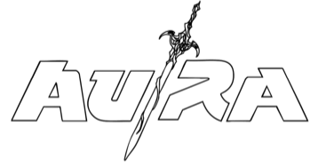
ANNOUNCES NEW SINGLE “SWAMP” — A HYPER-REAL ODE TO ESCAPISM, THE COLOUR GREEN AND… SHREK!
LISTEN HERE
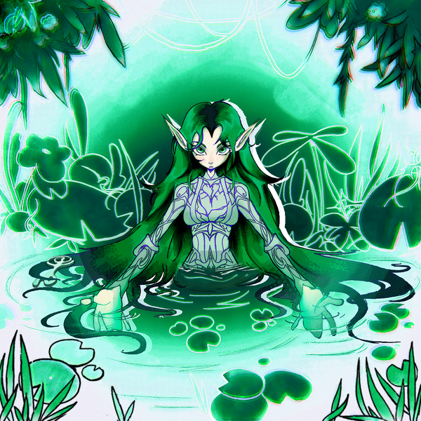

Au/Ra continues her journey into a bold new creative era with the release of “SWAMP”, a hyper-real ode to escapism, the colour green, and Shrek!
“SWAMP” (SUPER WEIRD AND METAL PLEASE) introduces a thrilling new sonic direction for Au/Ra - playful, atmospheric, and transportive. Written by Au/Ra alongside Janeva and produced by Janeva, “SWAMP” plunges fans into a hypnotic, immersive sound world where heavy beats and distorted textures meet dreamlike atmospheres. The production blends hip-hop grit and experimental electronica to create a sonic experience that feels both futuristic and feral.
Lyrically, “SWAMP” mirrors this genre-bending sound with vivid world-building and surreal imagery. Au/Ra crafts a digital fairytale where reality and fantasy merge,
“I design where I wanna be / pick and choose on the touch screen / SUPER WEIRD AND METAL PLS / In the swamp ‘cause I like it green.”
The song captures Au/Ra’s fascination with digital escapism, how we can build and inhabit our own worlds online whilst also embracing the absurdity, humour, and beauty that comes with it. It’s both a love letter to imagination and a wink to internet culture, proving that sometimes the most authentic form of self-expression comes from getting a little lost in the SWAMP.
Au/Ra says, “There are so many pros and cons to living in this technological era, but what I love about it is that you can jump into fiction and play through all these different worlds in video games. Also, I love Shrek and the colour green — so that naturally played into somewhere I wanted to be in the song.”
“SWAMP” became a standout moment in Au/Ra’s recent sold-out headline shows and was a highlight in her set supporting Katy Perry at London’s O2 Arena show last month. The track follows fan-favourite singles “HIGH FANTASY” and “CRACK!”, with the latter already surpassing over 1 million streams since release.

FOLLOW AU/RA
TIKTOK/YOUTUBE/INSTAGRAM/SPOTIFY/DISCORD/TWITCH

For more information and press enquiries please contact

Warren Higgins
warren@chuffmedia.com

