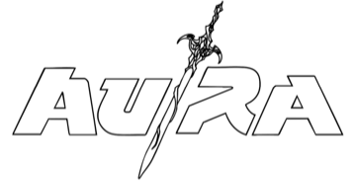
AU/RA REVEALS HAUNTING NEW INTERPRETATION OF ‘MAD WORLD’ OUT NOW
LISTEN HERE

Au/Ra continues to expand the immersive universe surrounding her new creative era with the release of Mad World — a stark and intimate foil to the cinematic world she has been building.
Following the realm-shifting escapism of more recent releases SWAMP, HIGH FANTASY and CRACK! where listeners are invited into imagined places and inner landscapes, Au/Ra’s version of Mad World shifts the lens inward exploring reality— and how it can be disorienting, fragile, and overwhelming.
Fans first experienced Au/Ra performing the track at London’s O2 Arena last year while supporting Katy Perry, where the moment landed with a hushed intensity, watch here, soon becoming a fan favourite with calls for the track to be released. For Au/Ra, reimagining Mad World felt like a natural extension of her current storytelling.
“I really enjoy the process of reimagining songs, and I’ve always wanted to try this one,” she explains. “The song came out 40 years ago — I decided to cover it two years ago — but the message will always be relevant. Because we do, unfortunately, live in a mad world. Especially right now.”
The release marks Au/Ra’s first music of 2026 and signals the next step in a year set to further reveal her evocative storytelling, and the visual and emotional threads of her new era.
In May Au/Ra will head out across the UK, including shows in Glasgow, Manchester, Birmingham, Bristol and London. Au/Ra was announced in the Great Escape FIRST FIFTY with a show on May 14th at Club Revenge.

Full Tour Dates below.
May 7th King Tut’s Wah Wah Hut, Glasgow
May 9th Club Academy, Manchester
May 10th O2 Institute 3, Birmingham
May 12th The Exchange, Bristol
May 13th The Garage, London
May 14th, Club Revenge, The Great Escape, Brighton



FOLLOW AU/RA
TIKTOK/YOUTUBE/INSTAGRAM/SPOTIFY/DISCORD/TWITCH

For more information and press enquiries please contact

Warren Higgins
warren@chuffmedia.com

