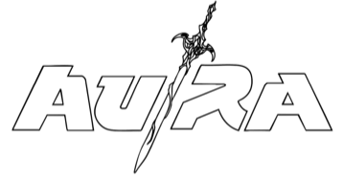
Opens the Door to “HIGH FANTASY” – OUT NOW
LISTEN HERE / WATCH HERE
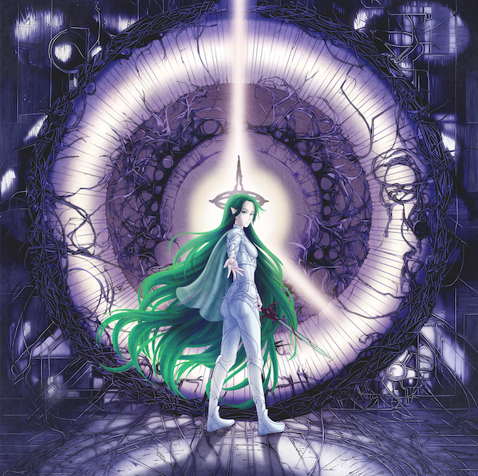

Au/Ra continues her journey into a bold new creative era with the release of “HIGH FANTASY” — a sweeping anthem of escapism, imagination, and the fragile beauty of illusion. Out now, the track follows fan-favourite single “CRACK!”, which racked up over 100,000 video views in just five days on launch.
“HIGH FANTASY” begins in a dreamlike haze, carried by Au/Ra’s stunning vocals that set an otherworldly tone. Driving alt-rock guitars surge alongside pulsating drumbeats as the track unfolds building into a chorus that feels both transportive and exhilarating. Written by Au/Ra alongside Violet Skies and produced by Micah Jasper, the song imagines a world where reality blurs, swords are raised, and a radiating inner universe shimmers brighter than life outside. It explores the desire for the world you’ve built in your imagination to be real, and the desperation to stay there — a place that feels both haunting and beautiful.
Au/Ra says, “High Fantasy” is my love letter to escapism. It’s 100% written for my inner child. I spent so much time growing up in my own world, completely immersed. The reason my artist name is Au/Ra, is because of an OC (own character) I made in a Wattpad Lord of the Rings fanfiction that I wrote when I was 13. Fantasy has been such a core part of my creative, especially for this next project. I really want my listeners to feel like they are entering another world with me, and this song is the gateway. On the flip side, it also explores the darker side, this undertone of longing, knowing it isn’t real, and you can’t stay there forever.”
With lyrics that paint vivid scenes — “A city in the sky / world building in my mind” — “HIGH FANTASY” is as cinematic as it is personal. The single marks the next chapter in the immersive narrative universe Au/Ra is crafting — a psychological and emotional quest told through music, visuals, and captivating storytelling.
Au/Ra plays four shows this month—marking her first live performances since 2022:
15th September – YES, Manchester SOLD OUT
16th September – Camden Assembly, London
18th September – Berlin, Kantine Am Bergahin
19th September - Reeperbahn Festival
Ticket on sale here
About Au/Ra
Ibiza-born to German parents and raised in Antigua, songwriter Au/Ra has created a unique and powerfully emotive world, filled with songs that explore the dark nature of humanity with real and relatable storytelling. Her music captures the complexities of Gen-Z life in an internet-core era, where reality and illusion constantly overlap.
She has already scored two UK Top 40 tracks with 2018’s platinum hit, the Camelphat remix of “Panic Room”, and 2020’s silver single with Jax Jones “i miss u”. Meanwhile, her collaboration with Alan Walker on “Darkside” has amassed over 700 million streams globally. To date, Au/Ra has accumulated over 1.7 billion global streams, has 5 million monthly Spotify listeners, and earned over 240 million video views.

FOLLOW AU/RA
TIKTOK/YOUTUBE/INSTAGRAM/SPOTIFY/DISCORD/TWITCH
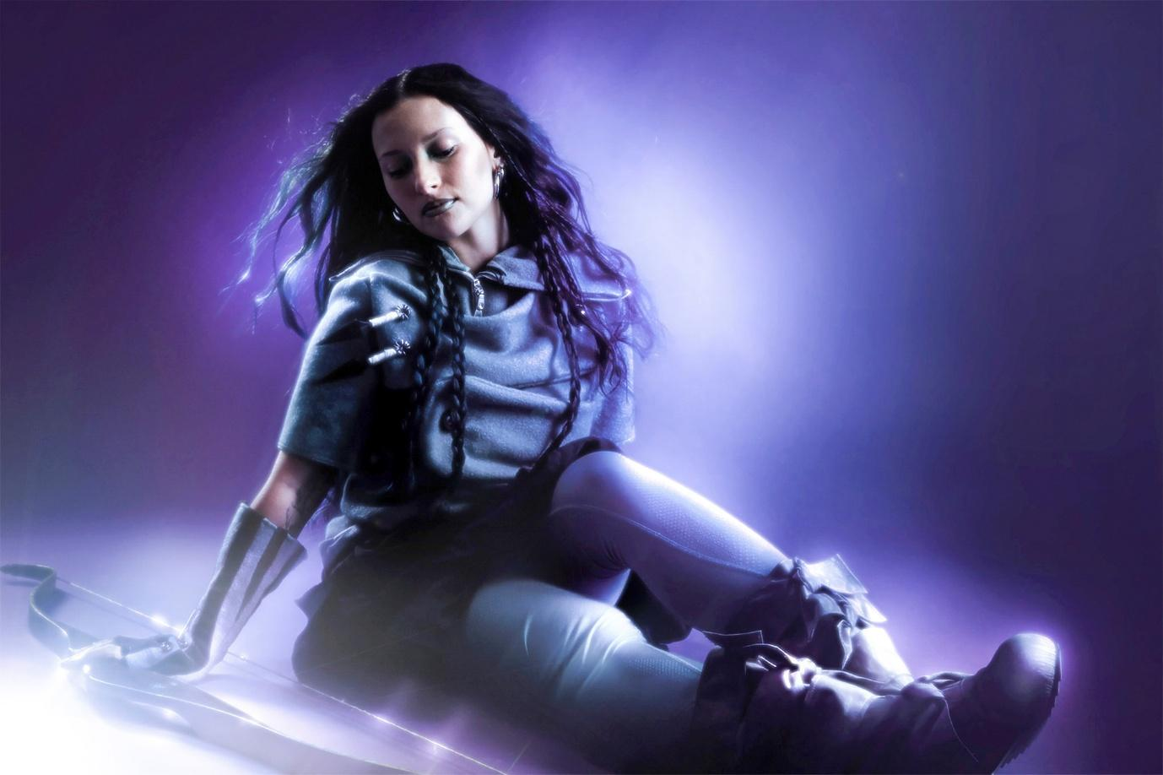
For more information and press enquiries please contact

Warren Higgins
warren@chuffmedia.com

