Another Sky Announce Autumn 2024 UK Tour

New Album Beach Day Out Now via Fiction Records
Listen Here

Listen To New Single ‘I Never Had Control’

Credit – Darina // Download hi-res

“an artistic triumph rising from the ashes of personal disaster” **** The Times
“a fearless beauty” 4.5* DIY Magazine
“a band in their prime” **** Dork

Another Sky are excited to announce a run of UK shows for autumn 2024. The tour kicks off in Manchester on 19th September and takes in Glasgow, Manchester, Sheffield, Leeds, Birmingham, Bristol, Southampton, Brighton and London’s Scala on 1st October. Tickets will be available here via artist pre-sale on 7th March and general sale on 8th March. The band will shortly be hitting the road for a run of intimate record store dates to celebrate last week’s release of Beach Day, the new album out via Fiction Records. All live dates are outlined below.

On 29th Feb Clara Amfo on BBC Radio 1 premiered the final pre-release track from Beach Day, listen to ‘I Never Had Control’ here.
‘I Never Had Control’ was written after a walk to Nick Drake’s grave. Lead singer Catrin Vincent wrote it in the first lockdown, jobless and on benefits, ready to quit music. On the eve of her 27th birthday, she discovered Nick Drake, who died at 26. She picked up the guitar “just one more time” and learned one of his songs, ‘Road’, then realised his hometown was very near to hers. She visited his grave and laid down some lilies to thank him for the music. ‘I Never Had Control’ is about overcoming self-flagellation, self-blame and the ego. It’s about the realisation that when things are beyond your control, you no longer have to live in fear. You can just live each day and accept what happens to you.
About Beach Day –

At this moment in time for Another Sky, there are maybe three certainties in this life: death, taxes, and rage. White-hot rage that takes you inwards, deeper into yourself, your fears, all the hidden truths you desperately tried to keep quiet while finding yourself.

With the band’s sophomore album Beach Day, that feeling opens a doorway to the most confident, fully formed and forthright version of Another Sky so far. Frontwoman Catrin Vincent points out the relationship between anger and freedom on this record. “If you don't move through anger, it'll calcify into bitterness, and it's not worth it,” she says, “but it’s about having the freedom to find and feel that anger. How can you move through something you don’t even know is there?”.

The album gave Vincent the opportunity to go more personal than ever – Another Sky has always supported and valued their front-woman’s vulnerability, but here it’s at its rawest. “Wait, why did I do this? Wait, why did I do this in the first place?” Vincent sings in the propulsive, almost euphoric climax of ‘Death of the Author’, one of many tracks on the album wrestling with a lack of control and surrender to the circumstances that great wreckage leave you with, whether you like it or not. The least you can do is make something of the rubble.

That rubble was rebuilt in the crypt of a church for Another Sky: the Covid years saw the band’s former studio flooded, as well as the painful consequences of a personal betrayal for all the band members (“all I had to do was be a good view as I fell from the sky you built for me,” Vincent spits on the explosive and impossibly direct lead single ‘Psychopath’). Both huge blows razed what you could perhaps call the first version of Another Sky to the ground. They needed a new space, and a new perspective, so they called out to their friends to help. “Does anyone know of any community spaces?”, they asked, and a Vicar, an avid Idles fan desperate to help some musicians, answered.

They built the crypt-based studio from scratch, with help from guitarist Jack Gilbert’s builder Dad, where Gilbert produced much of the album himself – costing less and giving the band infinitely more freedom to take back control of their own narrative.

The anger and the fight is real, and it’s everything – but that doesn’t mean it always will be. Hold onto that feeling while it lasts: Another Sky are steadfast and galvanised to make you understand everything that got them here. How they survived. All you have to do is listen.

Live Dates –

6th Mar ch Jacaranda, Liverpool
7th Mar ch Rough Trade East, London
8th March Resident, Brighton
12th March Rough Trade, Bristol
18th September Glasgow, King Tut’s Wah Wah Hut
19th September Manchester, Deaf Insitute
20th September Sheffield, Yellow Arch Studios
21st September Leeds, Brudenell Social Club (Community Room)
26th September Birmingham, Hare & Hounds (Main Room
27th September Bristol, Strange Brew
28th September Southampton, The Joiners
29th September Brighton, Chalk
1st October London, Scala

Beach Day Track-Listing
- Beach Day
- The Pain
- A Feeling
- Uh Oh!
- I Never Had Control
- Death Of The Author
- Burn The Way
- Psychopath
- Playground
- City Drones
- I Caught On Fire
- Star Roaming
- Swirling Smoke

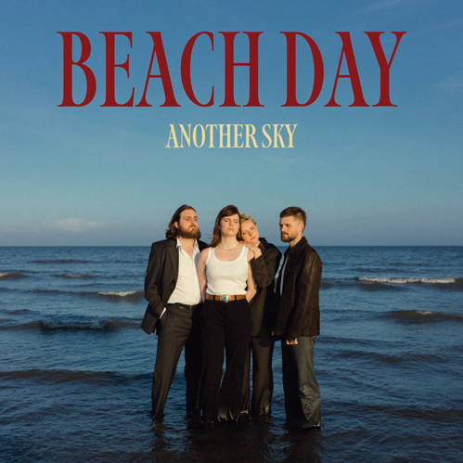
(Beach Day artwork // credit: Darina)
Download

For more on info contact warren@chuffmedia.com

