EMBARGOED UNTIL 9AM MONDAY 10TH MARCH 2025

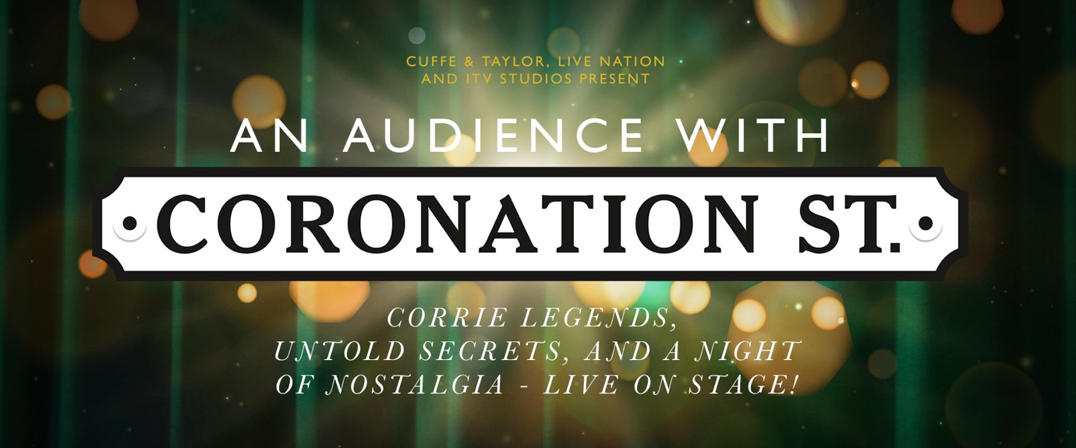

TICKETS ONSALE FRIDAY 14TH MARCH 10AM
PRICED FROM £29.50 (+ BOOKING FEE) VIA CUFFEANDTAYLOR.COM

Media assets available here.

For the first time ever, the legendary stars of the world’s longest-running soap are stepping off the famous cobbles and onto the stage for an unforgettable evening! An Audience with Coronation Street is hitting the road, and it’s shaping up to be the must-see event of the year!

This is your exclusive chance to get up close and personal with your favourite Corrie stars as they spill behind-the-scenes secrets, share hilarious stories, and relive heart-warming moments from the iconic ITV show. Hosted by This Morning’s resident soap expert Sharon Marshall, this spectacular show will be packed with laughter, nostalgia, and more than a few jaw-dropping surprises!

In the first half, the audience will be treated to an intimate and lively interview session with some of Corrie’s most beloved cast members. Ever wondered what goes on between takes? Curious about those off-screen friendships and real-life dramas? This is your chance to hear all the gossip straight from the source. You’ll also get to know the actors behind the characters like never before, their journeys, their funniest on-set moments, and the real-life bonds that make Weatherfield feel like home.

Just when you think the night couldn’t get any better, the second act brings a showstopping twist! A very special guest; a bona fide Coronation Street legend will take to the stage. But who will it be? We’re keeping it a cliffhanger, Corrie-style!

Each event will feature five Coronation Street stars live on stage, including a surprise Corrie legend. The line-up will vary at each venue, with fan-favourite cast members including Andrew Whyment (Kirk Sutherland), Jack P Shepherd (David Platt), Samia Longchambon (Maria Connor), and Simon Gregson (Steve McDonald), with more names to be announced soon.

Whether you’ve been watching since 1960 or you’ve just discovered the magic of Weatherfield, An Audience with Coronation Street promises an evening of laughter, nostalgia, and stories you won’t hear anywhere else. Don’t miss your chance to be part of this extraordinary event!

Tickets are expected to sell fast, so don’t miss out — grab yours now for an unforgettable night on the cobbles!

AN AUDIENCE WITH CORONATION STREET
CORRIE LEGENDS, UNTOLD SECRETS, AND A NIGHT OF NOSTALGIA LIVE ON STAGE!

Cast Members Appearing Include*

Andrew Whyment (Kirk Sutherland)
Jack P Shepherd (David Platt)
Jimmi Harkishin (Dev Alahan)
Jodie Prenger (Glenda Shuttleworth)
Patti Clare (Mary Taylor)
Rob Mallard (Daniel Osbourne)
Samia Longchambon (Maria Connor)
Simon Gregson (Steve McDonald)

More cast members & Legends to be announced.

14 September 2025: London, Dominion Theatre
19 September 2025: Sheffield, City Hall
20 September 2025: Salford, The Lowry, Lyric Theatre
24 September 2025: Glasgow, Royal Concert Hall

*Cast members will vary for each show

Tickets onsale Friday 14th March 10am
Tickets priced from £29.50 (+ booking fee)
Ticket via cuffeandtaylor.com

For all media enquiries please contact Warren@chuffmedia.com / 07762 130510

