THE ITCH

ANNOUNCE DEBUT ALBUM
IT’S THE HOPE THAT KILLS YOU

ARRIVING 10TH APRIL 2026
VIA FICTION RECORDS / I OH YOU

SOHO BASEMENT SHOW AT ST. MORITZ CLUB
28TH JANUARY

LISTEN TO ‘AUX ROMANTICISER’ HERE

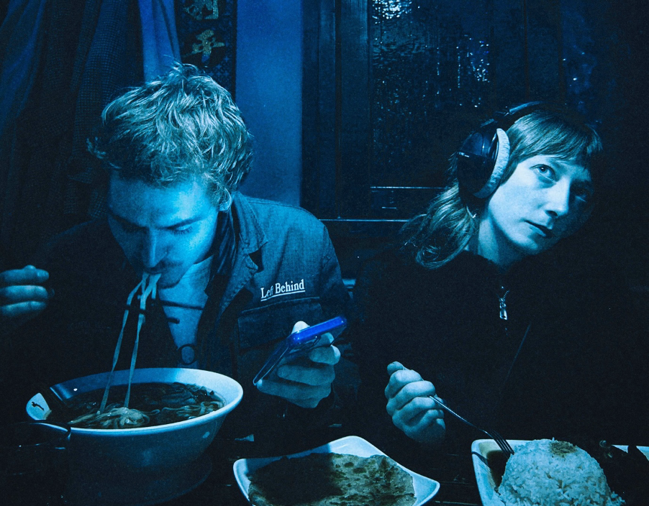

credit: The Itch [alt versions + album artwork here]

The Itch share the news that their debut album It’s The Hope That Kills You will arrive 10th April 2026 via Fiction Records & I OH YOU. This announcement comes alongside new single ‘Aux Romanticiser’.

Over the course of a debut album which finds harmony in juxtaposition, Simon & Georgia pool a hundred different touchstones to create something entirely singular. It’s The Hope That Kills You is crisp yet dishevelled. Introspective yet exuberant. And delivered with candid conviction while wry sarcasm consistently looms moments away.

Announcement single ‘Aux Romanticiser’ exemplifies The Itch’s wide net of influences, sampling both the viral webseries Subway Takes and Pearson Sound’s WAD. “You don't need to know how to crossfade / Just stick it in your phone and play some Beyoncé,” Simon declares on the track, preceding a spacious breakdown and euphoric climax worthy of closing any set.

Watch ‘Aux Romanticiser’ Video Here

Remixes for each of ITHTKY’s singles will see The Itch teaming up with The Twins, 1-800 GIRLS, Gabe Gurnsey and Tom Sharkett.

Since first arriving in 2024 with a single headline performance (which sold out in a day), The Itch re-emerged in the summer of 2025 with a second sold-out headline - this time at Corsica Studios - and a sweaty midnight set at The Great Escape which saw an hour-long queue jostling for entry and has since gained a cult-like status in its own right.

It’s The Hope That Kills You will be released in a collaborative record deal between Fiction Records [The Cure, Kae Tempest] and I OH YOU [Confidence Man, Rolling Blackouts Coastal Fever]. Vocoder-topped europop gem ‘Space in the Cab’ and The Itch’s metamorphic, 7-minute long debut single ‘Ursula’ feature in the albums tracklist alongside ‘Aux Romanticiser’.

Pairing undulating dancefloor fillers with disenchanted pop songwriting, Simon & Georgia have captured a moment in time to conjure a debut offering which is both a product of and an antidote to an age of pessimism.

Pre-order It’s The Hope That Kills You Here

Live Dates:
28.1.25 – St Moritz Club, Soho (London)
13-16.5.26 - Great Escape Festival (Brighton)
23.5.26 - Dot to Dot Festival (Bristol)
24.5.26 - Dot to Dot Festival (Nottingham)

The Itch - It’s The Hope That Kills You

Space In The Cab
No More Sprechgesang!
Can’t Afford This
Pirate Studios
Drugdealer
Radio Frequencies
It’s The Hope That Kills You
Aux Romanticiser
Ursula
Never Change
Switch It Off

DISCOVER THE ITCH
Website | Instagram | YouTube | Spotify

For more info contact Warren Higgins
warren@chuffmedia.com

