boygenius RELEASE THREE NEW SINGLES “$20,” “EMILY I’M SORRY” + “TRUE BLUE”

LISTEN HERE

NEW STUDIO ALBUM the record VIA POLYDOR RECORDS / INTERSCOPE OUT MARCH 31ST, 2023

AVAILABLE FOR PRE-ORDER HERE

(the record album art. Photo credit: Matt Grubb. Download High Res HERE)

Following news that they will be performing at this year’s Coachella music festival, boygenius have announced their long awaited return with the release of three singles from their upcoming album the record via Polydor Records / Interscope: “$20,” “Emily I’m Sorry,” and “True Blue.” The album is due out March 31, 2023 and marks the first full length project for the band.

STREAM THE SINGLES HERE
PRE-ORDER the record HERE

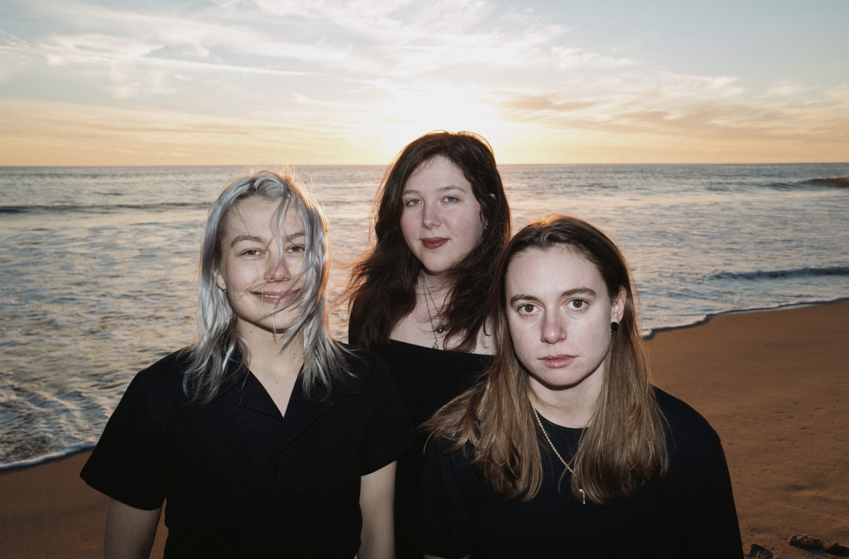
L-R: Phoebe Bridgers, Lucy Dacus & Julien Baker
(Photo credit: Harrison Whitford. Download High Res HERE)

boygenius, the acclaimed trio comprised of Julien Baker, Phoebe Bridgers and Lucy Dacus, released their self-produced debut EP boygenius together back in 2018. The release of “$20,” “Emily I’m Sorry,” and “True Blue” marks the first new music from the band since 2020, when they released a handful of demos from the recording sessions for the EP to raise money for charitable organizations in their respective hometowns on behalf of the Downtown Women's Center of Los Angeles, OUTMemphis, and Mutual Aid Distribution Richmond.

The long-awaited album is produced and written by boygenius. It was recorded at Shangri-la Studios in Malibu, California.

Track listing for the record below:

- Without You Without Them
- $20
- Emily I’m Sorry
- True Blue
- Cool About It
- Not Strong Enough
- Revolution 0
- Leonard Cohen
- Satanist
- We’re In Love
- Anti-Curse
- Letter To An Old Poet

boygenius will perform at this year’s Coachella Music Festival on Saturday, April 15th and Saturday, April 22nd.

Praise for boygenius:

“The band instantly became the “Infinity War” of female-led indie-rock outfits…it’s not your average vision of feminist empowerment via extreme independence” – Vogue

“The sizable talent and personalities of Julien Baker, Phoebe Bridgers, and Lucy Dacus come together for a harmonious, confrontational, and all too brief EP” – Pitchfork

“an astonishing record” – NME

“Rock’s best super group” – Daily Beast

KEEP UP WITH BOYGENIUS:
Web / Instagram / Twitter

For more information and press enquiries please contact

Jenny Entwistle
Jenny@chuffmedia.com

