mgk Announces New Album lost americana Releasing August 8
Watch The lost americana Album Trailer HERE
lost americana Is Now Available For Pre-Order
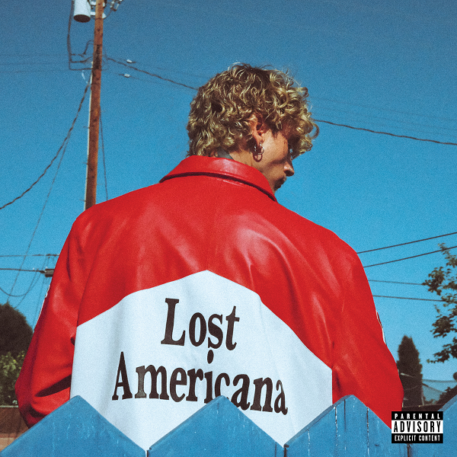

Today, GRAMMY nominated recording artist mgk has officially announced the title of his forthcoming album: lost americana. With the release of his exciting summer single “cliché,” mgk has been teasing the album title with a trail of online clues for fans to discover. Available globally on August 8, lost americana is an emotionally honest new chapter that reflects on his past with help from longtime collaborators and friends SlimXX, BazeXX and Nick Long. The legendary narrated trailer captures mgk on a journey where the past is reimagined, and the future is forged on your own terms through music that celebrates beauty found in the in-between spaces. Pre-order lost americana HERE.

mgk has been building anticipation with a series of reimagined covers, including the Goo Goo Dolls' classic "Iris," Juice WRLD's "Empty Out Your Pockets," and Green Day's iconic "Boulevard of Broken Dreams." Each rendition offered a glimpse into mgk's evolving artistry and emotional depth. On June 20, mgk will perform live on the TODAY Plaza as part of the Citi Concert Series on TODAY! Adding to the excitement, mgk is set to headline the 30th Anniversary Vans Warped Tour in Washington, DC this weekend on June 14 and in Orlando, FL on November 15-16.

The renowned superstar eclipsed genre expectations by releasing the widely acclaimed album Tickets to My Downfall in 2020. The platinum album topped the Billboard 200 and became his first No. 1 effort. The album landed 18 tracks on the Hot Rock Songs chart. Platinum singles, “bloody valentine" and "my ex’s best friend," both went No. 1 at Alternative. His follow-up album, mainstream sellout, became his second album to hit No. 1 on the Billboard 200 and was nominated for a Grammy Award for “Best Rock Album”

mgk – 'lost americana' Pre-Save (eAlbum)
Pre-save: https://mgk.lnk.to/lostamericana
Trailer: https://www.youtube.com/watch?v=S-oC9YVtxlU

mgk – “cliché” eSingle
Retail: https://mgk.lnk.to/cliche
“cliché” Video: https://mgk.lnk.to/clicheVideo
“cliché” BTS Video: https://www.youtube.com/watch?v=0v70-WuEBoc

For more information visit www.machinegunkelly.com
mgk Press Photos: https://umusic.box.com/s/cwahmmpd9nq5hl8v4octujsh74u9hz5w

For more information please contact jenny@chuffmedia.com

