

THIS IS A ROYEL OTIS PRESS RELEASE
ANNOUNCING THEIR SOPHOMORE ALBUM
hickey OUT AUGUST 22ND

TICKETS TO THE “meet me in the car” tour NOW AVAILABLE.

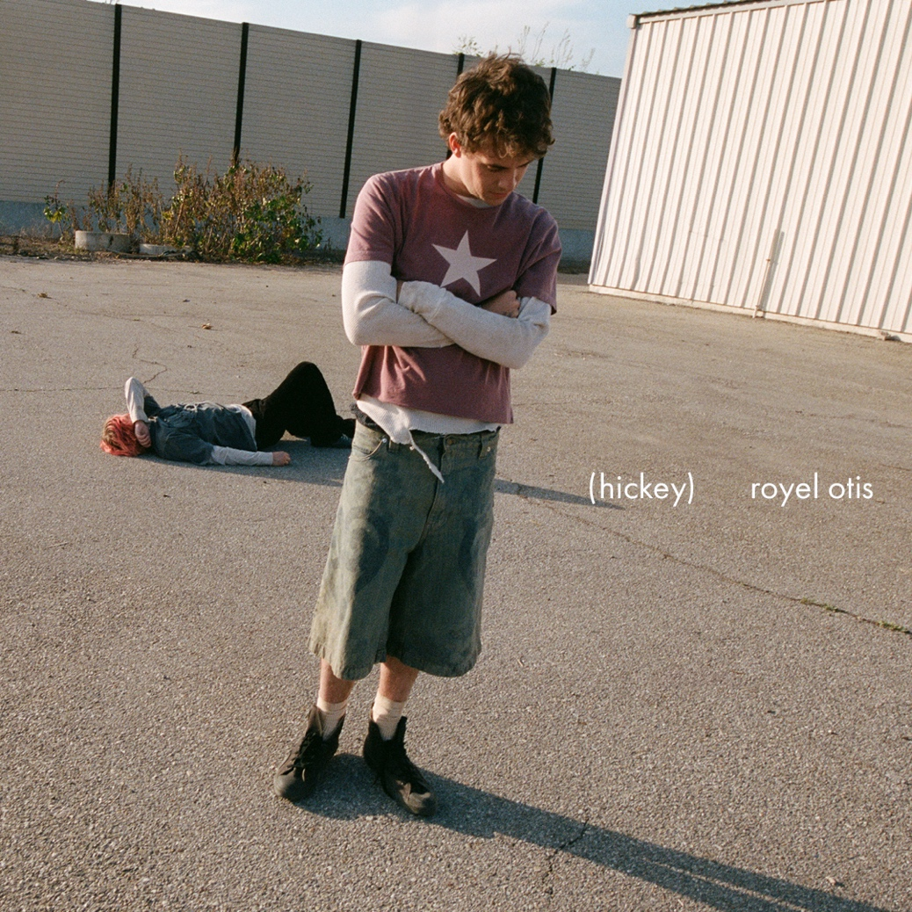

Pre-order or add that highly anticipated set HERE.

Today, Royel Otis have announced the news that their much-anticipated sophomore album, titled hickey, will be released on August 22nd (out on OURNESS / Capitol Records).

hickey comes just a year after the band’s shimmering debut album, PRATTS & PAIN (February 2024). The pair have been in the States playing pop up shows across the coasts giving fans a taste of what to expect alongside the release of their first single off the album, “moody.” Speaking to the album’s title, Royel Otis shared “…because love bites harder than any other emotion in the world.”

While the band is currently on a tear through just about every festival worth attending — including Governor’s Ball (New York City), Lollapalooza (Chicago), Outside Lands (San Francisco), and more — Royel Otis also recently announced their upcoming “meet me in the car” tour which will find them headlining cities across North America. The pair have already sold out major cities such as Austin, TX and New York City. Visit https://www.royelotis.com/tour/ for more info or see below for full tour routing.

Royel Otis have already earned a reputation not just for their charmed indie rock, but also a live show that puts the pair’s creative chemistry on full display. To celebrate the launch of their new musical era in May, they played back-to-back gigs at West Hollywood’s storied Troubadour which sold out within minutes. Fans lucky enough to attend were treated to more unreleased music.

Those eager to hear more from the Sydney-based band will have plenty of chances over the coming months. Take a look at Royel Otis’ itinerary below, and stay tuned for more from hickey.

Royel Otis live dates + “meet me in the car” tour
(headlining dates in bold)
06/27/25 – St.Gallen, Switzerland @ Sittertobel, St. Gallen
06/29/25 – Pilton, UK @ Glastonbury Festival
07/03/25 – Barcelona, Spain @ Vida Festival
07/06/25 – Belfort, France @ Eurockéennes
07/07/25 – Montreux, Switzerland @ Montreux Jazz Festival
07/10/25 – Madrid, Spain @ Mad Cool Festival
07/13/25 – Berlin, Germany @ Lollapalooza Berlin
07/27/25 – Minamiuonuma, Niigata @ Fuji Rock
07/31/25 – Chicago, IL @ Lollapalooza
08/01/25 – St.Charles, IA @ Hinterland Music Festival
08/03/25 – Montreal, QC @ Osheaga Festival
08/05/25 – Seattle, WA @ Paramount Theatre *
08/06/25 – Portland, OR @ PDX Live at Pioneer Courthouse Square *
08/09/25 – San Francisco, CA @ Outside Lands
08/15/25 – Hamburg, Germany @ MS Dockville
08/16/25 – Biddinghuizen, NL @ Lowlands Festival
08/23/25 – Reading, UK @ Reading Festival
08/24/25 – Leeds, UK @ Leeds Festival
09/12/25 – Philadelphia, PA @ Franklin Music Hall ^
09/14/25 – Washington, DC @ The Anthem ^
09/15/25 – Asbury Park, NJ @ Sea.Hear.Now Festival
09/16/25 – Raleigh, NC @ The Ritz ^
09/17/25 – Atlanta, GA @ The Eastern ^
09/19/25 – Dallas, TX @ The Bomb Factory ^
09/20/25 – Austin, TX @ Stubb’s ^ (SOLD OUT)
09/21/25 – Austin, TX @ Stubb’s ^
09/28/25 – Tempe, AZ @ Marquee Theatre ^
09/30/25 – Denver, CO @ Mission Ballroom ^
10/02/25 – St. Paul, MN @ Palace Theatre ^
10/03/25 – Kansas City, MO @ Grinders KC ^
10/04/25 – Chesterfield, MO @ The Factory ^
10/06/25 – Toronto, ON @ History^
10/10/25 – Boston, MA @ MGM Music Hall at Fenway ^
10/11/25 – New York, NY @ The Rooftop at Pier 17 ^ (SOLD OUT)
10/12/25 – New York, NY @ The Rooftop at Pier 17 ^
11/09/25 – Copenhagen, Denmark @ Poolen
11/10/25 – Stockholm, Sweden @ Fällan
11/11/25 – Oslo, Norway @ Sentrum
11/14/25 – Prague, Czech Republic @ SaSaZu
11/15/25 – Vienna, Austria @ Gasometer
11/17/25 – Munich, Germany @ Zenith
11/19/25 – Amsterdam, Netherlands @ AFAS Live
12/01/25 – Paris, France @ L’Olympia
12/02/25 – Zurich, Switzerland @ Halle 622
12/03/25 – Milan, Italy @ Fabrique
12/05/25 – Esch-sur-Alzette, Luxembourg @ Rockhal
12/06/25 – Brussels, Belgium @ Forrest National
12/08/25 – Cologne, Germany @ Palladium

*= DANCER opening
^= bby opening


This is a photo of Royel Otis by Zora Sicher | Download HERE

THIS IS PRAISE FOR ROYEL OTIS:

“This duo from Australia, nuts, just NUTS...” – Zane Lowe, Apple Music

“Melting together their penchant for melody with DIY mess-thetics, Royel Otis have sketched out a singular sound.” – CLASH

“An intangible sonic it-factor that many bands these days are hoping to replicate.” – V MAN

“Royel Otis is on one of those runs where you best get on-board, or move clear out the way.” – BILLBOARD

ABOUT ROYEL OTIS:
Royel Maddell and Otis Pavlovic’s chance meeting feels almost destined. They were both working at bars and cafes in the same neighborhood (the beachside town of Bondi) before getting together one day in 2019 with their guitars and some song sketches. And without any expectations, they soon spotted it: an unspoken chemistry that resulted in effortless rock wonders, new tunes that somehow seemed as if they’d always existed. The rest of the world would soon follow suit when the pair became true breakout acts both online and in rock clubs alike with early charmers such as “Oysters in My Pocket” (Bar & Grill EP, 2022) and “Sofa King” (Going Kokomo EP, 2023). Then came their soaring debut album called PRATTS & PAIN and the legendary run that catapulted the band to indie-rock infamy, globally. The album was named for the south London pub where the pair would pen lyrics between sessions with GRAMMY nominated Dan Carey (Wet Leg, Fontaines D.C., Caroline Polachek) and bore hits like “Fried Rice” and “Foam.” Preceding the album’s release in February of 2024, was the pair’s Triple J “Like A Version” recording, taking on Sophie Ellis-Bextor’s “Murder on The Dancefloor.” The performance became a zeitgeist shaping hit, eventually hitting #1 on Alternative U.S. Radio Chart, #2 on Billboard Alternative Airplay, #5 on Billboard Rock & Alternative and rounding out at the #2 position on Triple J’s Hottest 100 of 2024 charts, earlier this year. Their twilit cover of the Cranberries’ “Linger,” cut for a Sirius XM Session a few months later, led the band to their first Billboard Hot 100 hit and currently has over 220 million global streams. With the demand for live shows at a high, the guys played more than 100 sold out shows the rest of 2024, selling over 100,000 tickets across Australia, U.K, Europe and U.S. This included multiple nights in major cities like New York (Brooklyn Steel), Chicago (Metro & The Salt Shed) and Los Angeles (The Bellweather). The pair returned home to Australia later that year as one of the most nominated artists at the 2024 ARIA Awards (Australia’s biggest and prestigious music award shows); and went on to win four awards including “Best Rock Album” and “Best Group.” Since their culmination, Royel Otis have drawn from an endless source of good hooks and spirit — riding on their musical chemistry that exudes into mixes of melody and bittersweet humor. Whether it is an original body of work or taking on their favorite song, the pair have cemented their status as one of the most effortless and endearing indie rock bands to emerge this decade.

THIS IS WHERE YOU CAN FIND ROYEL OTIS ONLINE:
INSTAGRAM | TIKTOK | SPOTIFY | YOUTUBE | X

For more information and press enquiries for ROYEL OTIS please contact

Jenny Entwistle
Jenny@chuffmedia.com

