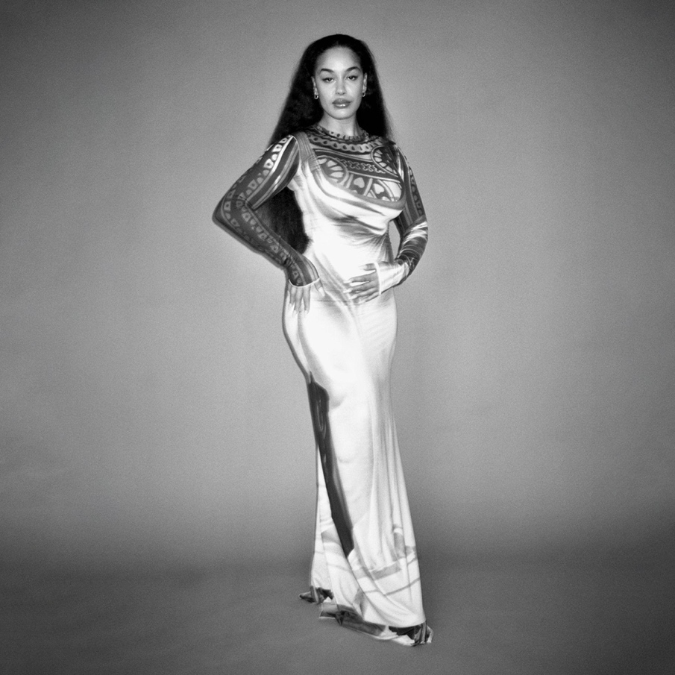
Artwork shot by Liz Johnson Arthur
JORJA SMITH ANNOUNCES SECOND ALBUM
‘FALLING OR FLYING’
SET FOR RELEASE SEPTEMBER 29TH 2023 - PRE-ORDER HERE
+ ANNOUNCES A SERIES OF ALBUM LAUNCH SHOWS IN THE UK
PRESS SHOT HERE / ARTWORK HERE
May 18th 2023 - Jorja Smith is officially back. Further to making a recent return to the musical sphere with her singles ‘Try Me’ and ‘Little Things’, today she has confirmed the details of her highly anticipated second album, ‘falling or flying’, set for release globally on September 29th 2023 via FAMM and available to pre-order now - here.
Alongside the announcement, Jorja has also unveiled the album's poignant artwork; a stunning portrait of her, shot on film by the prestigious British photographer, Liz Johnson Artur. In addition, Jorja has also announced a series of UK live shows in September, commemorating the release of the album. Further details below.
Through her new record, Jorja has delivered an undeniable modern classic, effortlessly condensing any number of disparate styles and genres into music which thrillingly broaches any gap between Jazz, Soul, R&B and Funky House. A bold, brave and courageous leap forward from her critically acclaimed debut album ‘Lost and Found’ - ‘falling or flying’ is an album that speaks to the musical and emotional era where Jorja is now, and how she got here. It isn’t so much an exploration of how she’s found herself but more a statement that she has arrived, and that her understanding of her life, her relationships, and her feelings, have deepened, matured and crystallised as she enters her twenty six year. ‘And despite it all,’ she says, ‘it's definitely a journey I've just started. That's what's crazy. It's only just begun.’
Sonically, this album, a no-skips body of work, isn’t like anything you’ve heard before. It sits masterfully in this same space of excitement, self-exploration and self-assertion that Jorja does. Compromised of deep, thumping drums, racing basslines, irresistible hooks and distinctive beats, ‘falling or flying’ runs at the same pace that Jorja’s mind does. ‘I don't slow down enough’ she says. ‘This album is like my brain. There’s always so much going on but each song is definitely a standstill moment.’
Much of the creative energy that shaped the album emerged from studio sessions with the producer duo DAMEDAME* back in her hometown of Walsall, where, to Jorja, the heart is. The album is both a sonic and an emotional tour of where she’s been, and what she’s been about, in the two years since she dropped her latest offering, ‘Be Right Back’. ‘It touches on breakups, relationships with my friends, relationships with old friends, relationships with myself.’ She says. ‘It's definitely about a lot of relationships, but every song I write I can sing it to myself.’
Of the many British voices in music today, Jorja is among the most commanding, writing at a pitch of intensity and urgency that few can match. Over the past five and half years, since the release of her debut album ‘Lost & Found’, she has been celebrated unanimously across the world for her evocative song-writing, powerful delivery, pure emotion and unbridled talent as a young woman navigating her way through life and in 2021 was the year Jorja’s hiatus from music was broken. Enter ‘Be Right Back’, the holding space between the sensation that was ‘Lost & Found’, and ‘falling or flying’. ‘Be Right Back’ was born from playing, jamming, freestyling, and sounding out what Jorja had been on the edge of expressing all her life. It was a project entirely for her fans. “Be Right Back did exactly what I wanted it to do. It was a little waiting room so people knew I was coming back.”
And come back she has - entering a chapter of her return to music that’s certain to draw in and intoxicate Jorja’s fans and new listeners alike. And what has changed for her, in the five years since ‘Lost & Found’ dominated the charts and the soundscape? “I like this world that I've just come into. And I’m still figuring things out. Always figuring things out.” Jorja says. “This is the first time I’m putting stuff out there that I can connect with right now.” Over the last few years, it’s been a reflective and transformative step into her mid twenties for her. She’s been able to step into herself and evolve as a songwriter and a woman despite an ever-changing musical landscape.
While she recognises that the global pandemic has been completely devastating, she acknowledges that it allowed her to stay still, to come more into herself, and to be more in control of the person she is, and of her musical output. Like some of the legendary musicians that came before her, Jorja is looking at the chaos and disorder in the world right now with resourceful, refined eyes, and she sees the glorious opportunity and enormous responsibility that affords. The net result is that while ‘falling or flying' sounds very much like Jorja Smith, it sounds like no Jorja Smith album you have ever heard before.
‘falling or flying’- released globally on September 29th 2023, available to pre-order now - here.
‘falling or flying’- album launch live shows. Tickets on sale 10am BST 19th May via jorjasmith.com
Thursday 28th September - Pryzm, Kingston (with Banquet)
Saturday 30th September - Level, Nottingham (with Rough Trade)
Wednesday 4th October - Outernet, London (with Rough Trade)
Monday 9th October - SWX, Bristol (with Rough Trade)
PRESS SHOT HERE / ARTWORK HERE
FOLLOW JORJA SMITH ONLINE: INSTAGRAM // FACEBOOK // TWITTER // TIKTOK

For more information please contact warren@chuffmedia.com on 07762 130510

