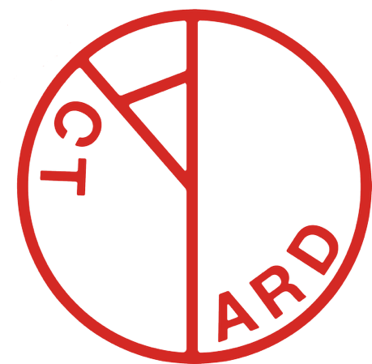

YARD ACT ANNOUNCE NEW ALBUM DETAILS + SHARE FIRST SINGLE, REDEEMER

“YOU’RE GONNA NEED A LITTLE MUSIC” RELEASES 17TH JULY

LISTEN TO REDEEMER STREAMING NOW / WATCH VIDEO HERE

+ FULL UK TOUR ANNOUNCED FOR NOVEMBER


Credit: James Winstanley
Yard Act are pleased to share details of their third studio album, “You’re Gonna Need A Little Music”. The record will be released on 17th July via Island Records.

To coincide with the announcement, the band have shared the first new music to be lifted from the record. Redeemer is streaming now, and video is here

The album was recorded between the band’s hometown of Leeds and in Los Angeles with producer Justin Meldal-Johnsen (Nine Inch Nails, Beck, St Vincent).

Simultaneously the most dynamic, collaborative, energised work they’ve laid to tape, but also containing some of the darkest, most cynical and truly questioning moments they’ve concocted too, You’re Gonna Need A Little Music picks up their tale and examines the findings more unsparingly than ever.

Weirdly, for a band so associated with incendiary live shows and constant touring, their third LP marks the first time that the quartet have ever made an album together, as a live band in the same room. “The first two records were both laptop records essentially,” says Smith. The Overload was written alongside Needham before the band had fully formed; its follow-up, Where’s My Utopia?, was carved out in snatches of time on tour buses and hotel rooms, amongst a relentless schedule of “slinging [all our gear] in the rehearsal space, going back home, and then a week later piling it back into a van again.”

For the first time in a long time, Yard Act were able to settle into an “uninterrupted five month period” of creativity, crafting “40 or 50 songs” and allowing themselves to follow their ideas with no external pressure. “It felt like freedom,” says Smith. “It felt like everything I’d wanted from being in a band”

The band will spend much of this year out on the road, kicking off with European dates in June before heading to North America throughout August, and back to Europe in October. A slew of new UK headline dates are shared today throughout November, in addition to the three dates – Leeds, Manchester, London – that are already on sale.

Fans pre-ordering the new album by 10:00am BST on Tuesday 12th May, will receive first access to tickets for the new UK live dates. A pre-sale will commence at 10:00am BST on Wednesday 13th May followed by general sale from 10:00am BST on Friday 15th May.

You’re Gonna Need A Little Music follows the band’s UK Top 5 charting Where’s My Utopia? in 2024, and their Mercury Prize nominated 2022 debut, The Overload.

Album Tracklisting: Empty Pledges / New Beginnings / Tall Tales / Fiction / You’re Gonna Need A Little Music / Cherophobe Rock / Thrill Of The Chase / Janey Said / Redeemer / Talky Talky People / Over The Barrel

Pre-order You’re Gonna Need A Little Music

Yard Act Live:

6th November – O2 Academy, Leeds
7th November – O2 Academy, Leeds *New Date*
10th November – NX, Newcastle *New Date*
11th November – Barrowland Ballroom, Glasgow *New Date*
12th November – Octagon Centre, Sheffield *New Date*
13th November – O2 Victoria Warehouse, Manchester
15th November – Wulfrun Hall, Wolverhampton *New Date*
16th November – O2 Academy, Leicester *New Date*
17th November – Rock City, Nottingham *New Date*
18th November – Junction 1, Cambridge *New Date*
20th November – O2 Academy, Oxford *New Date*
21st November – Bristol Beacon, Bristol *New Date*
23rd November – Plymouth Arena, Plymouth *New Date*
24th November – O2 Guildhall, Southampton *New Date*
26th November – O2 Academy Brixton, London

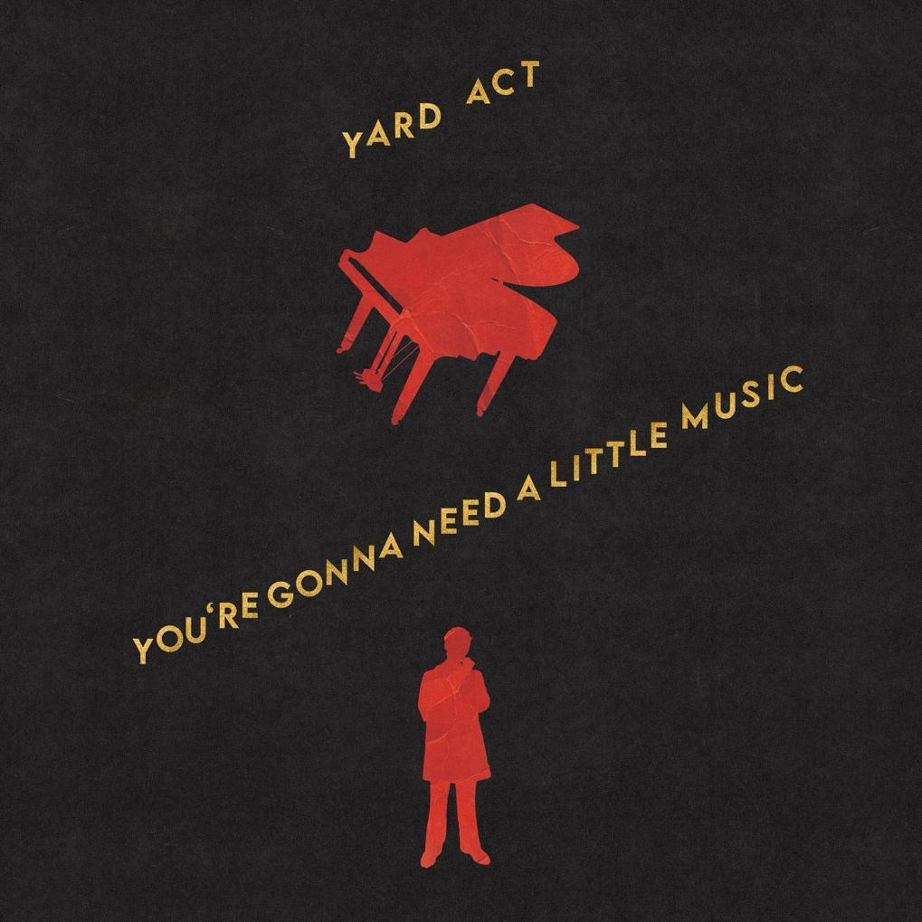
Album Artwork

FOLLOW YARD ACT:
Website | Instagram | Twitter | Facebook | TikTok | Spotify | Apple Music | YouTube

For more information and press enquiries please contact

Warren Higgins
warren@chuffmedia.com

