Jehnny Beth
Returns With New Album You Heartbreaker, You
Out August 29th on Fiction Records
Reveals First Taste ‘Broken Rib’
Watch HERE // Listen HERE

Announced To Play QOTSA Rock N Roll Circus in Sheffield
August 27th & 28th
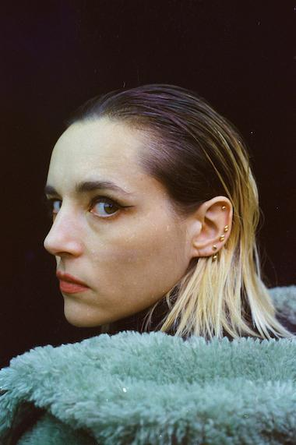
Photo Credit: Johnny Hostile

Songwriter, singer, and multi-disciplinary artist Jehnny Beth is back with her biting new album You Heartbreaker, You, which comes August 29th on Fiction Records. Alongside the announcement Jehnny has also revealed the album’s first cut ‘Broken Rib’. Listen to ‘Broken Rib’ HERE.

With a punch reminiscent of her days in Savages, ‘Broken Rib’ is a powerful raw return. “We learn to breathe with a broken rib” she sings, fighting to keep breathing through the damage, always bouncing back. “I knew that if I was going to sing again, it had to start with a scream,” she says of the track.

‘Broken Rib’ arrives with a powerful visual directed by Jehnny Beth and longtime collaborator Johnny Hostile. A stark, surrealist antidote to societal decay, the video matches the track’s urgency and grit. Watch HERE.
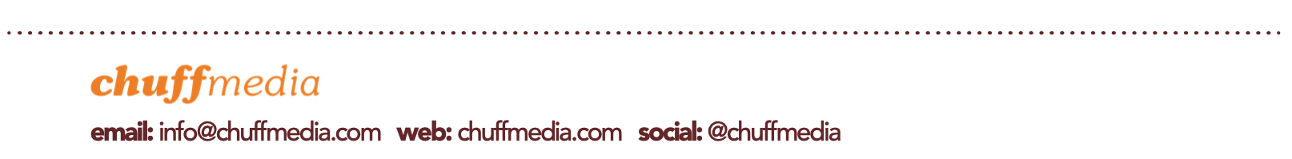
Recorded and produced by longtime co-creator Johnny Hostile at their 20L07 studio in France, You Heartbreaker, You is visceral, abrasive and cathartic.

“We’re living in a dark time, full of drama and barbarous tragedy. It became clear to me that, in these times, we either learn how to scream really well, or we learn how to whisper,” Jehnny says of the record.

Capturing the feeling of being broken in a broken world, where love still operates on a prehistoric level, You Heartbreaker, You is a radical work that cuts straight to the core: heart to heart.

You Heartbreaker, You Tracklisting:
- Broken Rib
- No Good For People
- Obsession
- Out Of My Reach
- I Still Believe
- Reality
- Stop Me Now
- High Resolution Sadness
- I See Your Pain

Known for her ferocious live shows, Jehnny has been announced to support Queens Of The Stone Age at their Rock N Roll Circus Festival in Sheffield on August 27th and 28th. She’ll also play a very special DJ set on the Shangri-La stage at 22:45 on Saturday 28th June at Glastonbury Festival. More info HERE.

Jehnny Beth Plays The Following 2025 Dates:
June
Sat 28th Pilton, Glastonbury Festival (DJ Set)

August
Wed 27th Sheffield, Rock N Roll Circus w/ QOTSA, Viagra Boys & More
Thu 28th Sheffield, Rock N Roll Circus w/ QOTSA, Viagra Boys & More

With more live dates set to be announced soon and her most accomplished work to date, 2025 is set to be the year of Jehnny Beth.

About Jehnny Beth: Having established her name in the acclaimed punk band Savages, who received Mercury Prize nominations for both of their albums Silence Yourself (2013) and Adore Life (2016), Jehnny Beth’s talents stretch far beyond the world of music. Since the release of her debut solo album To Love Is To Live in 2020, Jehnny has multiplied creative collaborations (Idles, Gorillaz, Sextile, Bobby Gillespie) and made a powerful impression in cinema with Jacques Audiard’s Paris, 13th District, before celebrating both a Palme d’Or and an Oscar for Justine Triet’s Anatomy of a Fall. She also hosts the celebrated music series ECHOES, a platform dedicated to supporting emerging music scenes, spotlighting artists like Wet Leg, Fontaines D.C. and Kneecap at the start of their careers.

https://www.jehnnybeth.com/
Instagram // YouTube // Facebook // X

For more info contact Warren warren@chuffmedia.com

