DIY-indie US superstars, The Backseat Lovers announce Waiting To Spill, the follow-up to their cult-classic debut

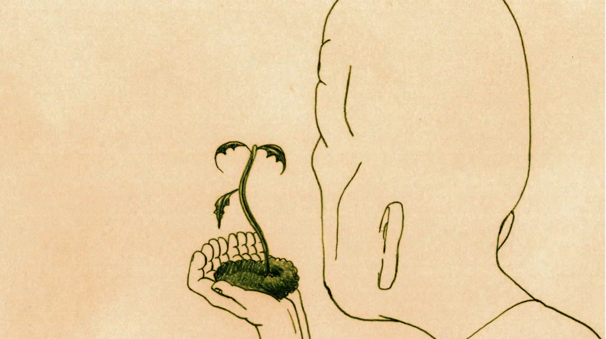
Play Video

- As combined global streams of Kilby Girl surpass 200 million, the Utah four-piece announce the follow up to 2019’s self-released debut, When We Were Friends

- Having performed two sell-out runs of dates in the UK and throughout Europe, The Backseat Lovers release Growing/Dying, their first single with Polydor

The Backseat Lovers – Growing/Dying
OUT NOW on Polydor
Waiting To Spill, the new album, released Fri 28 October 2022
Pre-Orders

Barely taking a breath since returning home from their latest run of sold-out UK and Ireland live dates, including blowing away a near-two thousand-strong audience at Electric Brixton, London in May, Utah’s The Backseat Lovers make their major label debut to present their first new music in almost two years by releasing Growing/Dying. Accompanied by a delicate, hand-drawn video, the intense, emotional delivery of the song offers the band’s committed, international fanbase a first glimpse through a window onto Waiting To Spill, The Backseat Lovers’ second album confirmed for release on Fri 28 October 2022 on Polydor.

Going little further than to confirm the follow up to 2019’s runaway, underground-to-rapidly-overground, self-released success story of When We Were Friends will contain ten, brand new tracks, produced by six-time Grammy Award-winner, David Greenbaum (Paul McCartney, Gorillaz, Beck), what lies in store on Waiting To Spill remains partly cloaked in mystery. However, Growing/Dying’s complexity, ranging from acoustic strum to fractured emotionally-charged waves of intensity hints at a band of ever-growing artistic surety and stature.

The album is heading fans’ way in digital, 180g vinyl and CD formats. Standard black vinyl will arrive alongside a dark green vinyl edition, available only from the band’s online store, while a clear vinyl version will be found at indies only.

Initially forming in high school and around the music scenes of Salt Lake City and Provo in 2018, primary songwriters Joshua Harmon (vocals/guitar) and Jonas Swanson (Guitar) with KJ Ward (Bass) and Juice Welch’s (Drums) journey as The Backseat Lovers began with the pure love of songcraft, live performance and DIY-ethics. They completed their first EP, Elevator Days, just before graduation. What soon became a runaway train has rolled on to include 370 million total worldwide streams, including the Top 20 Alternative hit Kilby Girl which spent five weeks on the U.S. Spotify top songs chart.

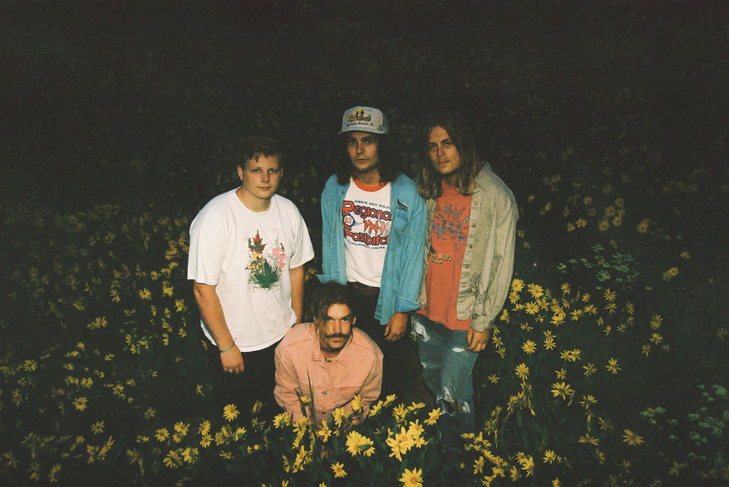

Their organic spread amongst a community of discerning music lovers has led to 60 dates completely selling out on the band’s first two North American headline tours, lock-outs throughput the UK and Ireland, main stage festival appearances including Lollapalooza, Bonnaroo and The Great Escape, arena/stadium support slots with The Killers and Jack White and the inevitable attention of major labels worldwide.

Carefully crafting the visuals to accompany their carefully-crafted songs, The Backseat Lovers have looked to band collaborator, Kohana Wilson for the hand-drawn and animated video for Growing/Dying, evoking the track’s predominant ideas of idea of new parts of life flourishing, while other parts are left behind. The artwork for the single is a photo taken by Tony Ehnle, who provided the shot that adorned When We Were Friends and whose film photographs from the 70’s had remained largely unearthed until the band was introduced to his work through a friend.

Initially fiercely self-propelled, the remarkable success of When We Were Friends appeared to catch the band off-guard, inadvertently producing their debut through necessity around playing shows. Able to consider their second album at longer-range, The Backseat Lovers, still proud of their first attempt, look at Waiting To Spill as an album that tells a coherent story.

Joshua Harmon says of the two records: “When We Were Friends was our first attempt at making an album, and it was essentially recording one song, selling some t-shirts at a show the next month, and being able to record another song. Upon finishing it, we were quickly filled with a strong desire to MAKE an album. We were pretty much obsessed with the idea of making something that really flowed together and felt like each song was intentionally placed, creating a cohesion that spanned the whole record. Making it a collective body of work as opposed to a collection of songs. Overall though it really feels like a continuation of the next chapter of our lives.

The Backseat Lovers will gradually present more of what lies in store across Waiting To Spill’s under-wraps track listing in a series of announcements and music reveals over the coming months.

For all information on The Backseat Lovers including upcoming tour dates and release news, connect with the band online at:

www.thebackseatlovers.com
www.twitter.com/Backseat_Luv
www.instagram.com/the.backseat.lovers
www.tiktok.com/@thebackseatlovers
www.facebook.com/The.Backseat.Lovers8

The Backseat Lovers Photo Credit: Travis Bailey
For more info contact Warren@chuffmedia.com

