NORAH JONES ANNOUNCES NINTH STUDIO ALBUM VISIONS
OUT MARCH 8 ON BLUE NOTE RECORDS
WATCH THE OFFICIAL VIDEO FOR LEAD SINGLE “RUNNING”

JONES ANNOUNCES SPRING NORTH AMERICAN TOUR DATES

PHOTO BY JOELLE GRACE TAYLOR

On March 8, nine-time GRAMMY winning singer, songwriter, and pianist Norah Jones will release her ninth solo studio album Visions, a collaboration with producer and multi-instrumentalist Leon Michels that is introduced today with the official video for the album’s lead single “Running.” The song was co-written by Jones and Michels and features Norah on vocals, piano, guitar, and bass with Leon on drums and baritone saxophone.

Jones has also announced her Spring 2024 North American tour dates which kick off May 6 in Boston (MGM at Fenway) and include concerts in Washington DC (The Kennedy Center, May 13), Brooklyn (Paramount Theatre, May 16-17), and Manhattan (Apollo Theatre, May 19). Ticket pre-sales begin today with a general on-sale January 25. See below for a full list of dates and visit norahjones.com/tour for more info.

Visions is a vibrant and joyous 12-song set that finds Jones singing about feeling free, wanting to dance, making it right, and acceptance of what life brings. It’s the yang to the yin that was Pick Me Up Off The Floor, Jones’ last album of new original songs which was released early in the pandemic lockdown of 2020 and foreshadowed many of the dark emotions of that period.

“The reason I called the album Visions is because a lot of the ideas came in the middle of the night or in that moment right before sleep, and ‘Running’ was one of them where you're half asleep and kind of jolted awake,” says Jones. “We did most of the songs in the same way where I was at the piano or on guitar and Leon was playing drums and we were just jamming on stuff. I like the rawness between me and Leon, the way it sounds kind of garage-y but also kind of soulful, because that's where he's coming from, but also not overly perfected.”

Michels played saxophone in Sharon Jones & The Dap-Kings and has performed with Lee Fields & The Expressions, Dan Auerbach’s band The Arcs, Menahan Street Band, and his own project El Michels Affair. Michels and Jones first collaborated on the single “Can You Believe” and later worked together on Jones’ 2021 holiday album I Dream of Christmas. Visions also features contributions from trumpeter Dave Guy, bassist Jesse Murphy, and drummers Brian Blade and Homer Steinweiss.

Visions is available for pre-order now, with formats including indie record store exclusive orange blend vinyl featuring an alternate cover, Barnes & Noble exclusive teal blend vinyl, as well as a Target exclusive CD with the bonus track “Until My Heart is Found” and poster.

The vinyl track listing is as follows:

Side A
1. All This Time (Norah Jones/Leon Michels)
2. Staring at the Wall (Norah Jones/Leon Michels)
3. Paradise (Norah Jones/Leon Michels)
4. Queen of the Sea (Norah Jones)
5. Visions (Norah Jones)
6. Running (Norah Jones/Leon Michels)

Side B
1. I Just Wanna Dance (Norah Jones/Leon Michels/Homer Steinweiss)
2. I’m Awake (Norah Jones)
3. Swept Up in the Night (Norah Jones/Leon Michels)
4. On My Way (Norah Jones/Pete Remm)
5. Alone With My Thoughts (Norah Jones/Leon Michels)
6. That’s Life (Norah Jones/Leon Michels)

NORAH JONES – 2024 TOUR DATES:
May 6 – MGM Music Hall at Fenway – Boston, MA
May 10 – The Capitol Theatre – Port Chester, NY
May 13 – Kennedy Center Concert Hall – Washington, DC
May 15 – The Met Philadelphia – Philadelphia, PA
May 16 – Brooklyn Paramount – Brooklyn, NY
May 17 – Brooklyn Paramount – Brooklyn, NY
May 19 – Apollo Theater – New York, NY
May 24 – BottleRock Napa Valley – Napa, CA
June 30 – Freihofer’s Saratoga Jazz Festival – Saratoga Springs, NY

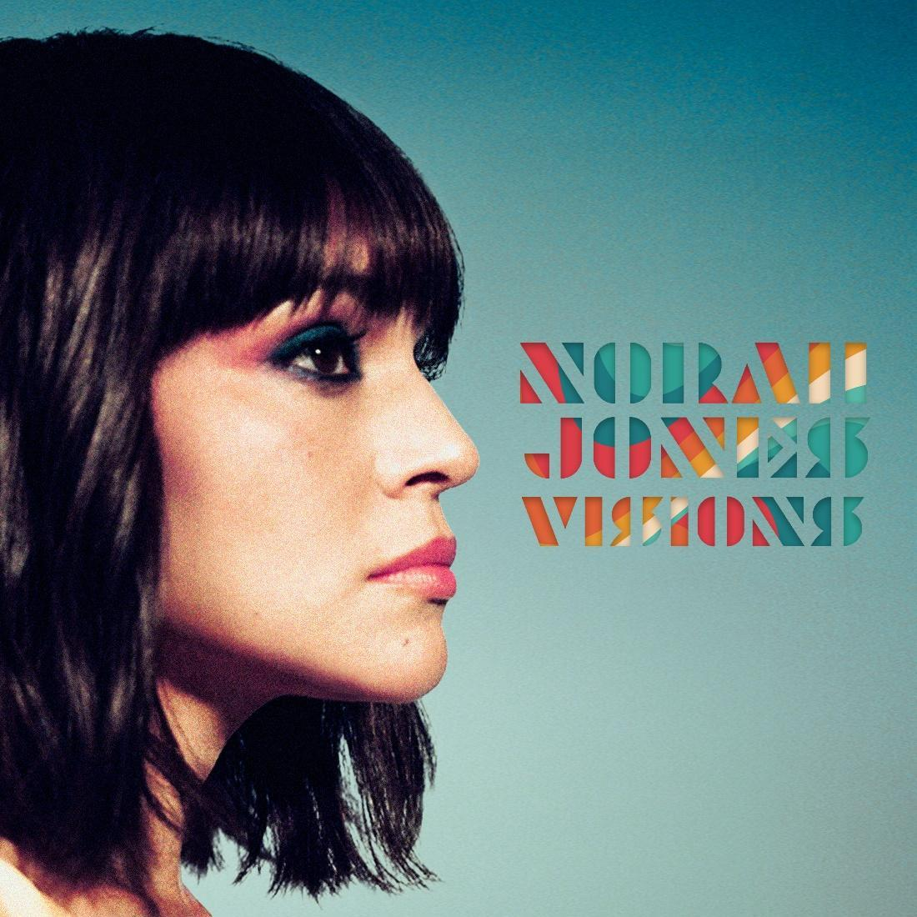

* * *

Norah Jones first emerged on the world stage with the 2002 release of Come Away With Me, her self-described “moody little record” that introduced a singular new voice and grew into a global phenomenon, sweeping the 2003 GRAMMY Awards including Album of the Year, Record of the Year, Song of the Year, and Best New Artist. Since then, Jones has become a nine-time GRAMMY-winner, sold more than 52 million albums, and her songs have been streamed ten billion times worldwide. She has released a series of critically acclaimed and commercially successful solo albums—Feels Like Home (2004), Not Too Late (2007), The Fall (2009), Little Broken Hearts (2012), Day Breaks (2016), Pick Me Up Off The Floor (2020), the live album ‘Til We Meet Again (2021), and her holiday album I Dream Of Christmas (2021)—as well as albums with her collective bands The Little Willies, El Madmo, and Puss N Boots featuring Sasha Dobson and Catherine Popper. The 2010 compilation …Featuring Norah Jones showcased her incredible versatility by collecting her collaborations with artists as diverse as Willie Nelson, Foo Fighters, Outkast, and Herbie Hancock. In 2022, Jones launched her podcast Norah Jones Is Playing Along which features candid conversations and impromptu musical collaborations with some her favorite musicians.

Follow Norah Jones:
Website • Facebook • Twitter • Instagram • Apple Music • Spotify • YouTube

more on info contact warren@chuffmedia.com

