**LORDE ANNOUNCES NEW ALBUM *VIRGIN* — OUT JUNE 27**

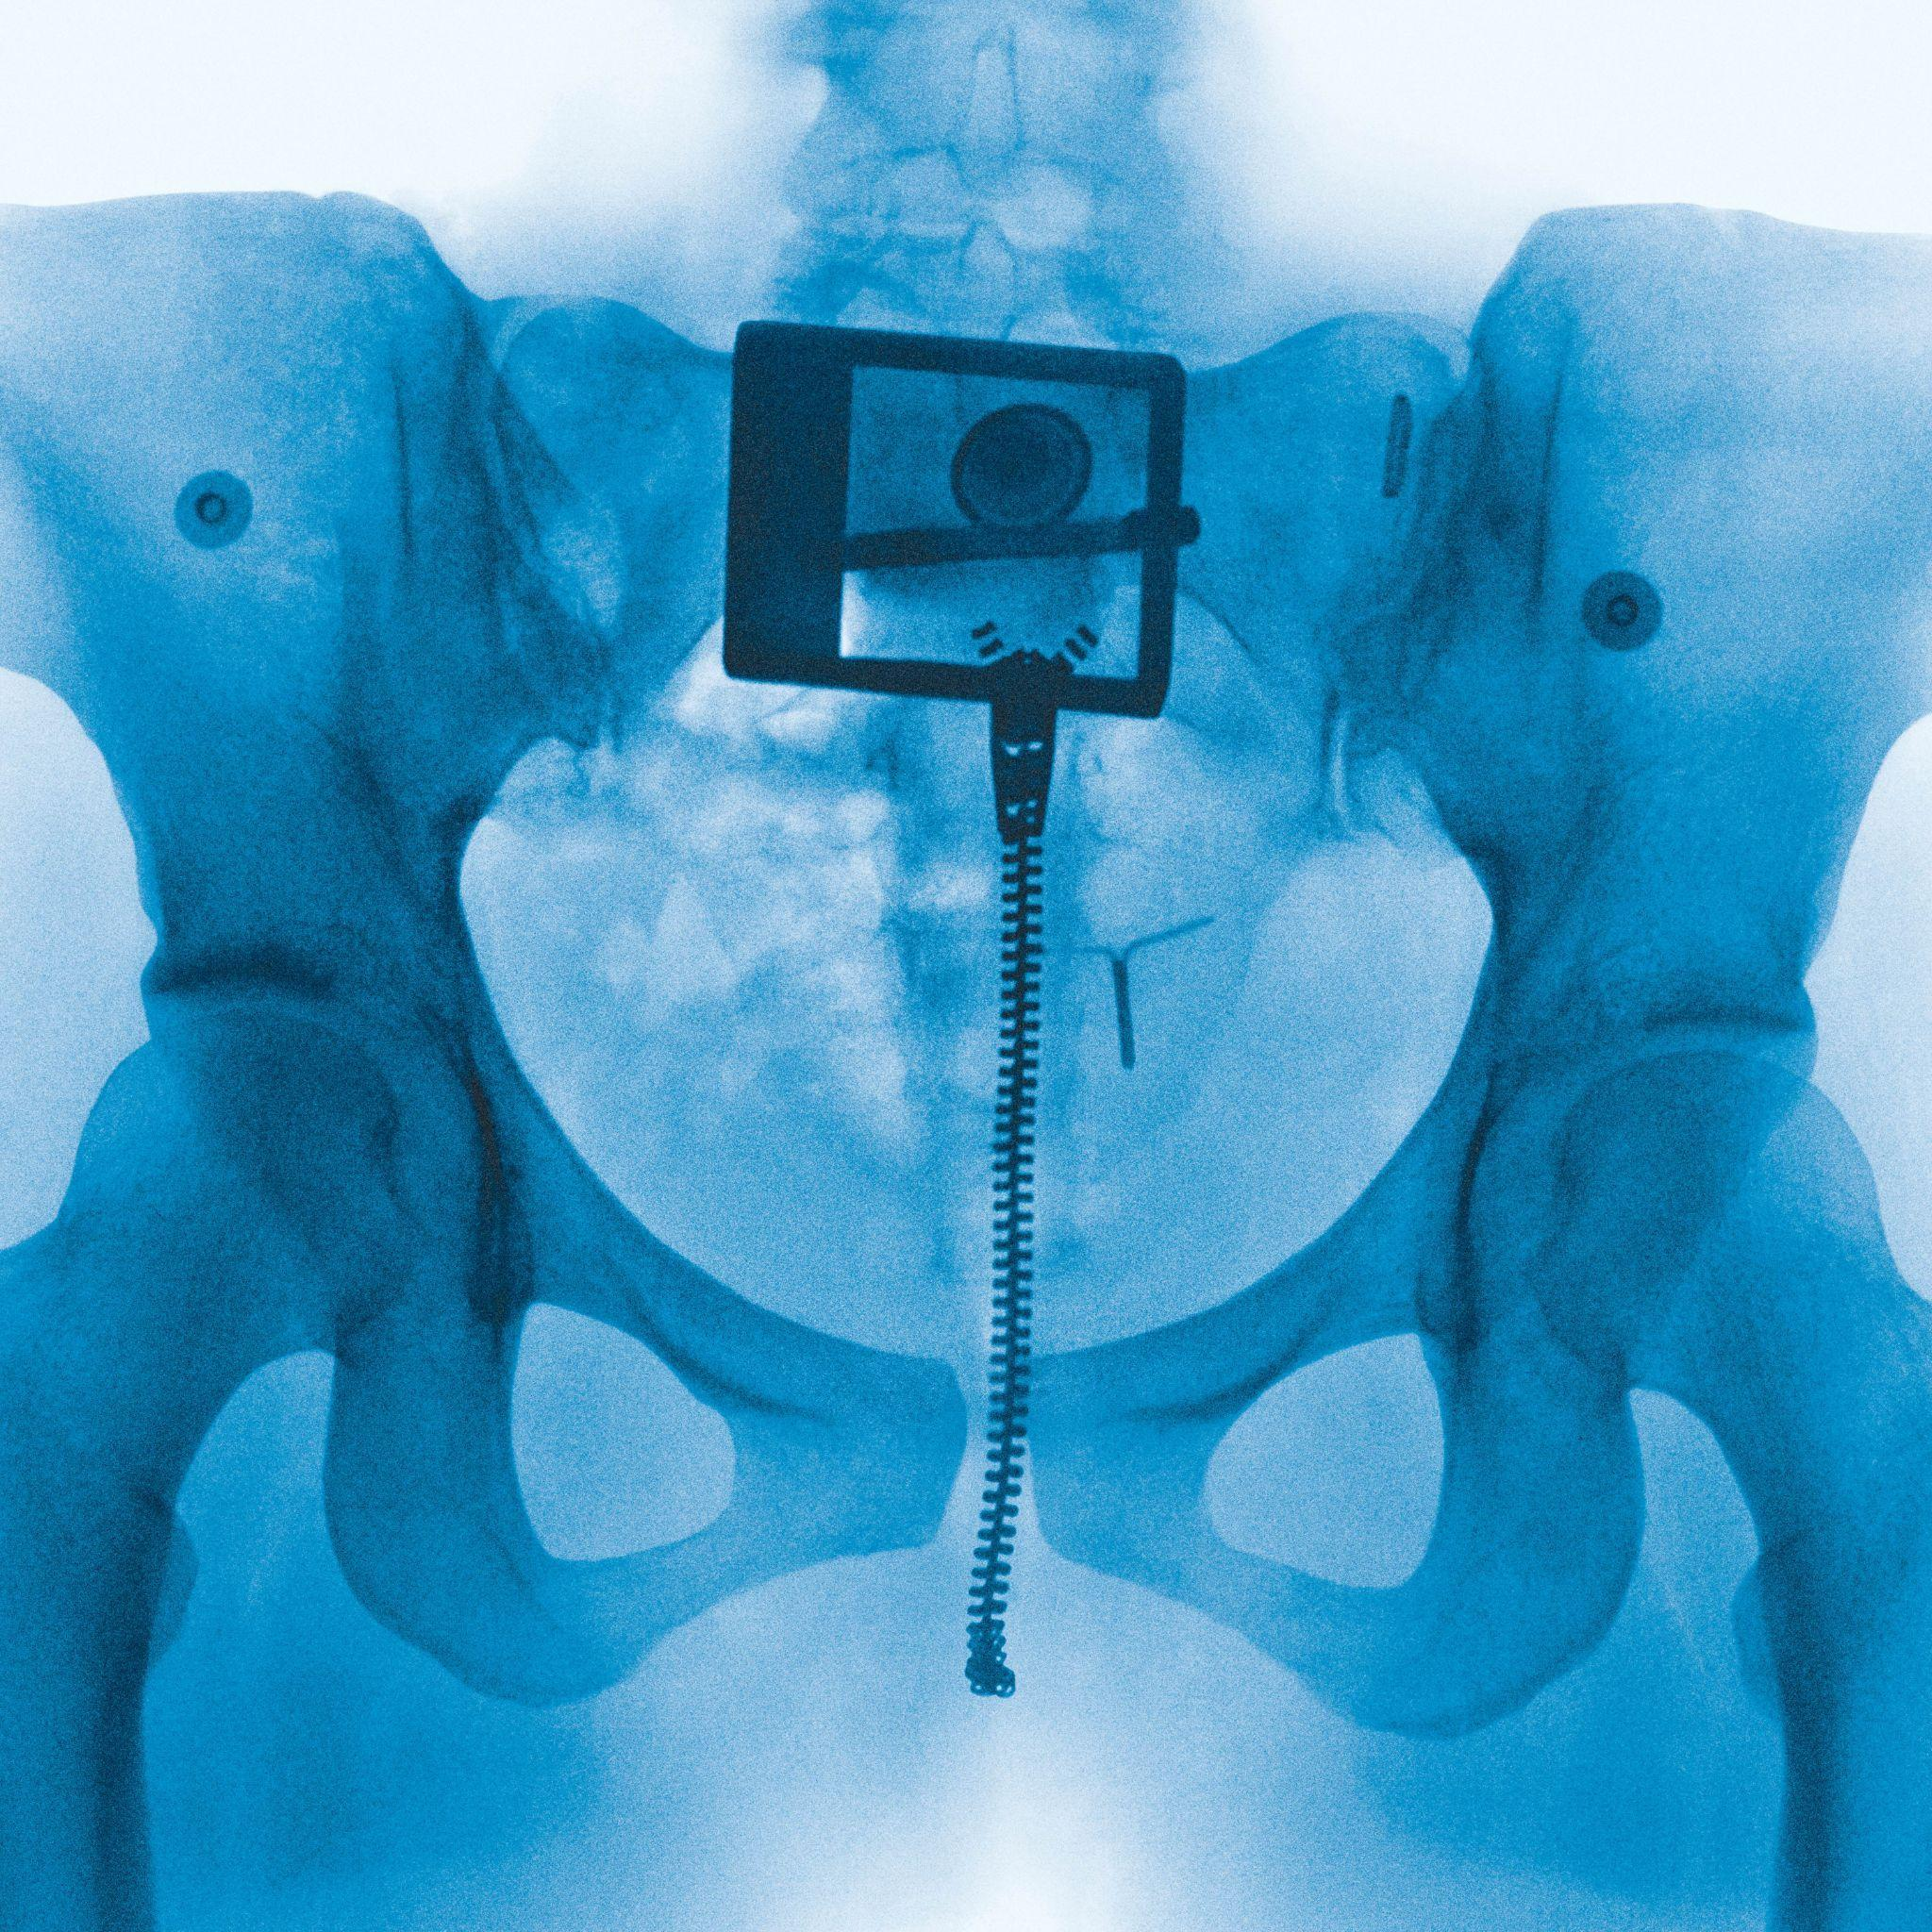Download artwork [HERE](https://umusic.ent.box.com/s/rq1b9mr6l7lee7id7v3lij87ge7kcdhk)

*“Get ready, Lorde season is here.”* – **Rolling Stone**

*“Pull back the curtains to Lorde summer.”* – **Variety**

*“The hunger for new Lorde music is wilder than ever.”* – **ELLE**

*“She’s fully ready to commit to the dancefloor once more”* – **NME**

*“sounds like summer, carried by a captivating synth arrangement and an intoxicating chorus.”* – **Hypebeast**

*“Lorde reclaiming centre stage”* – **Clash Magazine**

**[Wednesday 30th April, London]**Lorde has officially announced her highly anticipated new album, Virgin, set for release on **June 27**. The project marks the New Zealander’s first full-length body of work in four years and promises a bold evolution in her sound and storytelling. You can pre-order the album [**HERE**](https://lorde.lnk.to/Virgin)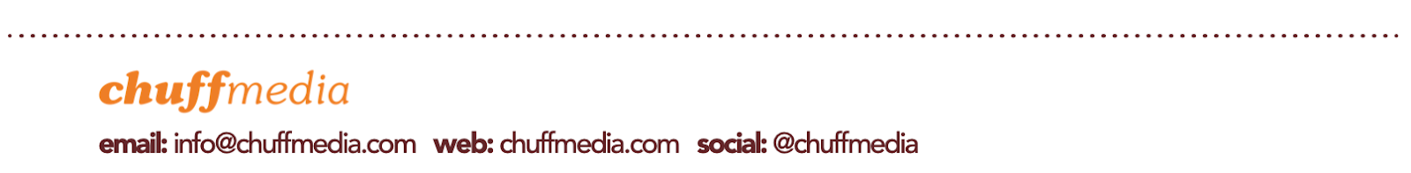

The announcement follows the release of her new single What Was That, co-produced by Lorde, Jim-E Stack and Dan Nigro. The track has been praised for its raw energy and emotional immediacy, offering a glimpse into the sonic world of Virgin.  
  
What Was That has already made a major impact, hitting #1 on Spotify in the US — Lorde’s first US #1 on the platform since Royals. It also landed at #3 in the UK and #5 globally, solidifying Lorde’s triumphant return to the top of the charts.

The video for What Was That, shot on location in New York — including a surprise performance in Washington Square Park — captures the intimate, spontaneous spirit of this new chapter. Watch it [[**HERE**](https://lorde.lnk.to/WWT_v)] and listen to the single [[**HERE**](https://lorde.lnk.to/WWT)].

**Download assets** [**HERE**](https://drive.google.com/drive/folders/1Aw7anwEYjvbH4AA56gOuxsXupbImVYYS?usp=drive_link)**.**



**##**

[**lorde.co.nz**](https://www.lorde.co.nz/)  **|** [**X**](https://x.com/lorde) **|** [**Instagram**](https://www.instagram.com/lorde/?hl=en) **|** [**Tik Tok**](https://www.tiktok.com/@lorde)

**##**

**For more information contact** [**warren@chuffmedia.com**](mailto:warren@chuffmedia.com)