DEBUT ALBUM ‘VICTORY’ TO BE RELEASED ON JULY 21ST
PRE-SAVE / PRE-ORDER HERE

FLASH MOB PERFORMANCES OF HIS CURRENT SINGLE ‘PART OF ME’
HAVE GONE VIRAL WITH 10.8 MILLION VIEWS SO FAR - WATCH HERE

“A phenomenal songwriter.” - Jack Saunders, Radio 1

“Rooted in a refreshing sense of honesty.” - Clash

“With Ducrot's raspy, strong, heartbroken vocals your feelings of regret are guaranteed to rise to the surface.” - Esquire

“One of the most exciting emerging pop acts” - Daily Star

“Incredibly catchy tunes.” - 1883

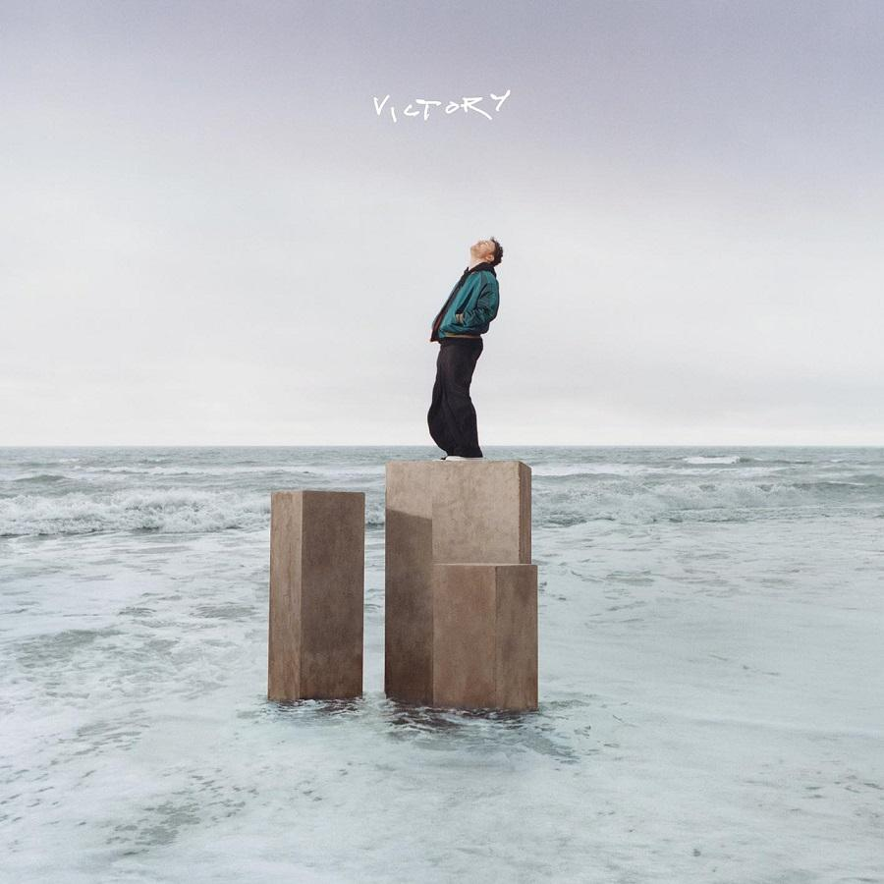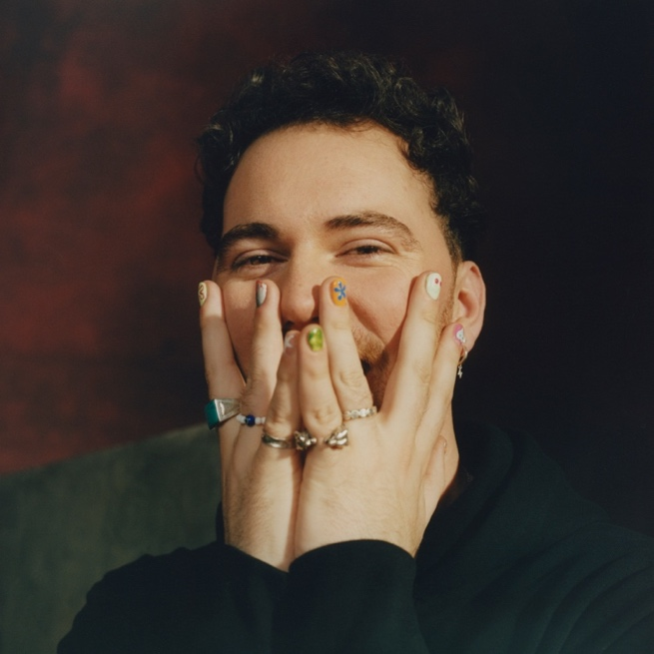
Album Artwork / Photo Credit: Holly Whittaker

Cian Ducrot is set to cement his rising star status with the news that his eagerly anticipated debut album ‘Victory’ will be released on July 21st and is now available to pre-order / pre-save HERE. The Irish singer-songwriter, producer and multi-instrumentalist has seen his recent singles - ‘I’ll Be Waiting’ and the Gold-certified ‘All For You’ - fly into the Top 20 of the Official Singles Chart and exceed 300 million streams to date. He has also hit Spotify’s global Top 200, aided by a wider international impact which has included two Top 10 singles in Ireland, Top 20 hits in Belgium, Denmark, the Netherlands and Norway.

Confirmation of the release of ‘Victory’ comes as Cian’s current single ‘Part of Me’ is making a powerful connection with fans. ‘Part of Me’ is Cian’s heartfelt tribute to his best friend Phily who ended his own life, reflecting on those shared moments that define a friendship - memories that will never be forgotten. And Cian is making new memories in honour of late friend, notably with a stunning flash mob performance. Cian falls to the floor apparently stricken, but soon bursts into song - and onlookers are awestruck as he’s joined by a previously hidden 30-piece orchestra as well as a choir who had been waiting nearby.

The video raced to 1.2 million views in twelve hours, and now stands at 10.8 million, and still continues to grow. It has helped elevate Cian’s social media following to 4.3 million at TikTok and 1.1 million at Instagram. The launch of the song saw numerous fans share their own touching experiences of similar tragedies, while Cian’s performances during his recent arena tour with Ed Sheeran saw huge venues lit up as fans flashed lights in memory of loved ones.

‘Part of Me’ provides an insight into the soul-bearing vulnerability and supreme songcraft that Cian demonstrates throughout the ‘Victory’ album. For Cian, it represents the culmination of a lifelong dream. But even more significantly, it represents a triumph in the face of insurmountable odds in which his mother’s selfless bravery, determination and support changed his future for the better.

Cian says, “To begin to understand the album there’s a lot you need to know about my life, where I came from, how I was raised, and the kind of kid I was. A broken home at an early age is where the story really began, my mom, my brother and I became a team and music was our saviour. It saved us mentally and spiritually but it also allowed my mom to literally put food on the table.

From a young age I was different, always stood out, always got picked on and bullied but most of the time it didn’t really bother me as I knew being different was ok. I was never interested in following the crowd. This pattern continued throughout my entire life and continues to this day. My dad was very abusive growing up both physically and sexually, my mother fought extremely hard to protect my brother and I, and to get us away from him. It wasn’t easy, it seemed like everything required years of fighting and perseverance. I have my mom to thank for the person I am today.

When I dropped out of college to pursue being a songwriter, when not one person believed in me, I reflected on our past and everything my mom managed to do as a single mother to raise my brother and I in a country that didn’t welcome her as a foreigner and in a system that was extremely patriarchal. I remember asking her, ‘How did you do it? How did you find the strength when you had no money and two kids to take care of? When a judge said, ‘Isn’t that what husbands do to their wives?’ after you telling him in court he was raping you? After your own kids told you their father was sexually abusing them and after you were left alone without a clue how to survive? How did you do it?’

My mom replied simply, ‘I had no choice so I figured it out.’ Never had I heard more inspiring words in my life. I carry those with me today everywhere I go. No matter how hard the road became and how much I had to fight to be heard, I never gave up. I believed in myself every single step of the way because I had a dream and what’s worth fighting for.

This album represents that victory, the victory of self-belief, the victory of everyone around me who I love and who loved me back, the story of my brother, of my mother, of my grandparents, of my friends, and everyone who fought by our side every step of the way, the victory of love and the victory of never giving up. This album is for all of those people, my family and friends, you know who you are, we made it out alive and more. This is for us.”

Raised in Cork, Cian was surrounded by music growing up and soon excelled himself, learning piano, classical guitar, saxophone, percussion, drums, violin and the flute. He studied at London’s Royal Academy of Music from the age of nine and soon felt split between his classical training and his desire to make pop music. He continued his studies while writing songs and posting on social media, but his mind was made up following a successful songwriting camp in Los Angeles. The deciding factor between the two worlds was the ability that a pop artist has to connect with their audience - and that remains a big aspect of his artistry to this day. He was far from an overnight success, however, often borrowing money, busking, surfing sofas and taking on random jobs to fund writing trips to London and LA. His first breakthrough on TikTok led to his debut EP ‘Make Believe’ and he grew in stature with every release, especially when ‘I’ll Be Waiting’ and ‘All For You’ completed his journey from pub gigs in Cork to the upper reaches of the charts. And there’s a lot more to come, beginning with ‘Part of Me’ and ‘Victory’.

Cian is also in growing demand as a collaborator, most recently featuring on Libianca’s ‘People’ remix. He was invited to co-write with SZA in Los Angeles, the resulting song set to be released in the future, and he also co-wrote Lauren Spencer-Smith’s global hit and UK Top 20 single ‘Flowers’.

21-Jul-23 Sheffield Tramlines
23-Jul-23 Oxfordshire Truck Festival
9-Aug-23 Belfast Limelight
25-Aug-23 Portsmouth Victorious Festival

HEADLNE TOUR

13-Nov-23 Glasgow O2 Academy
14-Nov-23 Newcastle O2 City Hall
15-Nov-23 Nottingham Rock City
17-Nov-23 Sheffield O2 Academy
18-Nov-23 Birmingham O2 Academy
20-Nov-23 Brighton Dome
21-Nov-23 London Eventim Apollo
22-Nov-23 Norwich UEA LCR
26-Nov-23 Bristol O2 Academy
28-Nov-23 Southampton O2 Guildhall
29-Nov-23 Manchester Academy
7-Dec-23 Belfast Ulster Hall
8-Dec-23 Belfast Ulster Hall

Follow Cian Ducrot:
Instagram |TikTok |Twitter |YouTube | Spotify | Apple Music

For more on info contact
Warren Higgins
warren@chuffmedia.com

