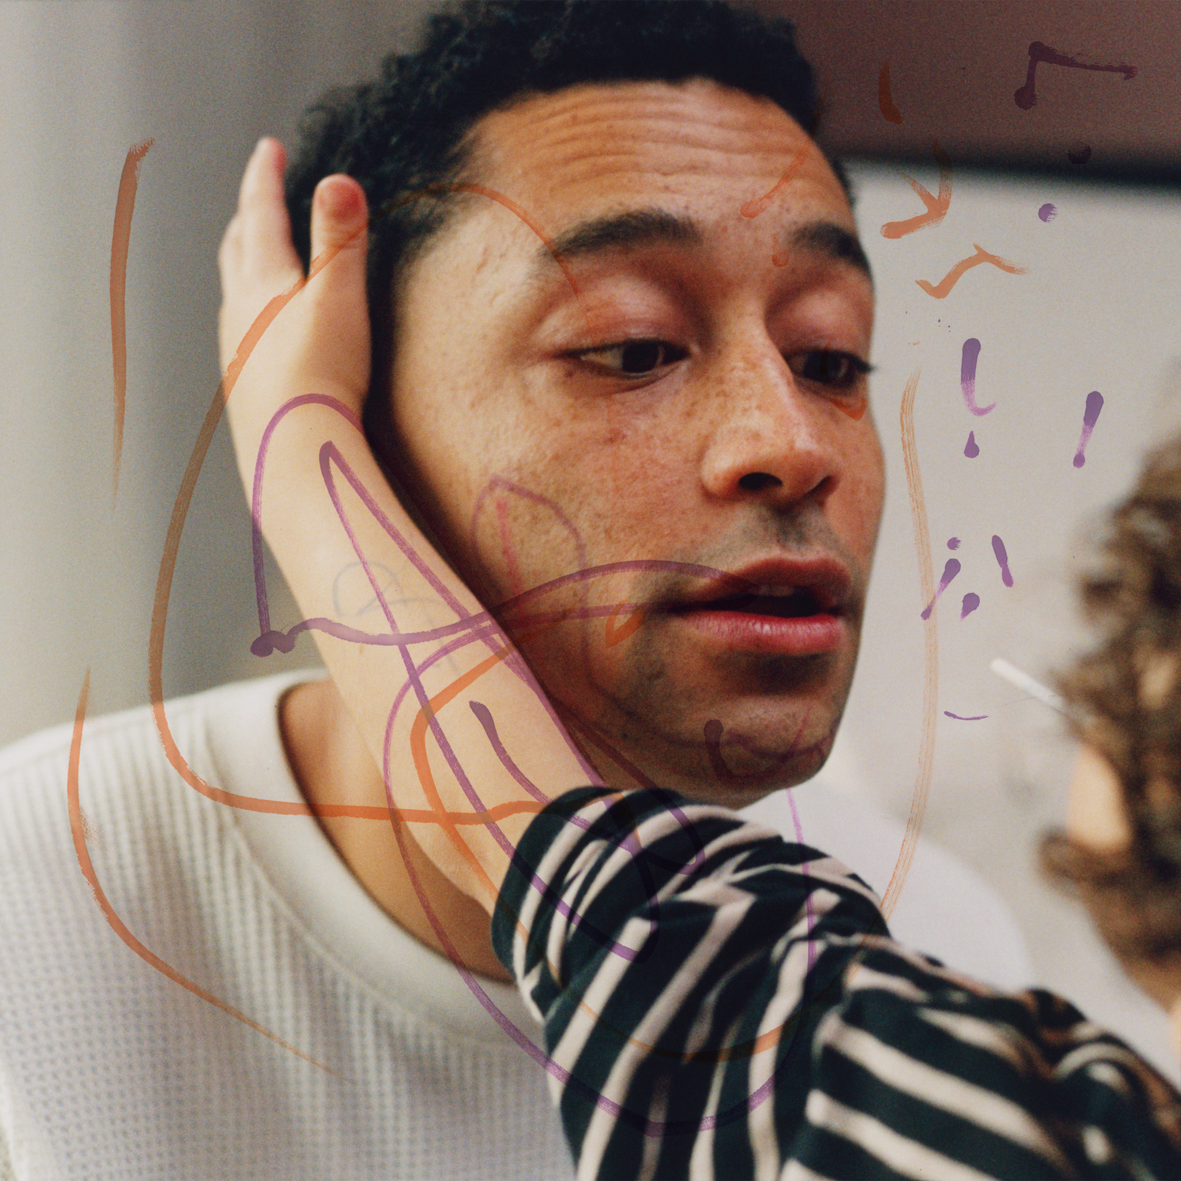
hopefully ! - album art

Loyle Carner announces new album, hopefully !
Out June 20th on Island EMI
Global tour also announced to follow Glastonbury headline show
Listen to first single, ‘all i need / in my mind’

Praise for hugo
“A beautiful, blistering masterpiece” - The Observer, ⭐⭐⭐⭐⭐
“Loyle Carner is opening himself up to the world” - NME ⭐⭐⭐⭐
“Loyle Carner proves his willingness to take risks and it pays off” - DIY Magazine ⭐⭐⭐⭐
“His most essential album to date” - The Wire

Pre-Order hopefully !: http://loylecarner.lnk.to/hopefully
Photo/Artwork: https://umusic.box.com/s/ho1ybs1qaukgnt2ni8bjn9su4gt4czil

Loyle Carner has today announced brand new album hopefully !, which is set for release on Island EMI on June 20th. Loyle has additionally detailed plans for a huge global tour to follow his Glastonbury headline set (The Other Stage, June 27th), including a four night residency at London’s O2 Academy Brixton in November. Pre-order hopefully ! for live access now: album pre-sale opens on April 30th at 9AM local time, with Live Nation and SJM pre-sale on May 1st (9AM), Spotify pre-sale beginning on May 1st (12PM), and tickets available for general sale on May 2nd (9AM).

hopefully ! was introduced recently alongside two surprise new songs, ‘all i need / in my mind’, marking the groundbreaking British artist as you’ve never seen or heard him before. A life-affirming exploration of fatherhood, childhood and alternative music, the album is buoyed by a positivity and lightness of touch achieved in large part by stepping out of your comfort zone. In a series of firsts - singing, producing, accidentally forming the band of his dreams - Loyle Carner cultivates healthier boundaries, whilst also allowing his audience in (the album’s moving artwork features his muse of a son, who can also be heard throughout the record).

A musician, writer, director, producer, entrepreneur and actor, Loyle Carner first emerged with 2013’s A Little Late EP, and has since forged a signature blend of unflinching, diaristic lyricism with ambitious, genre-disruptive sounds. His debut album, 2017’s Yesterday’s Gone, untangled personal experiences of grief, and the pressures of coming-of-age; 2019 follow-up, Not Waving, but Drowning, further showcased Loyle’s ability to set lithe rap against old-soul wisdom. A cathartic turning point proved to be 2022’s hugo: a taut, textured exploration of Black identity and anger, which also secured his second Top 3 album. Having been twice shortlisted for the Mercury Prize - and scored further BRIT and NME Award nominations - Carner has earned an impassioned worldwide following, with 1.1B streams, campaigns with global brands (YSL, New Balance, Nike) and sold-out shows including Alexandra Palace, Wembley Arena, Eventim Apollo, O2 Academy Brixton and Royal Albert Hall in his beloved London hometown alone. This journey climaxed in a headline appearance at All Points East’s 35,000 capacity Victoria Park last summer, which hopefully ! emerged in the wake of.

Sunlight streaming through the window, hopefully ! signals a new era in which Loyle Carner continues to push the boundaries of his art (and himself). A passionate advocate around his experiences of dyslexia and ADHD - notably founding the Chilli Con Carner cookery workshops - last year he received an honourary doctorate from UAL in recognition of his powerful rise thus far. He was also recently confirmed to make his acting debut in Mint, a BBC drama from BAFTA-nominated Scrapper director Charlotte Regan, with further exciting visual projects to follow. In an always-unpredictable career, Loyle Carner’s work has remained as affectingly personal as it is uplifting and universal. Now a decade in, his impact has never been clearer: the same local hero, now rightly regarded as one of the UK’s most vital voices.

HEADLINE TOUR

07.10.25 Stockholm Annexet
08.10.25 Oslo Sentrum Scene
11.10.25 Amsterdam AFAS Live
13.10.25 Copenhagen KB Hallen
15.10.25 Berlin UFO im Velrodrom
16.10.25 Hamburg Sporthalle
18.10.25 Munich Zenith
19.10.25 Zurich Halle 622
21.10.25 Frankfurt Jahrhunderthalle
22.10.25 Cologne Palladium
24.10.25 Paris Zenith
25.10.25 Brussels Forest National
02.11.25 London O2 Academy Brixton
03.11.25 London O2 Academy Brixton
04.11.25 London O2 Academy Brixton
05.11.25 London O2 Academy Brixton
07.11.25 Cardiff Utilita Arena
09.11.25 Dublin 3Arena
12.11.25 Glasgow O2 Academy
13.11.25 Glasgow O2 Academy
14.11.25 Glasgow O2 Academy
18.11.25 Newcastle O2 City Hall
19.11.25 Newcastle O2 City Hall
20.11.25 Birmingham O2 Academy
21.11.25 Birmingham O2 Academy
23.11.25 Manchester O2 Victoria Warehouse
24.11.25 Manchester O2 Victoria Warehouse
25.11.25 Manchester O2 Victoria Warehouse
02.12.25 Brisbane Fortitude Music Hall
04.12.25 Sydney Opera House Forecourt
06.12.25 Melbourne Sidney Myer Music Bowl
09.12.25 Perth Metro City
19.02.26 Chicago Thalia Hall
21.02.26 Toronto History
22.02.26 Montreal Beanfield Theatre
24.02.26 Boston Royale
26.02.26 Washington DC The Fillmore
27.02.26 Brooklyn Paramount
03.03.26 San Francisco The Regency Ballroom
03.05.26 Los Angeles The Novo

For more information please contact
Warren Higgins warren@chuffmedia.com

