HUNDRED REASONS
ANNOUNCE FIRST ALBUM IN 15 YEARS AND
SPRING 2023 UK HEADLINE TOUR

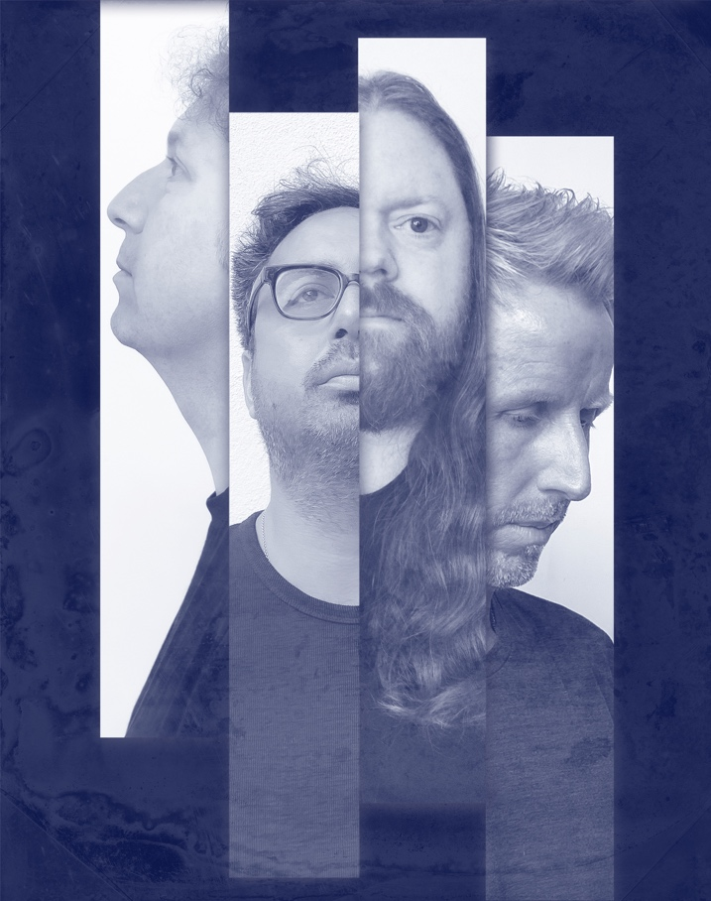

Hundred Reasons are announcing their first album together in 15 years. Glorious Sunset is due for release on 24th Feb 2023 via SO Recordings. The lead single and title track ‘Glorious Sunset’ is available to stream now. Hear new single ‘Glorious Sunset’ on streaming services here. Pre-order the album Glorious Sunset on CD and white 12" vinyl, as well as T-shirts and signed lenticular prints here.

The path to the first Hundred Reasons album in a decade and a half may well have taken many detours for the Aldershot quartet as lives, roles and responsibilities diverged but ultimately their route back to one another came as something of a natural process. The creative urge seemingly never left the band - Colin Doran (vocals), Larry Hibbitt (guitar, vocals), Andy Gilmour (bass), Andy Bews (drums) – and their first sessions back together became less about re-capturing the magic of their previous four studio albums, or addressing unfinished business, and more satisfying a growing urge to be creative together once more. They set about fanning the flame of a spark that was never truly extinguished, aiming to capture spontaneity in its rawest form, and later hone and perfect their work with the band’s own Larry Hibbitt on production duties. Consequently, Glorious Sunset is as vivid, exciting, and as fresh a collection as they have ever produced - distinctly Hundred Reasons and full of fire. Lead singer Colin Doran says of the first writing session; “I came away from that session not just feeling closer to the other guys, having not seen them for some time, but thinking the music was f****** awesome. We all looked at each other and knew it was a go.”

Lead single ‘Glorious Sunset’ is the perfect distillation of their renewed artistic impulse. Doran’s distinctive, emotive vocal and soul-baring honesty deliver a gorgeous, thrumming ode to grief that reminds us that while the death of a loved one brings pain and the regret of time wasted and words unsaid, it’s vital we remember to celebrate the life that’s been lost.

He continues about the single: “When we started writing again it was really important that we did not go back to any material that had been cut previously. It all had to be completely new. We started writing just before Covid and got together sporadically as and when we could to write and demo which was not our usual way. We would normally be in a room together for the most part but this time it was not always possible. Larry and I would write, The Andy and Larry would write and then I would join the session later in the day (I have a day job) but we were all super happy with what was coming out. This was a deal breaker for all as if we were putting out new material it had to be amazing.

Glorious Sunset came about from an instrumental idea from The Andy which was nearly complete minus any vocal ideas. The lyrics for the song completely changed from the demo version to the recorded version as within that space of time my mother passed away after a 4-year battle with cancer. She had gone into remission twice previously and it come back again but this time it would be terminal. The title of the song took on a new meaning as the song talks about being relieved that someone you love is no longer suffering. The sunset refers to the light that many people say they see when they die.

During recording, Larry started playing around with synths and effects that added more to the song but by the time all the music was recorded, no one in the band knew that the lyrics had changed so it ended up being an emotionally draining session in the studio that day. In all lots of lyrics changed during that time period as it brought on a new perspective which shaped the narrative of the material."

“This album isn’t something we felt we had to do. We simply arrived at a position where the music was so good that it was something we needed to do.”

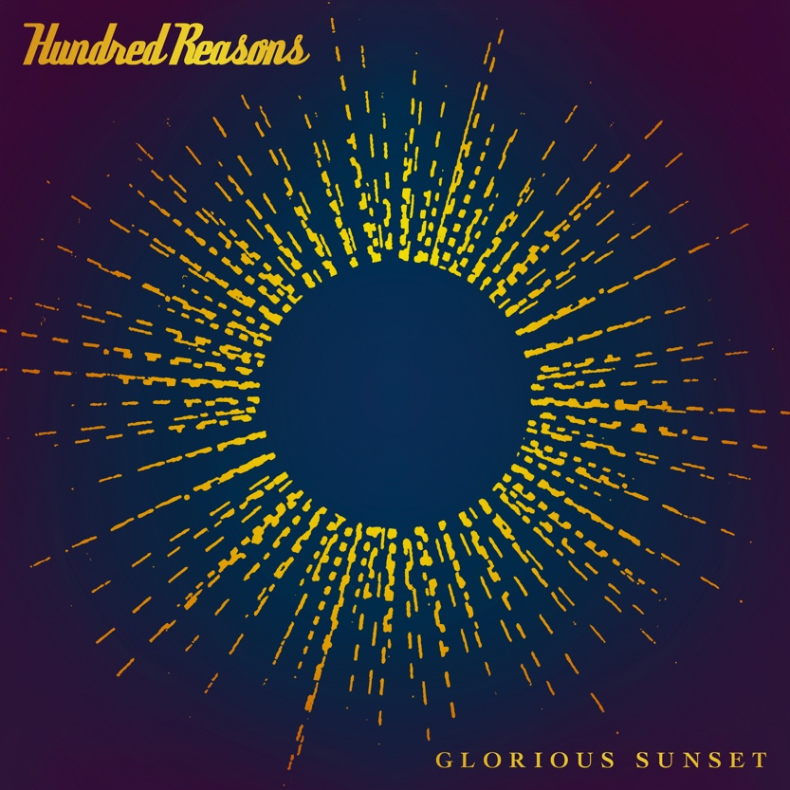

Hundred Reasons – Glorious Sunset album tracklist:

- Glorious Sunset
- New Glasses
- It Suits You
- Replicate
- Done
- Right There With You
- Insultiment
- So So Soon
- The Old School Way
- Wave Form

Pre-order the album here

Purchase tickets here

Tour Dates with special guests Hell is For Heroes and My Vitriol:
- 23-Feb-23 Leeds – O2 Academy
- 24-Feb-23 Glasgow – Barrowland
- 25-Feb-23 Manchester – Manchester Academy
- 02-Mar-23 Bristol – O2 Academy
- 03-Mar-23 Birmingham – O2 Institute
- 04-Mar-23 London – O2 Academy Brixton

Further Information:
- Website
- Facebook
- Twitter
- Instagram

For more information please contact warren@chuffmedia.com on 07762 130510

