YARD ACT
ANNOUNCE DEBUT ALBUM THE OVERLOAD - OUT JAN 21st VIA ZEN F.C/ISLAND
NEW SINGLE AND VIDEO ‘THE OVERLOAD’ OUT TODAY
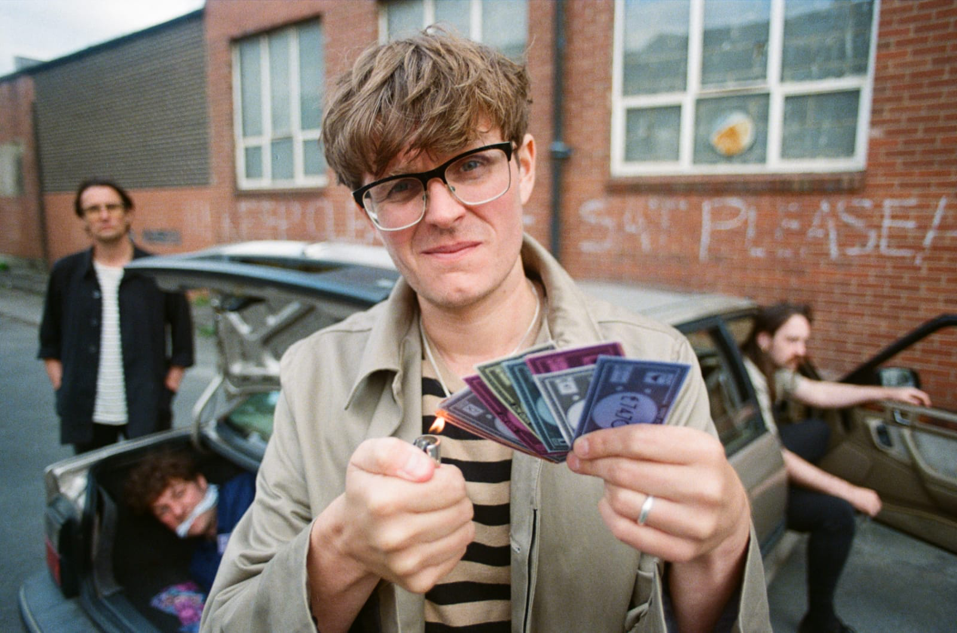
Photo credit: James Brown
“There's acuity, pathos and wit, deadpan storytelling over catchy, snaking riffs and relentless grooves” –
The Guardian
“Yard Act have cemented themselves as one of the most exciting bands on this Green earth” - So Young
“A whip smart take on current affairs and a bulging back pocket of infectious yet unpredictable bangers that satisfy both brain and feet”- Loud and Quiet
“Gloriously addictive and brilliantly bonkers in equal measure” – Dork
“Yard Act will have you in stitches with their fiercely humorous lyricism which they couple with the
catchiest post-punk grooves around” – NME
“Yard Act sit in an exciting space of which any rising band would be envious” - The Line Of Best Fit
“One of Yorkshire’s hottest prospects” - Gigwise
Preorder ‘The Overload’ HERE / Watch ‘The Overload’ video HERE
Leeds outfit Yard Act have shared their searing new single “The Overload”, along with an accompanying video by James Slater. The single comes ahead of the release of their feverishly anticipated album of the same name, due to be released on 21st January via Zen F.C./Island. Preorder The Overload HERE.
Spanning 11 entirely new tracks, The Overload is a record which rages with Yard Act’s inimitable wit, musical dexterity and tasteful curation. Littered with Yard Act’s signature dark humour and knowing cynicism, The Overload pokes fun at society without ever punching down from a place of superiority. “Lyrically, I think it’s a record about the things that we all do - we're all so wired into the system of day to day that we don't really stop and think about the constructs that define us,” says Smith. “But also beyond that, it's kind of exciting, because there’s still so much we don’t understand; how a hive mindset is forged, how information spreads, how we agree and presume things without thinking. Some people think more than others, but a lot of this sloganeering - ‘I'm on the left, I'm not wrong’ - doesn't achieve anything. Gammons, Karens, Snowflakes, whatever – I find it all so boring. I'm just not into that.”
Speaking about the first taste of their long-awaited album, vocalist James Smith said: “‘The Overload’ serves as an overture to the album. It’s written from the perspective of someone sitting in a pub overhearing snippets of all these different conversations from different characters and acting as a vessel, a medium even, for their own thoughts and opinions. That cut and paste approach means it’s hard to decipher where one person’s musings end and another’s statement begins, and that feels like a fairer representation of why human existence is at the point it is right now. Society doesn't prevail because of the absolute, it struggles on in spite of it. It’s our ability to compromise which helps us to coexist.”
Lead single and title track ‘The Overload’ also sees the return of fictional narrator Graham, the cocksure home renovator from ‘Fixer Upper’: “The second verse is dominated entirely by this character called Graham, a man more sure of himself than most. Maybe it’s both a blessing and a burden that the rest of us can learn to compromise with the Grahams of the world which allows society to stumble on. I’ve defended Graham as a harmless relic of the past, struggling to stay relevant in the modern world, but this Graham is a little more vicious than the Graham from ‘Fixer Upper’. Maybe it’s the heightened paranoia that’s come with two years living through the pandemic that’s given him a little more edge. He’s still like the rest of us though, no matter how tough he acts.”
“We all succumb to fear most of the time, and it explains a lot about why we make the decisions we do. I imagine the chorus delivered by a Greek chorus; omnipresent, and encompassing the themes of not only this song, but the whole album. That’s what ‘The Overload’ is essentially. It’s everything happening at once, and it’s our tiny, feeble minds trying to process and cope with it. Good luck.”
***
Spearheaded by James Smith (vocals) and Ryan Needham (bass), the now four-piece, completed by Sam Shjipstone (guitar) and Jay Russell (drums), have built a sound that speaks inherently to their birthplace of Leeds, West Yorkshire, and yet ties together observations from all walks of modern British life – the small-town bloke in the local pub, the anti-capitalist stuck at a desk job, the tired activist in all of us torn between easy complicity and the desire to fight.
Having grown from relatively casual pub acquaintances to housemates, Smith and Needham found living together to be conducive to a high work rate, racking up demos in quick succession. Settling into a system of programming, looping and layering, the alchemy between the two created a base from which to build their narrative world. “Ryan is a vibe guy, whereas I overthink everything,” laughs Smith. “It’s been the greatest creative partnership I've ever had. When you find a groove that works, it just kind of looks after itself.”
With just three hometown shows under their belt, world events intervened. But rather than letting the pandemic derail them Yard Act set up their own imprint, Zen F.C. and across the course of 2020 and into early 2021 released four increasingly coruscating, hilariously dark singles with ‘The Trapper’s Pelts’, ‘Fixer Upper’, ‘Peanuts’ and Dark Days’ all securing BBC 6 Music airplay, and despite the circumstances developing a remarkable, ever increasing fanbase.
Pulling off a debut album in a pandemic isn’t easy, but somehow, Yard Act have made it work. Recording with Ali Chant (PJ Harvey, Perfume Genius, Aldous Harding) at his Bristol studio, those prolific demos have been sharpened down into something that speaks to the times we live in, creating a statement of intent that survives on nuance – a record of retro influences, recorded in a modern way. The Overload is a political record, but in the same way that all great observations of human nature are – a messy, complex, knowingly hypocritical snapshot of our current state of play.
***
See Yard Act live in 2022
14th Jan – Oxford – The Bullingdon
15th Jan – Stoke on Trent – The Sugarmill
16th Jan – York – The Crescent Community Venue
21st Jan – London – Rough Trade East
22nd Jan – Kingston Upon Thames – Banquet Records
22nd Jan – London – Sister Ray/100 Club Outstore
23rd Jan – Portsmouth – Pie & Vinyl Instore
23rd Jan – Brighton – Resident Instore
24th Jan – Bristol – Rough Trade
24th Jan – Oxford – Truck Instore
27th Jan – Nottingham – Rough Trade
17th Feb – London – Village Underground
18th Feb – Brighton – Patterns
19th Feb – Southampton – The Joiners
21st Feb – Bristol – Exchange
22nd Feb – Cardiff – Clwb Ifor Bach
23rd Feb – Nottingham – Bodega
24th Feb – Salfords – The White Hotel
25th Feb – Hebden Bridge – Trades Club
26th Feb – Leeds – Brudenell Social Club
1st March – Newcastle – The Cluny
2nd March – Edinburgh – The Caves
3rd March – Glasgow – Mono
5th April – London – EartH
30th April – Liverpool – Liverpool Sound City
11th May – Bristol – Trinity Centre
18th May – Nottingham – Rescue Rooms
19th May – Liverpool – The Zanzibar Club
20th May – Leeds – The Irish Centre
21st May – Manchester – Band on the Wall
26th May – Sheffield – the Foundry
27th May – Norwich – Norwich Arts centre
28th May – London – Brockwell Park
Yard Act - The Overload - out now via Zen F.C.
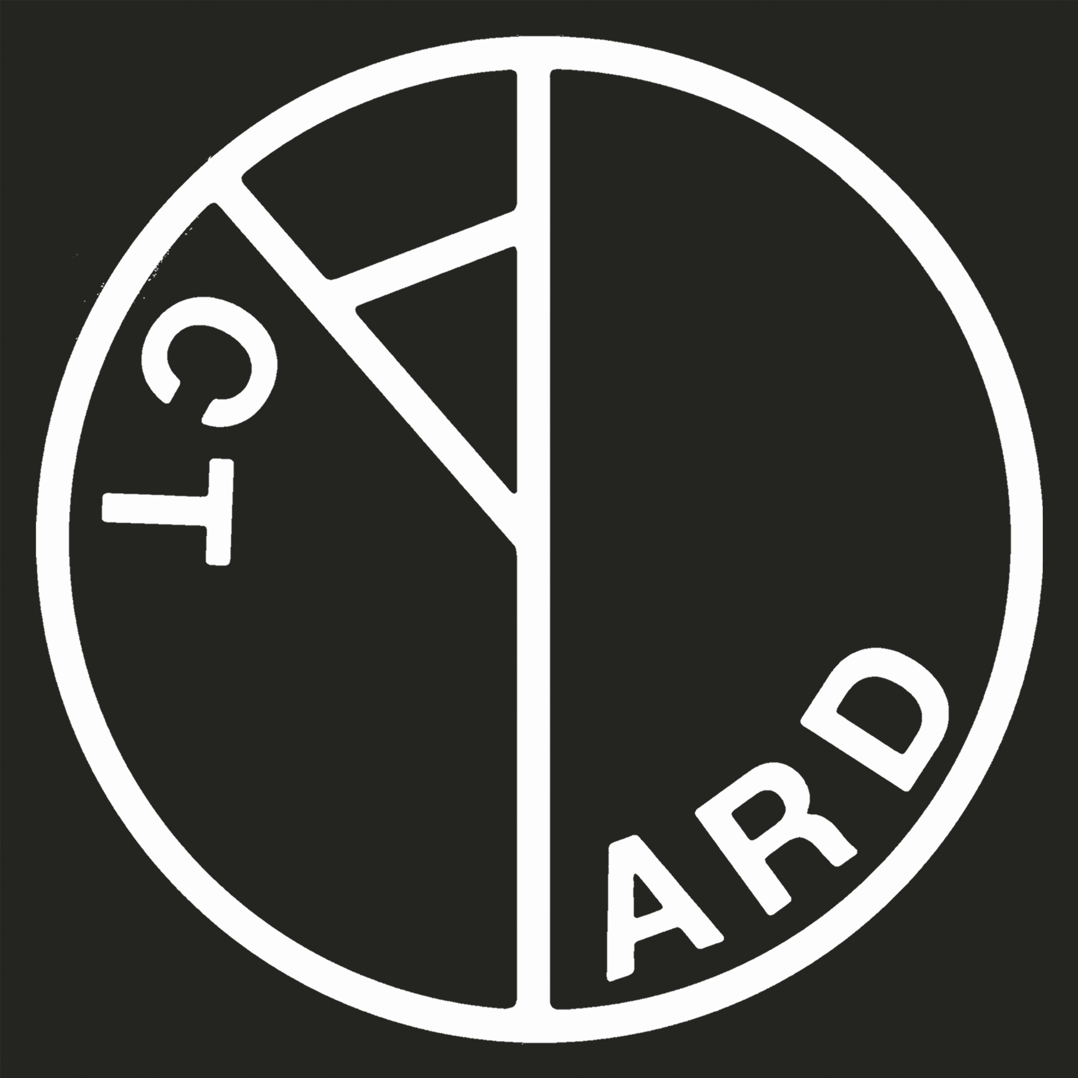
1. The Overload
2. Dead Horse
3. Payday
4. Rich
5. The Incident
6. Witness
7. Land Of The Blind 8. Quarantine The Sticks 9. Tall Poppies
10. Pour Another
11. 100% Endurance
For more information please contact Warren & Jenny
warren@chuffmedia.com
jenny@chuffmedia.com

