Announce Their Anthem-Filled New Album
How Will I Know If Heaven Will Find Me?
Out September 2nd 2022 on Fiction Records
New Single ‘Bloodrush’ Out Now
October UK Headline Tour Announced
+ On Tour with Royal Blood this month
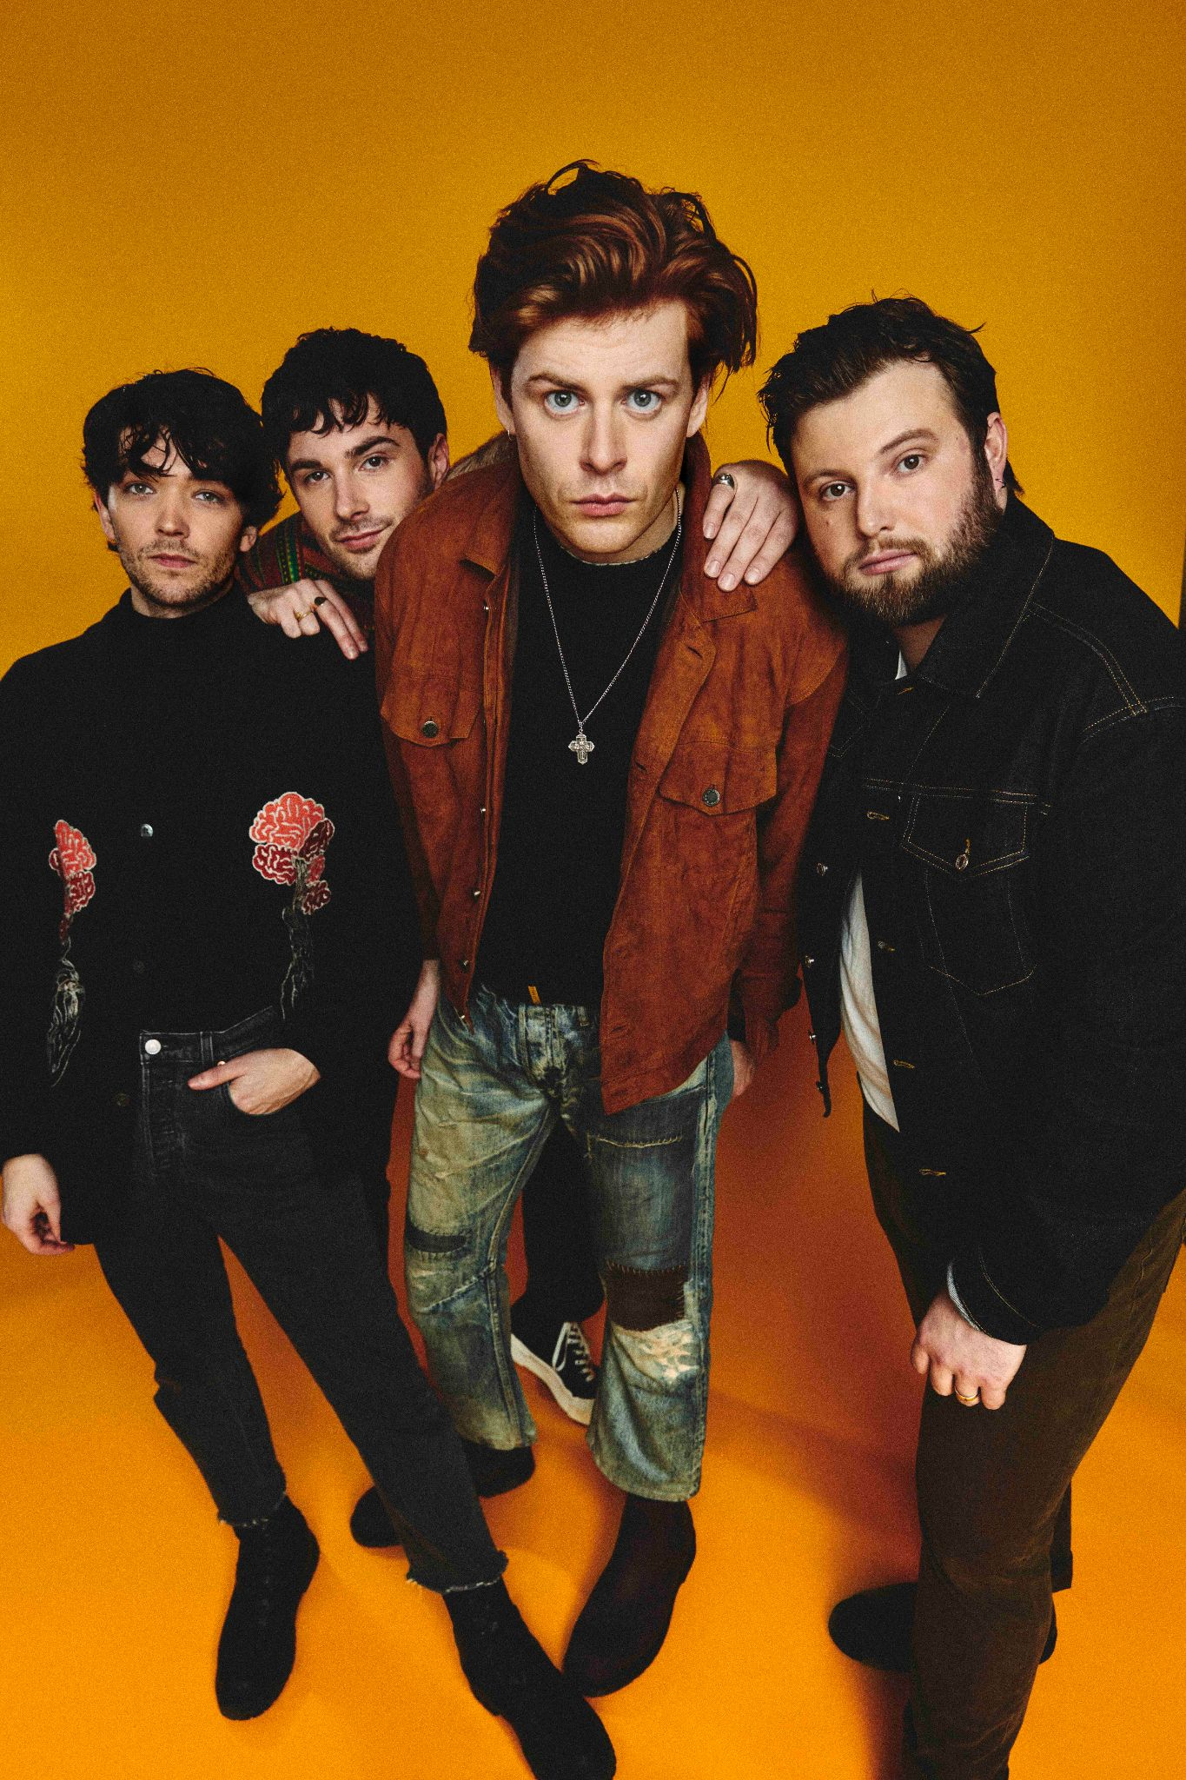

Following two huge Top 10 records and sold out shows across the globe, one of the UK’s most exciting bands, The Amazons, have announced their stratospheric, anthem-packed new album How Will I Know If Heaven Will Find Me? - out September 2nd 2022 on Fiction Records.
The third record is both a love letter and a rallying cry. Expansive, uplifting, sun-drenched singalongs produced by Jim Abbiss (Arcade Fire, Arctic Monkeys, Adele), and featuring co-writing collaborations with the likes of Maggie Rogers & Jamie Hartmann, find the Reading 4-piece emerging from the darkness of 2019’s Future Dust full of lust for life and post-pandemic hope.
Premiered by Jack Saunders on BBC Radio 1 last night, and due to be debuted live on the band’s upcoming arena tour with Royal Blood, the band drop the album’s first taste with the all-guns-blazing ‘Bloodrush’ - Listen HERE.
“The verses are all about communicating with my girlfriend - I’d had enough of the monotony of waiting to see her”, says frontman Matt Thomson. “We finally met up in Mexico, quarantined for two weeks together, then spent two wonderful months together in LA. I came home and went straight to Jamie Hartmann’s place where we captured the rush of what I’d just been through. It’s about whatever it is you never want to live without and the joy of being given it back.”
Locked down in Brighton, in the case of a newly-moved Matt – a mere week after returning from a US tour, The Amazons thought they had their third album already half written. But the prolonged lockdown proved otherwise. After months of seeing his L.A.-based girlfriend only online, Matt started writing songs for her which he assumed only the pair of them would ever hear.
“The gap between us was no longer being bridged by WhatsApps and Facetimes,” he says. “I sent letters but that didn’t do it either. We felt further apart than ever. Writing songs about what we’d do when we were together again became my way of taking control of the situation. It allowed me to share something truly intimate. Writing songs is how I process life. It’s the best skill I have and being able to use it to fix a problem gave me purpose again.”
In late 2020, with the band already cooling on the music they had previously written, Matt sent his bare bones new songs, written alone at home on acoustic guitar, to his band mates to gauge their opinion. Straight away they knew that he had inadvertently discovered a new direction for The Amazons.
“I said to the boys, enough with the darkness. As cheesy as it sounds, I wanted to make music that was a force for good, after everything we’ve all been through. It’s easily our most joyous album - sonically we set out to celebrate the return of real life and the communal experience of being back at shows.”
And with that, it all starts here: the boys hit the road immediately with a UK arena tour supporting friends Royal Blood this month, followed by a summer of festivals and a huge newly-announced UK tour in October which will see the band headline London’s Roundhouse.
The Amazons are a band unleashed and How Will I Know If Heaven Will Find Me? is a fresh marker in the sand. A new chapter. The start of something very special.
UK ROYAL BLOOD SUPPORT TOUR
March
Fri 25th Bournemouth, International Centre
Sat 26th Birmingham, Utilita Arena
Sun 27th Cardiff, Motorpoint Arena
Tue 29th Nottingham, Motorpoint Arena
Wed 30th London, O2 Arena
April
Fri 1st Leeds, First Direct Arena
Sat 2nd Manchester, AO Arena
Sun 3rd Glasgow, The SSE Hydro

UK FESTIVAL DATES
May
Thu 12th The Great Escape Festival
Sun 29th Neighbourhood Weekender
June
Sat 18th Isle Of Wight Festival
July
Sat 9th 2000 Trees Festival
August
Fri 5th Bingley Weekender
UK HEADLINE TOUR
October
Wed 5th Dublin, Whelans
Thu 6th Belfast, Limelight 2
Sat 8th Manchester, Academy
Sun 9th Nottingham, Rock City
Tue 11th Southampton, Guildhall
Wed 12th Bristol, O2 Academy
Thu13th Leeds, O2 Academy
Sat 15th Birmingham, O2 Institute
Sun 16th Glasgow, SWG3 Galvanisers
Mon17th Newcastle, Boilershop
Wed 19th Norwich, UEA
Thu 20th London, Roundhouse
How Will I Know If Heaven Will Find Me? - Track Listing
- How Will I Know?
- Bloodrush
- Say It Again
- There’s A Light
- Northern Star
- Wait For Me
- One By One
- Ready For Something
- For The Night
- In The Morning
- I’m Not Ready
Pre-Order the album HERE
theamazons.co.uk
Instagram // Twitter // Facebook
For more info contact Warren@chuffmedia.com

