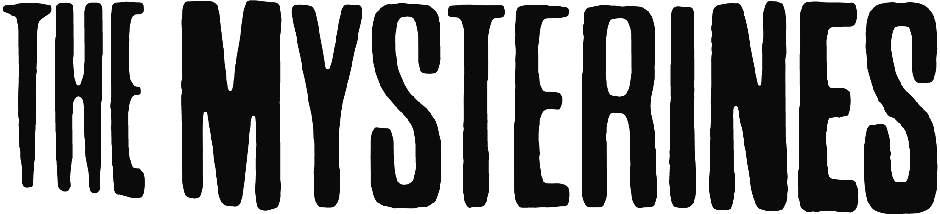

DEBUT ALBUM ‘REELING’
DUE FOR RELEASE MARCH 11TH VIA FICTION RECORDS
PRE-ORDER HERE

SELECTED AS BBC RADIO 1’S FUTURE ARTIST FOR JANUARY 2022
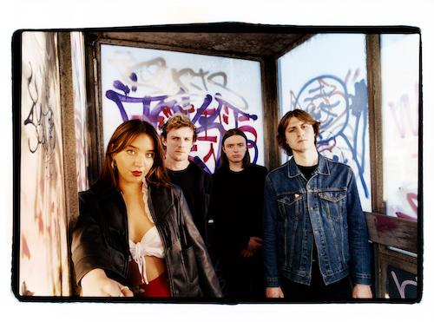
[PRESS SHOT CREDIT: STEVE GULLICK]

HEADLINE SHOWS MARCH & APRIL 2022
INCLUDING LONDON’S ELECTRIC BALLROOM
TICKETS HERE

“This Liverpool gang want it all – and they’re probably going to get it” NME

“Un-fuck-with-able attitude of Godzilla smashing down the street with a tequila in hand” DIY

“The band alchemise fuzztoned garage rock into something that feels fresh, electrifying and vital” MOJO

“This is without a doubt the best The Mysterines have ever sounded" Jack Saunders

2022 marks the release of Merseyside alt rockers The Mysterines’ debut album ‘Reeling’, due March 11th 2022 via Fiction Records.

The Mysterines are a true force to be reckoned within UK rock. Barely out of their teens, they completely sold out both their 2020 and 2021 headline tours, were selected as one of Amazon Music UK’s Ones To Watch 2022, have supported Royal Blood, The Amazons and Sea Girls on tour, as well as headlined the BBC Introducing Stage at Reading and Leeds. Their fans include Steve Lamacq, Jack Saunders, Clara Amfo, Dan P Carter and Huw Stephens, alongside tastemakers NME, Independent, Metro, MOJO, DIY, Dork, Upset, CLASH and Gigwise.

The Mysterines debut album ‘Reeling’ was made under the watchful eye of acclaimed producer Catherine Marks (Wolf Alice, The Big Moon, PJ Harvey) over three weeks in between lockdowns at Assault & Battery studios in London, recorded live to capture the intensity of the songs. “It’s a pretty ambiguous title for most people, but for me ‘Reeling’ sums up every emotion of the album in just one word,” says Lia. “It was the hardest thing I’ve ever had to do,” she explains.

Grief, self-destruction and heartache run heavy through the record, but all are brought together by the blackest of humour. The dirty desert blues of ‘Life’s A Bitch’ was actually meant to be the first single, “but it turns out I say ‘bitch’ too much on it,” chuckles Lia. Other tracks run the gamut from the grunged-up country of ‘Old Friends, Die Hard’ to the giddy, free-falling ‘On The Run’, Lia’s unique take on the tale of the teenage runaways in Terrence Mallick’s iconic Badlands. Then there’s the creepy, cultish ‘Under Your Skin’, which is The Doors by way of The Manson Family and the Stooges-esque ‘The Bad Thing’, of which Lia says: “It’s the most fun to play, and the words I find really funny as well – I’m digging someone up from the grave that I used to love.”

The Mysterines Record In-stores
7-Mar-22 Leeds Crash Records
8-Mar-22 Sheffield Foundry
9-Mar-22 Brighton Resident Music
11-Mar-22 London Rough Trade East
12-Mar-22 Bristol Rough Trade
12-Mar-22 Marlborough Town Hall
13-Mar-22 Nottingham Rough Trade
14-Mar-22 Liverpool Phase One
15-Mar-22 Preston Blitz

The Mysterines 2022 headline UK tour dates
18-Mar-22 Belfast Ulster Sports Club
23-Mar-22 Glasgow G2, The Garage
24-Mar-22 Kingston Upon Hull Social
25-Mar-22 Leeds Brudenell Social Club
26-Mar-22 Cambridge Mash
30-Mar-22 Manchester Band On The Wall
31-Mar-22 Birmingham The Castle & Falcon
1-Apr-22 London Electric Ballroom
2-Apr-22 Liverpool Invisible Wind Factory

The Mysterines are:
Lia Metcalfe (vocals/guitar)
George Favager (bass)
Callum Thompson (guitar)
Paul Crilly (drums)

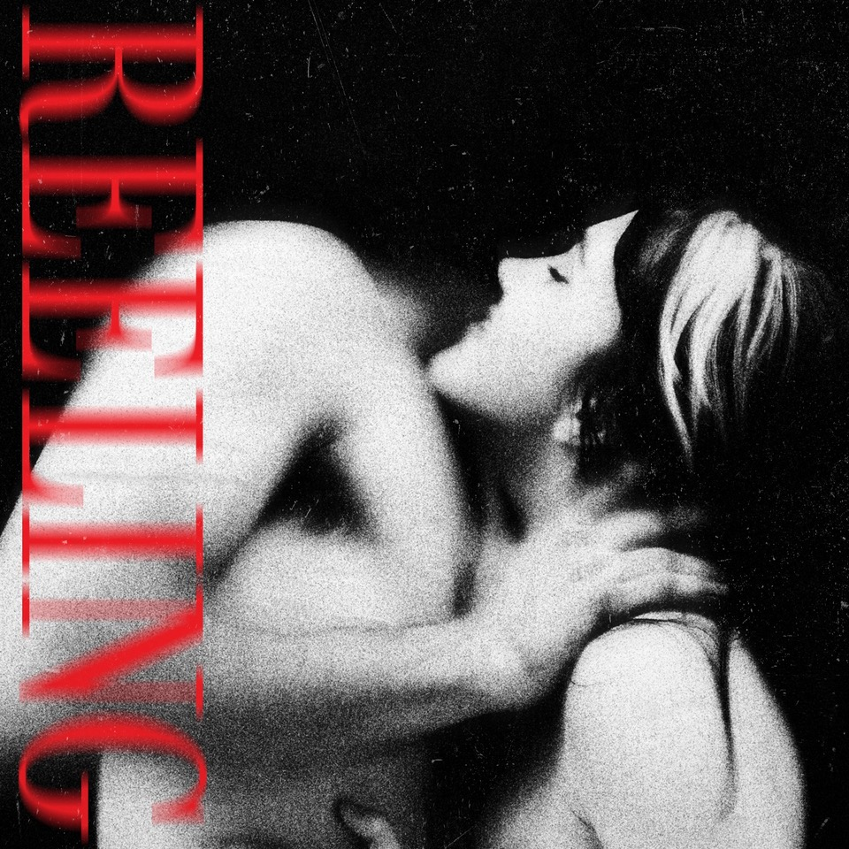

THE MYSTERINES ON SOCIALS
INSTAGRAM | TWITTER | FACEBOOK | SPOTIFY

For more information & media enquiries, please contact Warren
warren@chuffmedia.com

