Placebo announce new album Never Let Me Go

Hear new track ‘Surrounded By Spies’

Never Let Me Go to be released 25th March 2022

UK & European headline tour dates announced

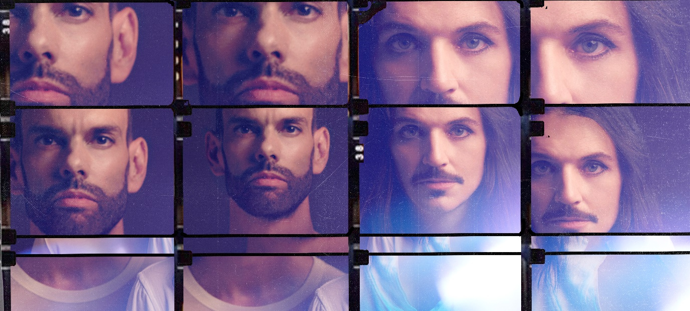

Placebo | Photo credit: Mads Perch | Download image here

Placebo are today announcing news of their long-awaited 8th studio album. Nine years on from the release of their last outing Loud Like Love, Never Let Me Go is confirmed for release on 25th March 2022. Also announced today is a new track from the album, ‘Surrounded By Spies’, along with 2022 headline UK / European tour dates.

Listen to ‘Surrounded By Spies’ here and view the visualizer here.

Pre-order Never Let Me Go and access ticket pre-sale here.
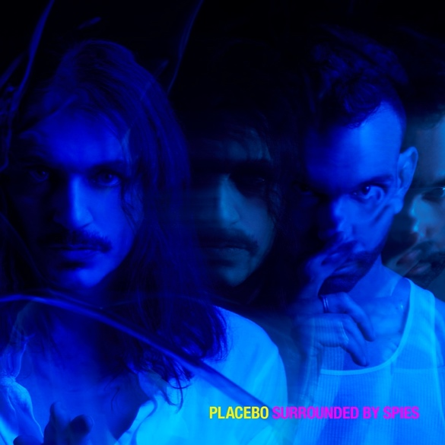

Placebo | ‘Surrounded By Spies’ single artwork | Download image here

In September, Placebo resurfaced from a long hibernation to release their first single in five years – and first from the new album - ‘Beautiful James’. A joyous and celebratory song, it came quietly loaded with antagonism for the increasingly prominent, ignorant, factions that have come to litter modern conversation. As Brian Molko commented at the time, “If the song serves to irritate the squares and the uptight, so gleefully be it.”

As great masters in cataloguing the human condition, Placebo’s unique way of examining both its flaws and beauty finds fertile ground in 2021. Crawling out of the pandemic into a landscape of intolerance, division, tech-saturation and imminent eco-catastrophe, theirs is a voice that has rarely felt more significant to contemporary discourse, and more appropriate to sing these stories to the world. Within the magnetic slow-burn of new track ‘Surrounded By Spies’ no punches are pulled in confronting the erosion of civil liberties, as Brian Molko’s deft lyrical delivery is married to a creeping sense of claustrophobia that fittingly makes the walls feel as though they are closing in from all around.

Brian Molko comments:

“I began writing the lyrics when I discovered my neighbors were spying on me on behalf of parties with a nefarious agenda. I then began to ponder the countless ways in which our privacy has been eroded and stolen since the introduction of worldwide CCTV cameras that now employ racist facial recognition technologies; the rise of the internet and the cellphone, which has turned practically every user into a paparazzo and spectators in their own lives, and how we have mostly all offered up personal information to enormous multinationals whose sole intent is to exploit us.

I used the cut-up technique invented by William S Burroughs and popularized in modern song by David Bowie. It’s a true story told through a lens of paranoia, complete disgust for modern society’s values and the deification of surveillance capitalism. The narrator is at the end of their tether, hopeless and afraid, completely at odds with our newfound progress and the god of money.”

Placebo have also shared headline UK & European tour dates for 2022.
PRE-ORDER YOUR COPY OF NEVER LET ME GO VIA THE OFFICIAL STORE TO GET EXCLUSIVE PRE-SALE ACCESS TO PLACEBO 2022 UK & EUROPEAN HEADLINE TOUR.
*Pre-sale access closes November 14th at 11:59PM GMT.
*Pre-sale starts November 15th at 9:00AM GMT.
*General on-sale starts November 17th at 9:00AM GMT
*Maximum 4x tickets per person. "

PLACEBO UK & EUROPEAN 2022 HEADLINE TOUR DATES

OCTOBER

Sat 1 - Frankfurt, Germany - Festhalle
Tue 4 - Stuttgart, Germany - Schleyerhalle
Thu 6 - Berlin, Germany - Mercedes-Benz Arena
Sat 8 - Copenhagen, Denmark - Vega
Mon 10 - Oslo, Norway - Sentrum Scene
Tue 11 - Stockholm, Sweden - Cirkus
Thu 13 - Helsinki, Finland - Ice Hall Black Box
Fri 14 - Tallin, Estonia - Saku Arena Black Box
Mon 17 - Warsaw, Poland - Expo XXI Hall 3
Wed 19 - Leipzig, Germany - Quarterback Immobilien Arena
Sat 22 - Hamburg, Germany - Barclaycard Arena
Mon 24 - Amsterdam, Netherlands - Ziggo Dome
Wed 26 - Munich, Germany - Olympiahalle
Thu 27 - Milan, Italy - Mediolanum Forum
Sat 29 - Zurich, Switzerland - Samsung Hall
Mon 31 - Prague, Czech Republic - O2 Universum

NOVEMBER
Wed 2 - Vienna, Austria - Stadthalle
Fri 4 - Esch El Azette, Luxembourg - Rockhal
Mon 7 - Cologne, Germany - Lanxess Arena
Tue 8 - Antwerp, Belgium - Sportpaleis
Thu 10 - Nancy, France - Zenith
Fri 11 - Paris, France - Accorhotels Arena
Sun 13 - Bordeaux, France - Arkea Arena
Mon 14 - Rennes, France - La Liberte
Fri 18 - Portsmouth, UK - Guildhall
Sat 19 - Brighton, UK - Brighton Centre
Mon 21 - Liverpool, UK - Eventim Olympia
Tue 22 - Manchester, UK - O2 Victoria Warehouse
Thu 24 - Cardiff, UK - Motorpoint Arena
Sat 26 - London, UK - O2 Brixton Academy
Sun 27 - London, UK - O2 Brixton Academy
Tue 29 - Leicester, UK - De Montford Hall
Wed 30 - Leeds, UK - O2 Academy

DECEMBER
Fri 2 - Newcastle, UK – O2 City Hall
Sat 3 - Glasgow, UK - O2 Academy
Mon 5 - Dublin, Ireland - 3 Arena
Wed 7 - Cambridge, UK - Corn Exchange
Thu 8 - Birmingham, UK - O2 Academy 1

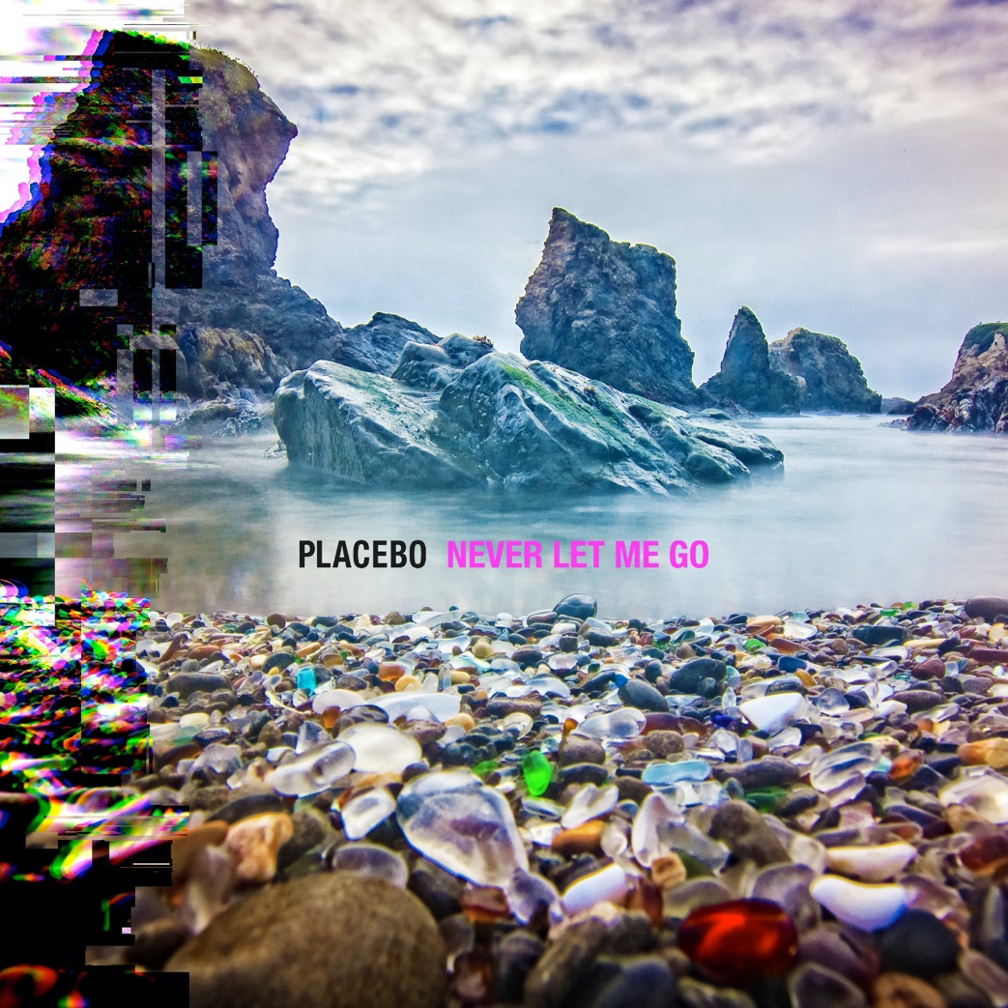

Placebo | Never Let Me Go album artwork | Download image here

Placebo – Never Let Me Go album track listing

- Forever Chemicals
- Beautiful James
- Hugz
- Happy Birthday In The Sky
- The Prodigal
- Surrounded By Spies
- Try Better Next Time
- Sad White Reggae
- Twin Demons
- Chemtrails
- This Is What You Wanted
- Went Missing
- Fix Yourself

For press only: Download the latest biography here.

Placebo: Website | Instagram | Facebook | Twitter

For more information please contact warren@chuffmedia.com on 07762 130510

