MAN/WOMAN/CHAINSAW SIGN TO FICTION RECORDS

SHARE NEW SINGLE "ONLY GIRL"

LISTEN | WATCH

ANNOUNCE FURTHER 2026 TOUR DATES + EUROSONIC


Photo Credit: Charlie & Charlie | Download Hi-Res HERE |
Alternative landscape shot HERE

"The most exciting live band in London right now." - The Line Of Best Fit
"This young British art-punk five-piece revel in taut chaos and wry lyrics." - The Guardian

"It’s one of those records where every song has its own unpredictable flavour but they all seem to flow from the same collective consciousness.” - Stereogum - Band To Watch

"I won't lie, I fucking love this band." - Steve Lamacq, BBC 6 Music

"The teenage five-piece making a thrilling noise." - Rolling Stone UK

"Eazy Peazy is a raw, ambitious and electrifying debut of forward-thinking rock music." - **** - NME

"As they continue to evolve and push their boundaries, one thing is certain: the future looks bright for Man/Woman/Chainsaw." - DORK
"['Ode To Clio' is] a cellular song that seems to smash together all kinds of contradictory ideas into one riveting whole." - CLASH
“['What Lucy Found There’ is] a swooning, shapeshifting, melodramatic earworm of a single that sets them apart from London indie's ever-crowded field.” - The Quietus
“['What Lucy Found There’ is] a virtuoso example of a band taking the listener through the emotions and leaving them unable to do anything but leap about the room.” - So Young Magazine
"The latest in a recent line of young bands from the capital making a buzz the old-fashioned, live circuit way, angsty sextet Man/Woman/Chainsaw’s third proper release rings hums with the sort of layered energy that’s clearly been honed on the stage.” - DIY

Man/Woman/Chainsaw today share news of their signing to Fiction Records, home to The Cure, St. Vincent, The Horrors and Billie Marten amongst others.
They also share with it their debut for the label, "Only Girl", a brightly brilliant new single, and a highlight of recent live performances. Perhaps their most immediate output yet, "Only Girl" was recorded at RAK Studios with Geordie Greep producer Seth Evans & Margo Broom, who also worked with the band on their BBC 6 Music playlisted single "Adam & Steve".
Watch visualiser for "Only Girl" HERE
Vera, lead vocalist on "Only Girl", had the following to say about the new track:
"Only Girl is our playful love song. Built around a ripping violin top-line and birthed from a grungy guitar jam, it gradually became something more boisterous and altogether more joyful - a total declaration of love. We had a lot of fun making it."
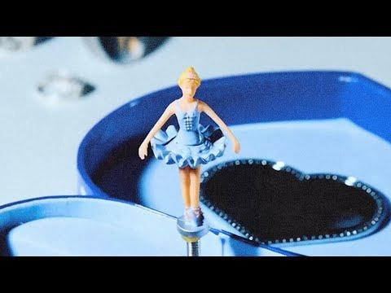

The new single and signing news follow a sold out London Scala and UK tour in October, their second sold out tour of the year, live sessions for both KEXP and Steve Lamacq at BBC 6 Music and a triumphant first trip to Austin for SXSW in the Spring, where Man/Woman/Chainsaw found themselves standing at the very forefront of a new wave of British bands "most likely to".
Described by Rolling Stone at SXSW as "a young band in the process of inventing something ecstatically new", the London-based six-piece, a close-knit group formed by friends Billy Ward & Vera Leppänen at only 16 years old, have already secured significant attention from the likes of The Quietus, Guardian, NME, The Line Of Best Fit, DIY, So Young, Stereogum, The Fader, BBC 6 Music and more.
The group have announced a free entry London show at Omeara in December, with tickets available now. Three further headline dates in February in Hebden Bridge, Edinburgh and Liverpool will all go on sale this Friday, 21st November at 10am.
Their debut album will follow in 2026.

Man/Woman/Chainsaw live:
Tue 02/12 - London, Omeara
Wed 14/01 - Groningen, Eurosonic Noorderslag
Fri 30/01 - Southampton, So Young Weekender, Suburbia
Sat 31/01 - Bedford, Ceremony 5.5, Esquires
Wed 18/02 - Hebden Bridge, The Trades Club
Thu 19/02 - Edinburgh, Cabaret Voltaire
Fri 20/02 - Liverpool, O2 Academy 2
Sat 21/02 - Dublin, Borderline Festival, Workman's Club

Man/Woman/Chainsaw are:
Billy Ward (vocals, guitars)
Emmie-Mae Avery (vocals, keys/synths)
Vera Leppänen (vocals, bass)
Clio Harwood (violin)
Lola Cherry (drums)
Billy Doyle (guitars)

FOLLOW MAN/WOMAN/CHAINSAW
Website | Instagram | YouTube | TikTok | Facebook | X | Spotify | Apple Music | Soundcloud

For more information and press enquiries please contact

warren@chuffmedia.com

