“ Ladies & gentlemen , Casper Walsh, Eskimo-su-motherf****in-preme, the super producer Evan Kennedy, It’s Versatile, the first Irish Hip Hop supergroup ! “ - Coolio

VERSATILE
share debut album ‘Fuck Versatile’ and announce UK & Ireland tour

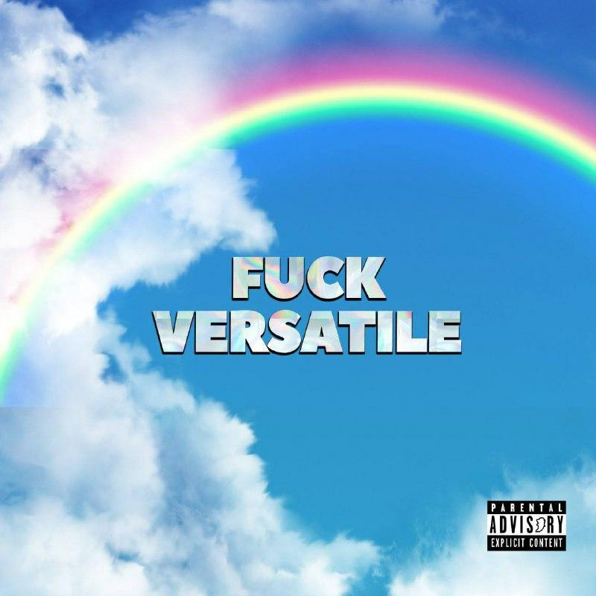
Listen Here

Among the current crop of rising Irish rap stars, Versatile have proven to be one of most resilient and loved acts in the Irish music industry. Through highs and lows, they weathered the storm, with the help of a cult-like following of fans we’ve seen Versatile make Irish music history headlining the 2019 Longitude Festival to a 40,000 strong crowd, followed by a sold-out headline at the Three Arena Dublin, cementing themselves as Ireland's biggest Hip Hop group.

Having finally released their debut album ‘Fuck Versatile’, with 13 wittingly titled tracks that straddle the world of EDM, West Coast Hip Hop, Irish Rap and other mystical genres, featuring production from behind the scenes guru, Evan Kennedy, the album’s sonics explore a multitude of genre-blending styles never heard before. Taking essence of their west coast influences and incorporating it with their infamous Irish satirical rap style, the pair undergo open-heart surgery, touching on every topic in need of addressing. The album takes us on a journey ’Terminal 1’ filled with moments of tranquillity ‘Man on’ and moments of pulsating ‘Panic attack’, we even experience an interlude from rap legend Coolio.

The group composed of Casper Walsh, Eskimo Supreme and Evan Kennedy, is widely known for the explicit nature of their lyrics and their bold ability to touch on taboo subjects whilst still supplying an element of comic relief. At heart, they are Dubliner’s whose music perfectly captures the time and the place they’ve grown up in. Their ability to embody the essence of old school hip hop has seen them closely affiliated with rap legends Snoop Dogg & Coolio. Securing Versatile a spot on Snoop Dogg’s ‘I Wanna Thank Me’ Arena Tour alongside Warren G, Obie Trice, D12, Tha Dogg Pound and RJmrLA with dates throughout the U.K, Ireland & Europe, this iconic lineup will be touring in 2022. But before that Versatile embark on a tour of their own to promote the album. Cruising on a 14-date UK and Irish tour, which will see them play three Irish shows, including their return to Dublin’s 3Arena and eleven UK shows.

Catch Versatile live:

13-Nov-21 Belfast Limelight
5-Dec-21 Dublin 3Arena
7-Dec-21 Glasgow Classic Grand
8-Dec-21 Edinburgh Liquid Rooms
9-Dec-21 Newcastle Riverside
10-Dec-21 Manchester Academy
12-Dec-21 Nottingham Rescue Rooms
13-Dec-21 Birmingham The Mill
14-Dec-21 London O2 Academy Islington
16-Dec-21 Bristol Fleece
17-Dec-21 Liverpool O2 Academy
18-Dec-21 Leeds Warehouse
20-Dec-21 Cardiff The Globe

Tickets are on sale now via: www.outburstpal.ie

Keep up with Versatile via:
Spotify
Instagram
Facebook
YouTube

For more information please contact warren@chuffmedia.com on 07762 130510

