DIVORCE

Debut album

Drive to Goldenhammer

out March 7th 2025 via Gravity / Capitol

Watch the video for new single 'Hangman' HERE

UK instore performance + UK headline tour dates in MARCH

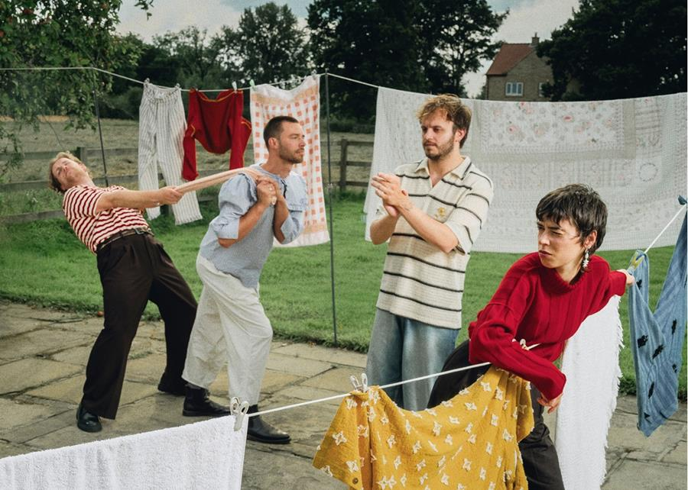
Divorce | Photo credit: Flower Up & Rosie Sco | Download hi-res image here

DIVORCE are today sharing new single 'Hangman', the final track to be taken from the band's forthcoming debut album Drive to Goldenhammer ahead of its release on March 7th via Gravity/Capitol.
Released on the heels of radiant lead single 'All My Freaks' and the breezy guitar wash of 'Antarctica' – both of which reached the A-list on BBC 6 Music - alongside January's shapeshifting new song 'Pill', the power of 'Hangman' lies in its emotional telling of being present, caring, and supporting of others. Co-vocalist and guitarist Felix Mackenzie-Barrow sings "I want to lift you up" in an impassioned mantra set to the bustling steer of the band.
Commenting on the new single, co-vocalist and guitarist Felix Mackenzie-Barrow says:
"I wrote Hangman late one night, freezing in my mouldy bedroom after a long shift as a support worker; the job I was doing at the time. The lyrics and chords and structure came out complete in about twenty minutes, I had stolen Tiger's Ominchord for it, which is not an instrument I would usually use for writing. The job I was doing necessitated a high level of emotional control, which was not something I had experienced before and so writing about the work and allowing my subconscious to flow freely helped me to gain some perspective. I listened to it on the way back to work the following morning over and over and I felt like I'd done a good one. I only worked in that job for about six months, but it was simultaneously the hardest and most rewarding work I've ever done. The admiration I have for the people I worked with and the people who choose that career is immense. The world of social care is hidden in a society that likes to pretend it doesn't exist, but it is vital and deserves much more focus and investment than it currently receives."
Hear 'Hangman' on streaming services here and watch the video below.
Pre-order the album here.

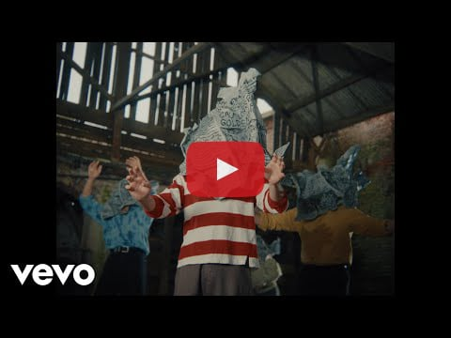
As anticipation continues to grow for Divorce's debut album Drive to Goldenhammer (March 7th via Gravity/Capitol) the band are also looking forward to a run of UK instore performances, followed by a full UK/EU headline tour. Full details are below.
Divorce UK instore performances 2025
Tickets are available here.
Mar 06 - Resident Music, Brighton, UK
Mar 07 - Jumbo Records, Leeds, UK
Mar 08 - Wax & Beans, Manchester, UK
Mar 10 - Rough Trade, Nottingham, UK
Mar 11 - Rough Trade, Bristol, UK
Mar 12 - Bear Tree Records, Sheffield, UK
Mar 13 - Rough Trade East, London, UK
Divorce UK & Ireland headline tour dates 2025
Tickets are available from the band's website here.
Mar 27 - The Bullingdon, Oxford, UK
Mar 28 - Strange Brew, Bristol, UK - SOLD OUT
Mar 29 - The Castle & Falcon, Birmingham, UK
Mar 31 - Ulster Sports Club, Belfast, UK
Apr 01 - The Workman's Club, Dublin, IE
Apr 03 - Gorilla, Manchester, UK
Apr 04 - Brudenell Social Club, Leeds, UK - SOLD OUT
Apr 05 - Stereo, Glasgow, UK - SOLD OUT
Apr 08 - Chalk, Brighton, UK
Apr 09 - KOKO, London, UK
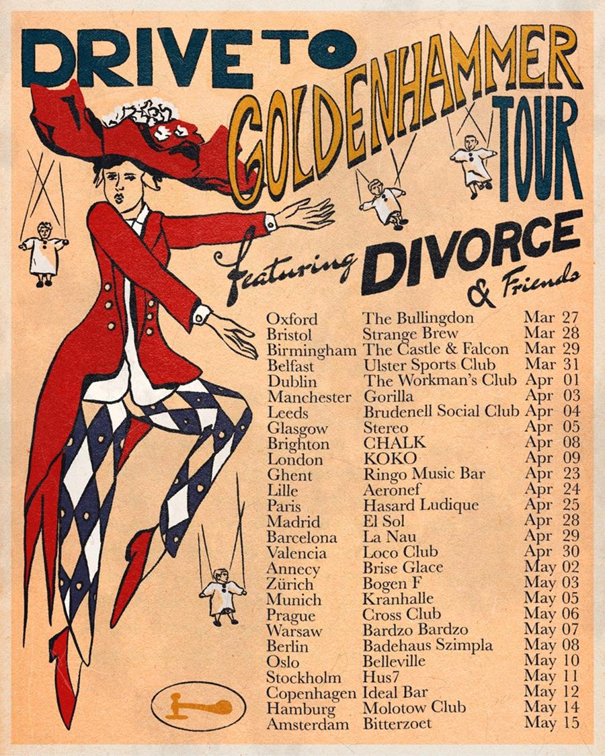
Divorce - 2025 UK & EU headline tour poster | Download image here

More about Divorce's debut album Drive to Goldenhammer
Initially meeting as teenagers through the city’s close-knit DIY scene, the band – completed by members Tiger Cohen-Towell (vocals / bass), Felix Mackenzie-Barrow (vocals / guitar), Adam Peter Smith (guitar / synth) and Kasper Sandstrøm (drums) - came together as Divorce in mid-2021, releasing a slew of genre-defiant singles that quickly caught the attention of tastemakers the world over. Last year they signed to Gravity Records (Universal Music) for their acclaimed Heady Metal EP, before filling 2024 with a raft of international festivals and tours with Bombay Bicycle Club, The Vaccines and Everything Everything. They have since sold out their own four-night residency at hometown venue Bodega (the first band to do so) and wrapped up their UK tour with their biggest headline show to date at a sold out Islington Assembly Hall.
Adjusting to life as a touring, transient entity began to leave the band feeling “like we were being dragged through a hedge backwards – in a nice way!” and as a result searching to carve out a place that they can call home within their music. The result is a pastoral blend of country, indie-rock, folk and chamber pop that traces the upheaval of the last few years while planting roots in their own sound. Influenced by location, memory, warmth and a deep-seated love for their post-industrial Midlands, they explore themes of transformation across 12 meticulously crafted tracks that balance heart-on-sleeve sentiments and tongue-in-cheek humour, devastation, playfulness and all-consuming feelings. Sonically rich and lyrically open-hearted, it sees Divorce assemble a shelter for themselves amid the chaos and leave the front door open to everyone.
Drive to Goldenhammer was written and demoed across four recording stays at rural North Yorkshire outpost The Calm Farm. Sessions spanned the spring, summer, autumn and winter - the band writing night and day - before the completed songs were brought to life with producer Catherine Marks (boygenius, Foals, Wolf Alice) at Real World Studios. As a result, the record has a well-worn and lived-in feeling, with a natural warmth, something they deliberately wanted to bake into the album to reflect the band’s identity as it relates to the Midlands, but also as – in a nod to the fantasy location of Goldenhammer - a fictional refuge from the world at large.
Still refusing to box themselves into a genre, Drive to Goldenhammer lays the Divorce “stamp” across a breadth of influences. Across songs that waltz around weaving riffs and vocal acrobatics, moody acoustic introspection, walls of alt-rock, shape-shifting electronic glitches, with string flourishes, these are songs that build, bloom and release, fittingly always finding their way home under the influence of the band’s stewardship. It is an album that much like its writers, leaves the door open to discovery, and actively reaches out for connection.
Tiger says of the album: "We’re very proud of Drive to Goldenhammer. We got to make an album the way we wanted to, kept the weird parts in, followed the warmth and didn’t overthink it. This album pays homage to seeking place and home; one of the great human levellers. Much of life feels at odds with this particular need. And to Goldenhammer; you are a reason to keep driving. We will find you again and again!"
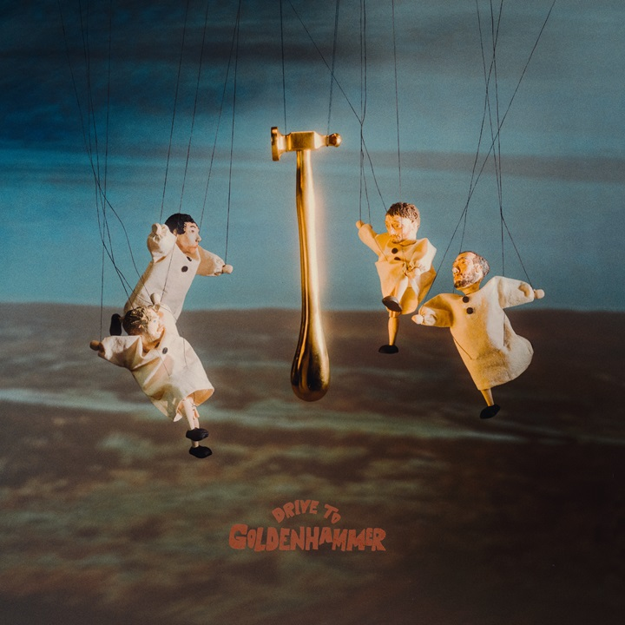
Divorce - Drive to Goldenhammer album artwork | Download image here

Divorce: Website | Bluesky | Facebook | Instagram | TikTok | YouTube

For more information contact Warren@chuffmedia.com

