BILLIE MARTEN RETURNS WITH NEW ALBUM, DOG EARED

THE BRITISH FOLK ARTIST’S FIFTH LP OUT 18 JULY VIA FICTION RECORDS

+ SHARES NEW SINGLE “FEELING” – LISTEN HERE

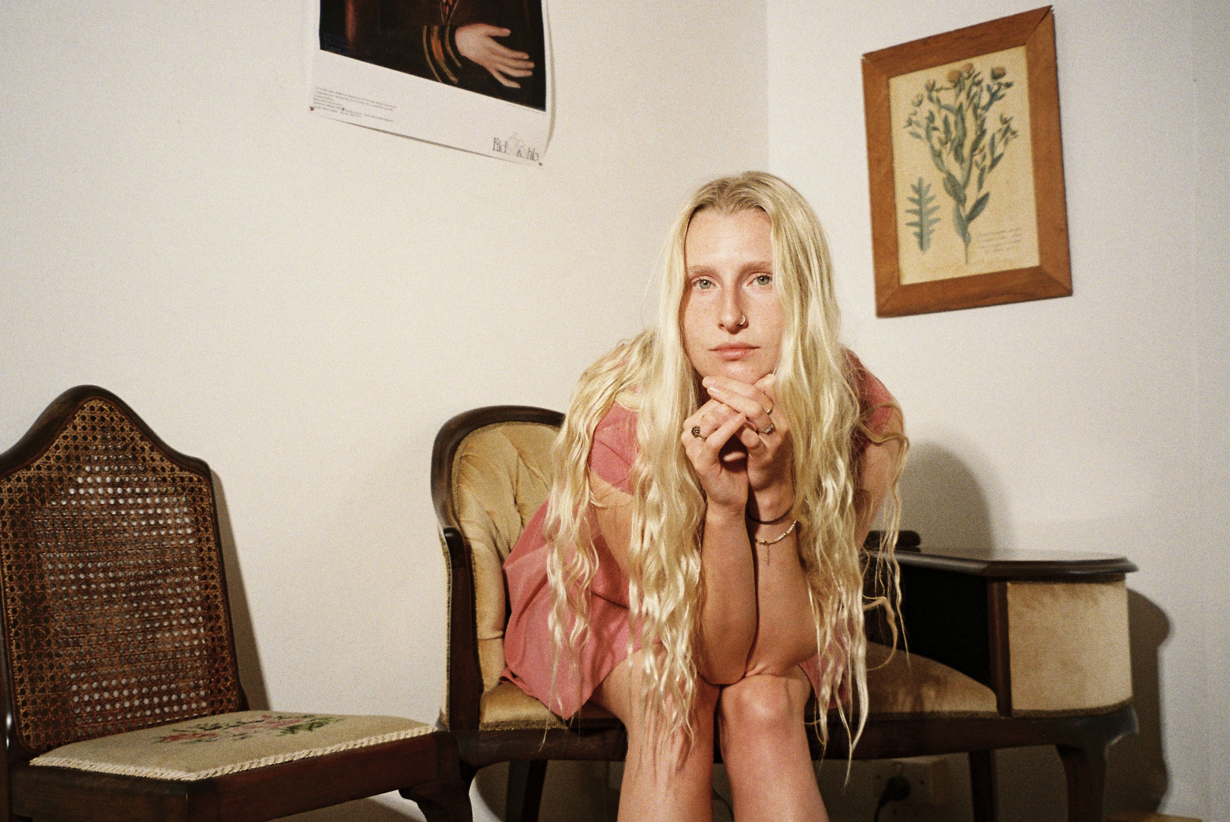Photo Credit: Frances Carter

Billie Marten is pleased to announce details of her fifth album, Dog Eared, out 18th July via Fiction Records. Pre-order HERE.

To coincide with its announcement, Billie shares a new single, the album’s opener “Feeling”. Listen HERE.

A full, extensive run of live dates that take in North America, the UK, Ireland and Europe are listed below, including a run of North American support shows with Tennis, and outdoor stages with Elbow in the UK. A headline tour of the UK later this year will call at the O2 Forum Kentish Town, Billie’s biggest headline show to date. Ticket details can be found at billiemarten.com.

The prolific British singer-songwriter headed to New York in the summer of 2024 to record with producer Phil Weinrobe (Adrianne Lenker, Buck Meek, Laura Veirs) at his Sugar Mountain studio, alongside an all-star cast of musicians. The likes of Catalan singer-songwriter/guitarist Núria Graham, bassist Josh Crumbly, virtuosic guitarist Mike Haldeman, multi-instrumentalist Shahzad Ismaily, revered indie-rock musician Sam Evian, former Dirty Projectors vocalist/folk musician Maia Friedman, Brazilian percussionist Mauro Refosco, drummer/multi-instrumentalist Vishal Nayak and acclaimed folk musician Sam Amidon sprinkle their gold dust over Dog Eared. A band packed with talent and cumulative credits across records by Cassandra Jenkins, Kamasi Washington, Moses Sumney, Robert Glasper, Tune-Yards, Empress Of, Nick Hakim, David Byrne, Atoms for Peace, Feist, Bonnie “Prince” Billy, and now Billie Marten.

Since the release of Billie’s fourth LP, 2023’s “Drop Cherries”, Billie’s largely spent her time on the road, honing her craft as a deeply instinctual artist and songwriter. Living and learning. Playing and writing. Collaborating with gifted strangers. Exploring questions of identity and self. All the while, sending demos and voice-notes across the Atlantic to Weinrobe and watching those embryonic songs come to life and flourish fully-realised in the studio.

Dog Eared is a warm, rich and textured record that bristles with confidence and self-belief, with Billie already approaching the prolificacy of a “lifer” with so much life left to live. It’s a left turn from her previous recordings, albeit a subtle one, taken with a deftness of touch. A musician embracing change, while staying true to her core self. There’s a certain strength of conviction here that finds its voice more prominently in the extensive pool of her acclaimed American contemporaries, of which she now surely stands shoulder to shoulder with. With Dog Eared, Billie calmly posits herself at the top of the tree of not just British contemporary folk artists, but with British songwriters at large.
Weinrobe says: “Dog Eared is a fucking miracle. This record feels like what music is supposed to be — a creative dialog between wide open musicians, all pushing in the exact same direction. And that direction is clear — the controls are set for the heart of Billie’s incredible songs.
“Yes, the record was recorded live. Yes, Billie sang the lead vocals as it was going down. Yes, we were huddled up in a circle — no headphones, no walls, no playback, nothing separating each person from the next, and nothing separating the performers from their performances.
“But that’s not why this record is a monument. It’s a monument because Billie walked into the studio every morning and opened her mouth and sang these incredible melodies and gorgeous lyrics without any worries or fears or desires to control the art. She was the art. And everyone surrounded her, and lifted her up, and in turn she lifted the music to heights that we are all lucky to get to listen to, on repeat, forever.”
Of the record’s opening number, “Feeling”, Billie explains: “I’ve discovered that I have a really particular long-term memory: I have specific sensory recollections from when I was two onwards, that I can recall easily now. One of these is marking out roads in my grandmother’s patterned carpet, for my Dad’s old 1950/60s toy cars to drive on. I used to trace patterns in everything: fabric seats at the dentist, carpets, wallpaper and walls, raindrops on car windows. Everything had a pattern to be noticed.”
“Another strong memory is the feeling of big, warm hands when you’re a child and how comforting and safe that feels. The notion of age being so far away from you, but you know it’s a future inevitability, and that you’re on your way there. The inarticulateness of that ‘feeling’ you can’t describe yet, but you’re aware of a push in the world that you don’t yet understand.”
“”Feeling” is really set alight by Núria Graham’s guitar part, the one you hear from the outset. It sparks the album info life and really sets a benchmark in terms of rhythm. This is an album of rhythmic focus.”

“Feeling” follows early Dog Eared single, “Crown”, a fan favourite released in late 2024, following Billie’s sold-out headline performance at London’s Barbican Centre with free-form string group, Her Ensemble.

Pre-order Dog Eared HERE
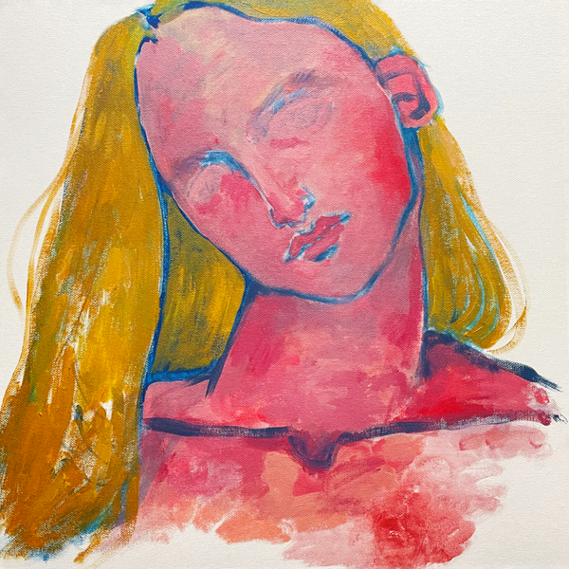
- Feeling
- Crown
- Clover
- No Sudden Changes
- The Glass
- Leap Year
- Goodnight Moon
- Planets
- You and I Both
- Swing

Billie Marten Live:
21 May - Minneapolis, MN @ First Avenue (w/ Tennis)
23 May - Chicago, IL @ The Salt Shed (w/ Tennis)
24 May - Indianapolis, IN @ HI-FI Annex (w/ Tennis)
25 May - Cleveland, OH @ Globe Iron (w/ Tennis)
27 May - Toronto, ON @ The Concert Hall (w/ Tennis)
30 May - Boston, MA @ Roadrunner (w/ Tennis)
31 May - Philadelphia, PA @ Franklin Music Hall (w/ Tennis)
1 June - New York, NY @ The Rooftop at Pier 17 (w/ Tennis)
3 June - Washington, DC @ The Anthem (w/ Tennis)
5 June - Raleigh, NC @ The Ritz (w/ Tennis)
6 June - Atlanta, GA @ The Eastern (w/ Tennis)
7 June - Nashville, TN @ Brooklyn Bowl (w/ Tennis)
9 June - Dallas, TX @ The Factory in Deep Ellum (w/ Tennis)
10 June - Houston, TX @ White Oak Music Hall (w/ Tennis)
11 June - Austin, TX @ Stubb's Waller Creek Amphitheater (w/ Tennis)
13 June - Cardiff, UK @ Cardiff Castle (w/ Elbow)
18 June - Coventry, UK @ Warwick Arts Centre (w/ Elbow)
19 June - Gloucestershire, UK @ Westonbirt Arboretum (w/ Elbow)
3 July - York, UK @ York Museum Gardens
5 July - Vilanova i la Geltrú, ES @ VIDA FESTIVAL 2025
30 August - Darmstadt, DE @ Golden Leaves Festival
8 September - Denver, CO @ Bluebird Theater
10 September - San Diego, CA @ Lou Lou's
11 September - Los Angeles, CA @ El Rey Theatre
13 September - San Francisco, CA @ The Independent
15 September - Portland, OR @ Aladdin Theater
16 September - Seattle, WA @ The Crocodile
17 September - Vancouver, BC @ Hollywood Theatre
9 October - Tourcoing, FR @ Le Grand Mix
10 October - Brussels, BE @ Botanique
11 October - Paris, FR @ Le Trabendo
12 October - Feyzin, FR @ L'Epicerie Moderne
15 October - Madrid, ES @ Teatro Lara
17 October - Zurich, CH @ Bogen F
18 October - Munich, DE @ Strom
19 October - Vienna, AT @ Flucc Wanne
21 October - Warsaw, PL @ Hybrydy
23 October - Berlin, DE @ Frannz Club
25 October- Copenhagen, DK @ Vega Small Hall
26 October - Stockholm, SE @ Nalen Klubb
28 October - Oslo, NO @ Parkteatret
31 October - Hamburg, DE @ Nochtspeicher
1 November - Amsterdam, NL @ Melkweg Max
2 November - Cologne, DE @ Luxor
5 November - Dublin, IE @ Vicar Street
6 November - Belfast, UK @ Empire Music Hall
7 November - Glasgow, UK @ SWG3 TV Studio
8 November - Newcastle, UK @ Newcastle University Student Union
10 November - Nottingham, UK @ Rescue Rooms
11 November - Bristol, UK @ SWX
13 November - Manchester, UK @ Academy 2
14 November - Leeds, UK @ Irish Centre
15 November - London, UK @ O2 Forum Kentish Town

Tickets at billiemarten.com

FOLLOW BILLIE MARTEN
Website | Instagram | YouTube | TikTok | Facebook | X | Spotify | Apple Music | Soundcloud

For more information and press enquiries please contact

Jenny Entwistle
Jenny@chuffmedia.com

