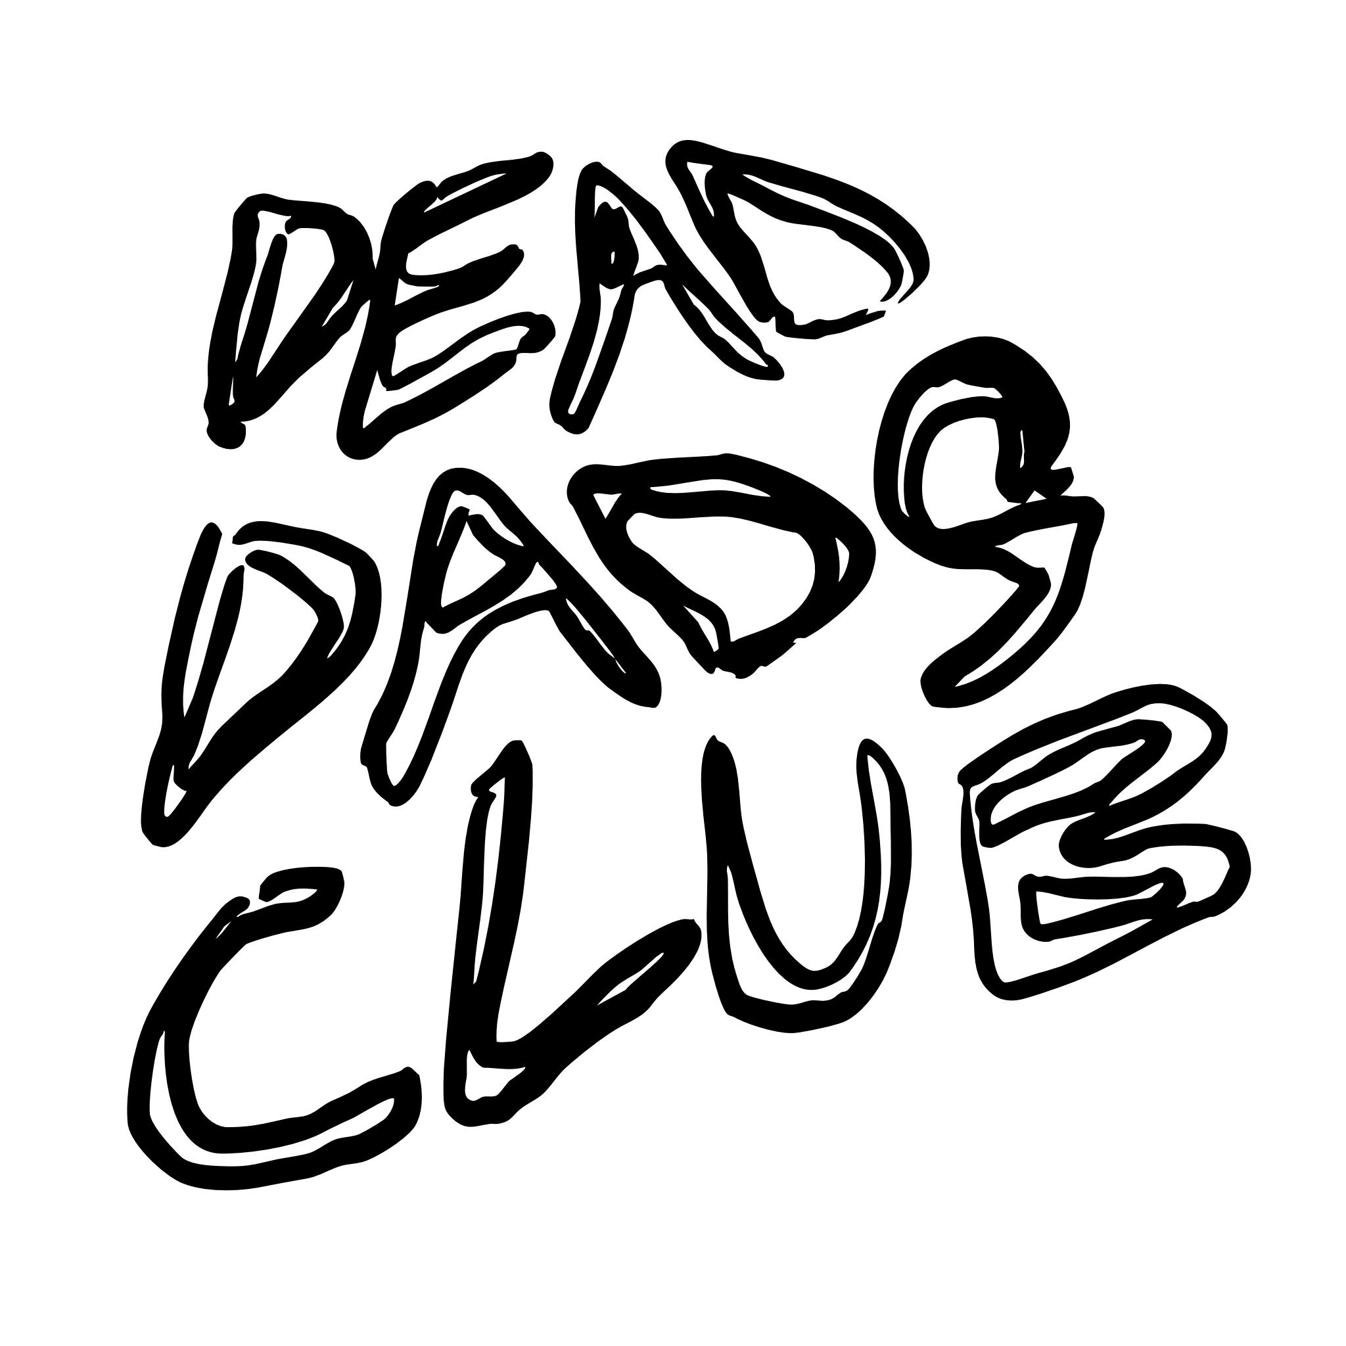

Photo credit: Adrian Lee

Dead Dads Club
announce details of self-titled debut album - out via Fiction Records on Friday 23rd January 2026

Also announced their first UK Record Store Tour, which will see the band performing at 7x record stores this coming January.

Today release ‘Volatile Child’, the final instant grat ahead of their album.

Listen to ‘Volatile Child’ here

Dead Dads Club, helmed by Chilli Jesson, have announced details of the release of their debut self-titled album, a deeply personal and affecting record which explores Chilli’s emotional journey following the death of his father.

To celebrate, the band will embark on a series of intimate instore dates across January, which will see them perform at 7 record stores. Full list of dates is below:

23 January – Banquet – KINGSTON
24 January – Rough Trade East – LONDON
25 January – Sound Knowledge – MARLBOROUGH
26 January – The Croft for Rough Trade – BRISTOL (out-store show)
27 January – Rough Trade – NOTTINGHAM
28 January– Jacaranda – LIVERPOOL
29 January – Vinyl Whistle – LEEDS



Released on Fiction Records on Friday 23rd January 2025, the band have today also shared ‘Volatile Child’, the latest single to be taken from the album following the release of ‘Goosebumps’ in November.

Listen to ‘Volatile Child’ here

The track listing of the album, produced by Carlos O’Connell of Fontaines D.C. is as follows:
It’s Only Just Begun
Volatile Child
Humming Wires
Goosebumps
Junkyard Radiator
Running Out Of Gas
That’s Life
Don’t Blame The Son For The Sins Of The Father
Need This Around
Hospital Pillow
Need You So Bad

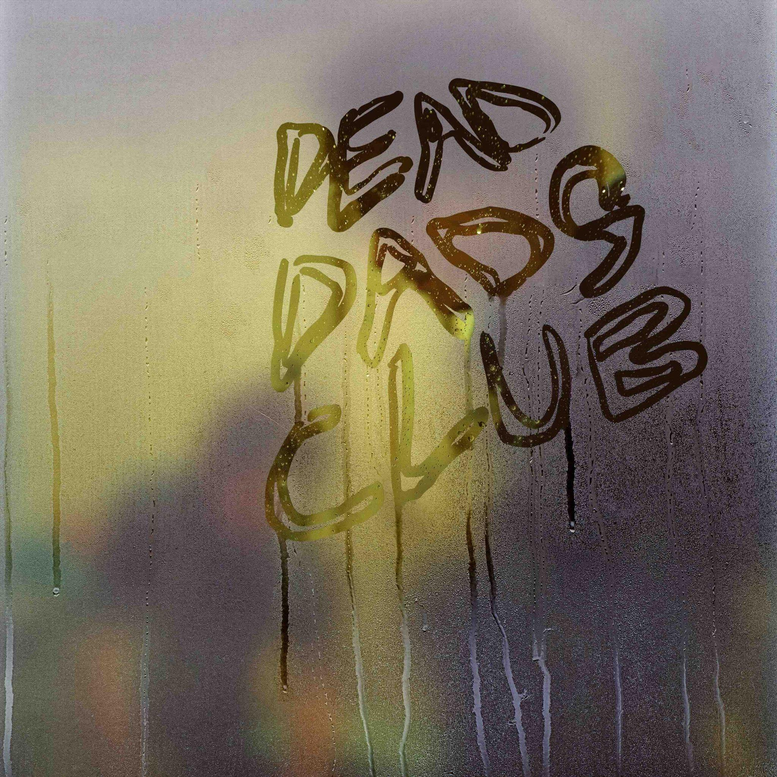

The album is available digitally and on CD & vinyl.
Cat. number: DDC001
Pre-order the album HERE.

…………………….

At 14, Chilli Jesson lost his father to drug addiction, a trauma he buried under rebellion and emotional suppression. His escape came through music, as his band Palma Violets skyrocketed to fame, landing on NME covers and topping charts. But when the band unexpectedly ended in his early twenties, Jesson was left disoriented. He tried to rebuild with a new project, Crewel Intentions, and later ventured into pop songwriting out of financial necessity.
Feeling disillusioned and creatively lost, Jesson stopped listening to the music that once defined him—until Fontaines DC invited him on tour. This rekindled his passion for raw, honest music. Inspired, he began crafting his most personal project yet: Dead Dads Club. Written with Rupert Greaves and produced by Fontaines DC’s Carlos O’Connell, the album chronicles Jesson’s grief and survival after his father’s death, from adolescence to present day.
The songs are emotionally candid and musically vibrant, blending gritty riffs with tender reflections. Tracks like ‘Don’t Blame The Son For The Sins Of The Father’ and ‘Running Out of Gas’ tackle strained familial relationships, while ‘Need You So Bad’ and ‘Need This Around’ reaffirm his commitment to music. Now on the verge of fatherhood himself, Jesson channels past pain into creative purpose. Dead Dads Club isn’t just an album—it’s a space for shared grief, resilience, and hope. As Jesson puts it: once you’re in the club, you’re in for life.

For further information about Dead Dads Club:
INSTAGRAM | FACEBOOK | TIKTOK | WEBSITE

For more information and press enquiries please contact

Warren & Harry
@chuffmedia.com

