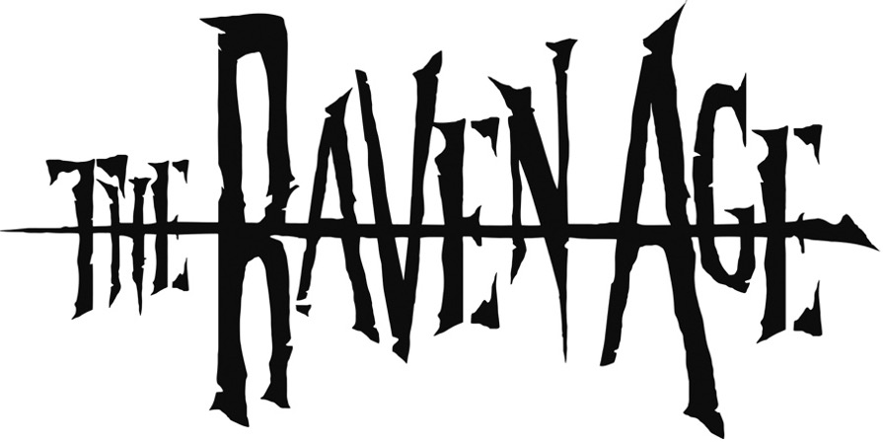
ANNOUNCE NEW ALBUM BLOOD OMEN
OUT JULY 7TH VIA MUSIC FOR NATIONS

IRON MAIDEN SUPPORT & UK NOVEMBER HEADLINE TOUR

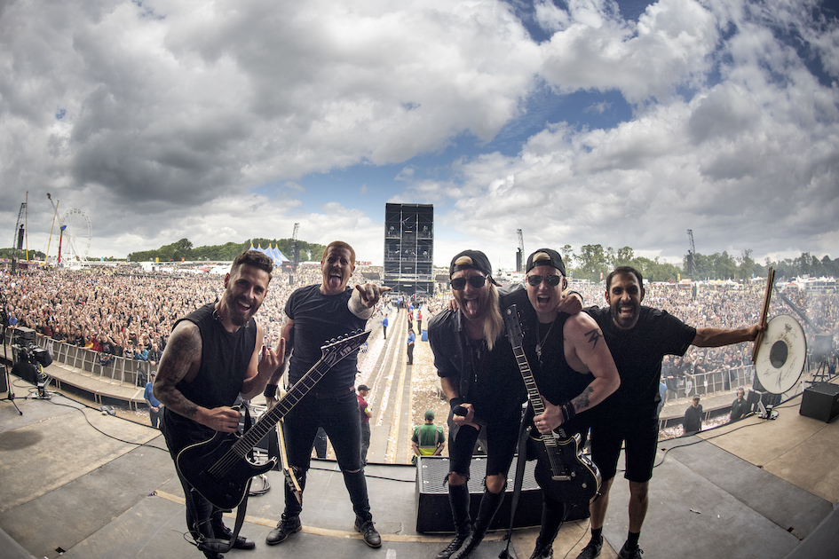

The Raven Age have announced their highly anticipated third album Blood Omen. Out July 7th, it is their first record with Music For Nations/Sony Music. The album is available to pre-order now here.
Having established their name as one of the finest in modern British metal, thanks to two brilliant albums, 2019’s Conspiracy and Darkness Will Rise debut in 2017, The Raven Age have garnered over 75 million streams worldwide and have toured heavily across the globe.

For the Essex quintet’s “all-important third album”, as guitarist George Harris puts it, they have expanded on every level.

This motivation is written into the album’s concept. Following the theme of its two predecessors, the raven motif looms large, this time centering on the overthrowing of old masters, with the band’s Raven King character coming to prominence.

Blood Omen pushes everything further than ever before. The choruses are made for arenas, the riffs are taut, direct, and free of fat. It all makes for a grand musical stage on which the record’s concept plays out. ‘Forgive & Forget’ rushes in on a scalding lead guitar riff, while the epic ‘Nostradamus’ is a tale of the great prophet. The heavy, raging ‘Serpents Tongue’, meanwhile, deals with “deceit, and never knowing if you’re being told the truth,” according to George.
To capture all this on record, the band enlisted the help of long-term producer Matt Hyde (Slipknot, Machine Head, Bullet For My Valentine) to lay down the album’s framework, before setting to recording the rest of the album themselves. The final mastering was put into the treasured hands of Mika Jussila at Finnvox (Nightwish, Children of Bodom, HIM).

Blood Omen is a record of several firsts for The Raven Age. With the metal end of the operation firmly nailed down, this time around the band were finally able to realise their ambitions of using real strings. Working with noted British cellist arranger Audrey Riley (Foo Fighters, Muse, Coldplay) at the ICMP [Institute of Contemporary Music Performance] studios in London. “Watching a quartet play along to our songs was a whole new experience,” says George. “They just made everything more dramatic.”

The album also sees the recorded debut of new guitarist Tommy Gentry, the prodigiously talented axeman – whose previous work includes stints with Marco Mendoza and former Judas Priest six-stringer KK Downing.

Blood Omen is a strong, focussed, and ambitious work from one of the most rapidly rising rock bands in Britain and live they solidify this status. They have performed over 400 shows internationally across 38 countries including major festival performances such as the main stage at Download Festival, Rock in Rio, Wacken, Hellfest and many more, as well as touring with the likes of Killswitch Engage, Volbeat, Shinedown and Alter Bridge.

This summer they will be touring arenas across Europe and the UK with Iron Maiden, including London’s O2 Arena on July 8th. They have also been announced to perform at a number of major European festivals this summer including Germany’s Rock am Ring, Belgium’s Graspop Metal Meeting, Return Of The Gods Festival in Italy, Sweden Rock as well as Metal Days in Slovenia.

Full tour dates are listed below. Now, watch this raven soar.

THE RAVEN AGE TOUR DATES 2023

May
23rd – Dover, The Booking Hall
26th – Vienna, Chelsea
28th – Ljubljana, Arena Stozice *
30th – Prague, O2 Arena *
31st – Prague, O2 Arena *

June
2nd – Nuremberg, Rock Im Park
3rd – Nürburgring, Rock Am Ring
4th – Tampere, Nokia Arena *
7th – Bergen, Koengen *
9th – Sölvesborg, Sweden Rock
11th – Leipzig, Quarterback Immobilien Arena *
13th – Krakow, Tauron Arena *
14th – Krakow, Tauron Arena *
15th – Dessel, Graspop
19th – Zurich, Hallenstadion *
21st – Hannover, Zag Arena *
23rd – Czech Republic, Basinfirefest
24th – Switzerland, Heavy Load Festival

July
8th – London, O2 Arena *
11th – Amsterdam, Ziggo Dome *
13th – Antwerp, Sportpaleis *
15th – Milan, Return Of The Gods Festival
18th – Barcelona, Palau Sant Jordi *
20th – Murcia, Estadio Enrique Roca *
22nd – Bilbao, Bizkaia Arena Bec! *
25th – Dortmund, Westfalenhalle *
29th – Frankfurt, Festhalle *
31st – Munich, Olympiahalle

August
1st – Lake Velenje, Metal Days Festival
2-5th – Wacken Open Air Festival

*supporting Iron Maiden

HEADLINE TOUR
October
12th – Krakow, Kamienna 12
15th – Helsinki, On The Rocks Club
17th – Stockholm, Nalen Klubb
18th – Copenhagen, Pumpehuset
20th – Berlin, Badehaus
22nd – Prague, Futurum
24th – Hannover, Musikzentrum
25th – Uden, Del Pul
27th – Paris, La Maroquinerie
29th – Milan, The Legend Club
30th – Zurich, The Plaza
31st – Munich, Strom

November
2nd – Dortmund, FZW
3rd – Antwerp, Kavka
5th – London, Lafyette
7th – Manchester, Academy 3
8th – Glasgow, Attic
10th – Dublin, Academy 2
11th – Belfast, Limelight 2
13th – Birmingham, Asylum
15th – Bristol, Exchange

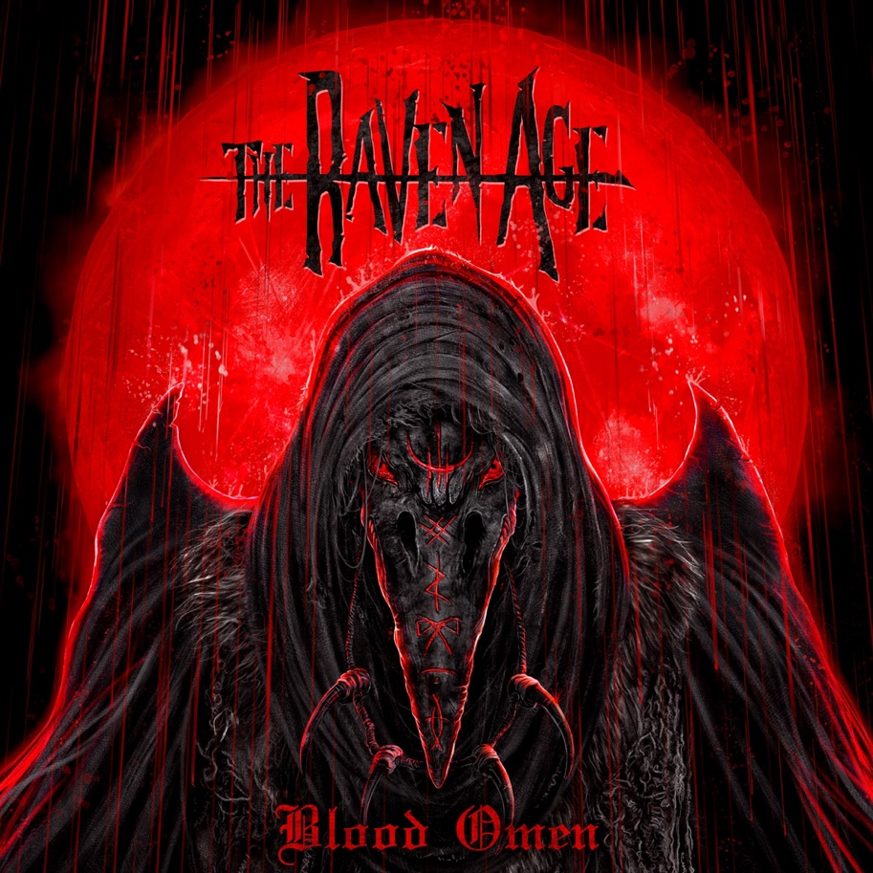

BLOOD OMEN TRACK LISITING
- Changing Of The Guard
- Parasite
- Serpents Tongue
- Essence Of Time
- Nostradamus
- Forgive & Forget
- The Journey
- War In Heaven
- Tears Of Stone

For more information contact Jenny@chuffmedia.com

