MUMFORD & SONS ANNOUNCE SIXTH ALBUM, PRIZEFIGHTER

NEW RECORD SET FOR RELEASE 13TH FEBRUARY 2026

FEATURES COLLABORATIONS WITH HOZIER, GRACIE ABRAMS, CHRIS STAPLETON, AARON DESSNER AND GIGI PEREZ

SOLD-OUT UK + EUROPEAN ARENA TOUR IN NOVEMBER/DECEMBER

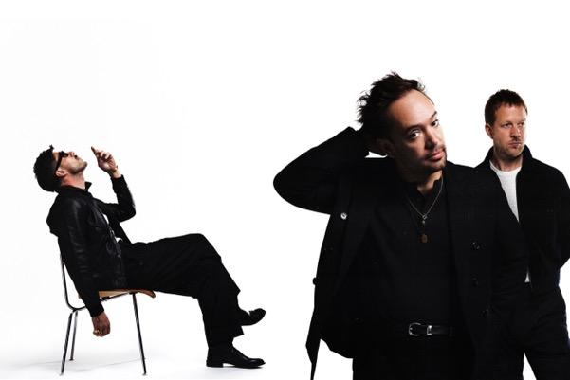
Credit: Conor Cunningham

Mumford & Sons are excited to announce a new album, Prizefighter released via Island Records on 13th February 2026. It’s the band’s sixth studio album.

The record was produced alongside The National’s Aaron Dessner at his Long Pond Studio in upstate New York.

The album’s announcement follows new single Rubber Band Man (With Hozier) last week. Listen here.

Pre-order Prizefighter here.

A mere seven months on from the arrival of RUSHMERE, the band’s long anticipated number one album in March 2025, Mumford & Sons take full advantage of a prolific period of songwriting with another full-length record in quick succession.

Co-produced and co-written with The National’s Aaron Dessner who the band previously worked with on their third record Wilder Mind, Prizefighter captures the band at their most open and instinctive. In just ten days, they’d written more than an album’s worth of songs, and a collection that feels both deeply personal, instinctive and unguardedly communal. Marcus Mumford’s lyrics grapple with resilience and striving, singing with a mix of confidence and urgency.

For Marcus, Ben Lovett, and Ted Dwane, the sessions were as much about rediscovery as recording. Days spent writing in Hudson cafés and nights spent around Long Pond’s kitchen table gave rise to songs that feel unpolished in the best sense—alive with first takes and the joy of simply making music together again. Re-energised, rejuvenated and in the form of their lives, Prizefighter embraces and reflects that full-strength energy and enthusiasm with 14 songs of light, shade and everything in-between.

Their lead single, Rubber Band Man (with Hozier), was recorded at Long Pond Studios in upstate New York alongside producer Aaron Dessner. Dessner has previously worked with the band on their third album Wilder Mind that debuted at 1 on both sides of the Atlantic.

Hozier’s involvement stems from a friendship with the band that stretches back to 2017 when he joined Mumford & Sons on stage to cover The Beatles’ A Little Help From My Friends when the British band headlined the Longitude Festival in 2017. He also guested with them at the Austin City Limits Festival in Texas in 2023.

Rubber Band Man is a confident next step for Mumford & Sons who have been busy on and off the road over the past twelve months, with RUSHMERE merely the starting point. With more songs than they’ve known quite what to do with, the band left the studio door open at Long Pond. Hozier here makes the first meaningful connection of many studio collaborations, and his distinguishable, rich baritone compliments Marcus’ vocal beautifully.

Marcus Mumford: “We feel like we’re hitting our prime as a creative force. We’re putting everything we have into this now, and we’re using everything about our experience so far to embrace exactly who we are. We’re comfortable in our skins these days. And Prizefighter is us going for it - serious and playful, sometimes bruised and always hopeful. We’re nowhere near done yet.”

“I hope and believe and we’re in the beginning of something we don’t want to let up on. I’m more excited to be in this band than I’ve ever been.”

Since RUSHMERE’s release, Mumford & Sons have largely been out on the road across the US, interspersing a string of sold-out arena dates with a return to a tour they initially started over a decade ago out on the US railroad, joined this time by the likes of Maggie Rogers and Noah Kahan. The band follow this new single’s release by returning to the UK and Europe for a 22-date run that concludes with two hometown shows at London’s O2 Arena. Any remaining tickets for the European leg of the tour are on sale now via www.mumfordandsons.com

Album Tracklisting:
Here (with Chris Stapleton)
Rubber Band Man (with Hozier)
The Banjo Song
Run Together
Conversation With My Son
Alleycat
Prizefighter
Begin Again
Icarus (with Gigi Perez)
Stay
Badlands (with Gracie Abrams)
Shadow Of A Man
I’ll Tell You Everything
Clover

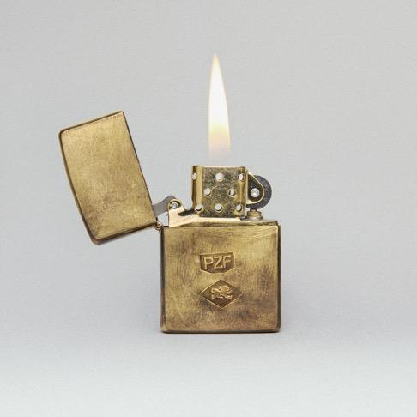
Prizefighter Artwork

Mumford & Sons Live (2025/26):
29th November – Utilita Arena, Newcastle (w/ Sierra Ferrell) SOLD OUT
30th November – First Direct Arena, Leeds (w/ Sierra Ferrell) SOLD OUT
2nd December – OVO Hydro, Glasgow (w/ Sierra Ferrell) SOLD OUT
3rd December – Co-op Live, Manchester (w/ Sierra Ferrell) SOLD OUT
5th December - Utilita Arena, Sheffield (w/ Sierra Ferrell) SOLD OUT
7th December - Utilita Arena, Birmingham (w/ Sierra Ferrell) SOLD OUT
8th December - Utilita Arena, Cardiff (w/ Sierra Ferrell) SOLD OUT
10th December – The O2, London (w/ Sierra Ferrell) SOLD OUT
11th December – The O2, London (w/ Sierra Ferrell) SOLD OUT

FOLLOW MUMFORD & SONS
Website | Instagram | YouTube | TikTok | Facebook | X | Spotify | Apple Music | Soundcloud

For more information and press enquiries please contact

warren@chuffmedia.com

