DERMOT KENNEDY
ANNOUNCES NEW ALBUM
‘THE WEIGHT OF THE WOODS’ OUT MARCH 27TH
NEW SINGLE “FUNERAL” OUT NOW
SUMMER UK + EUROPE ARENA TOUR
LONDON O2 JUNE 5TH + DUBLIN AVIVA STADIUM JULY 11TH+12TH

The Weight Of The Woods album artwork

Multi-platinum singer/songwriter Dermot Kennedy today announces his third album ‘The Weight of the Woods’, out March 27th via Island Records. The album announcement is accompanied by the release of lead single “Funeral” and its stunning official music video starring Charlie Rowe and directed by Charlie Sarsfield. The rousing, victorious new single premiered last night as BBC Radio 1’s Hottest Record.
WATCH THE OFFICIAL MUSIC VIDEO FOR “FUNERAL” HERE [LINK]
Largely written and recorded in a studio down the road from his home in rural Ireland together with close collaborator Gabe Simon [Noah Kahan, Lana Del Rey], alongside an enlightening spell together in Nashville, ‘The Weight of the Woods’ is Dermot’s most self-assured record to date. The poetry and music across these 14 tracks draw inspiration, energy, and strength from the country itself. “To me, the album is a beautiful homegrown thing with Irish instruments and an Irish story. There’s a forest behind my house, which is a haven for my sense of wonder. It’s a peaceful place where I can escape. I’ve entertained the idea of living somewhere else, but I don’t think I’d be happy anywhere else.”
With a refreshed approach to his songwriting and production, Dermot has peeled away the layers to let his stunning voice shine through brighter than ever; “If I get up in a pub with just a guitar or a piano, I’m certain that I can sing to a room full of people. It’s where I’m the most comfortable. I wanted that element to be front-and-center on this album.” The result is a thrilling blend of traditional folk textures, country authenticity, and soaring melodies that stay with you long after first listen.
The album release comes ahead of Dermot’s largest headline tour to date in May and June 2026. The landmark tour will see Dermot play bigger than ever venues across Europe before a run of 6 UK arena shows, including a return to London’s O2 on June 5th. In July, Dermot returns home for two headline shows at Dublin’s Aviva Stadium, the home of Irish Rugby.
Known for his passionate and powerful live performances, Dermot has graced the stages of such iconic venues as London’s O2 and New York City’s Madison Square Garden. The shows will feature favorites spanning Dermot’s discography, along with material from ‘The Weight of the Woods’.
Other recent live events for Dermot include intimate, stripped back tours of Europe, the UK and North America, a special half-time performance at Soccer Aid Match in Manchester, and an exciting bill with GRAMMY-winning singer/songwriter Zach Bryan at British Summer Time Festival, both in June. Dermot also supported Bryan in the U.S at Indiana’s famed Notre Dame Stadium on September 6th.
These announcements come hot on the heels of MISNEACH, a new annual global music festival conceived and curated by Dermot himself. The sold-out MISNEACH festival was held in Sydney, Australia and Boston, MA in March timed to St. Patrick’s Day celebrations. The joyous events successfully achieved the festival’s mission of spotlighting Ireland’s rich musical heritage and culture. The bill featured an array of both established and rising artists including The Frames, Matt Corby, Kneecap, Meg Mac, Amble, Sorcha Richardson, The Scratch, Susan O’Niell, Fynch, Cliffords Mick Flannery, Florence Road, The Swell Season, Ye Vagabonds, Nell Mescal and headline sets by Dermot.
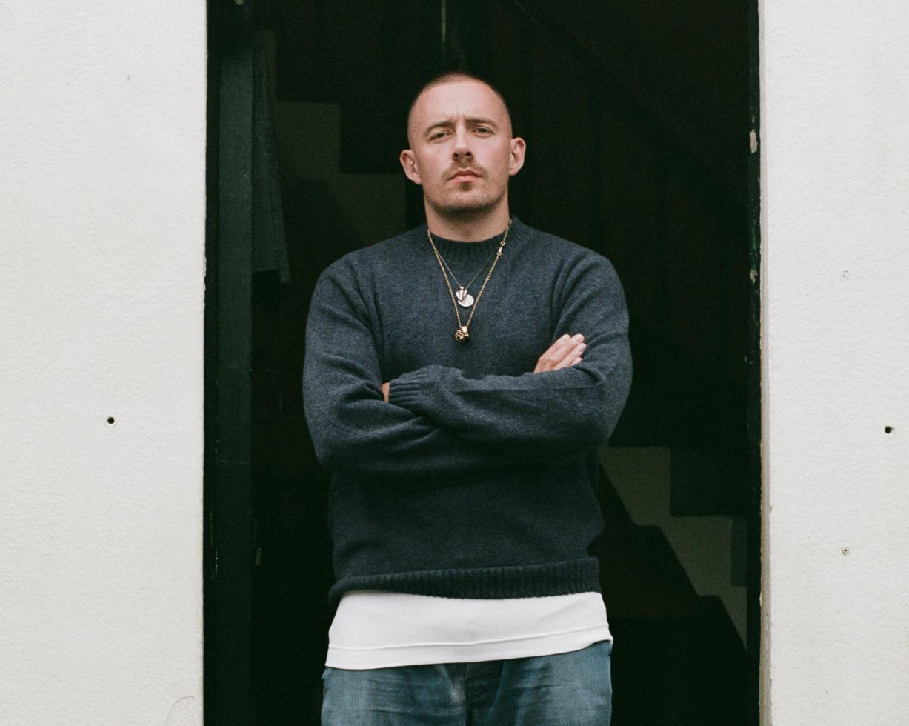
Photo credit: Silken Weinberg

EUROPE AND UK HEADLINE TOUR 2026
11 May – Copenhagen, Denmark, Falkonersalen - SOLD OUT
12 May – Stockholm, Sweden, Annexet
14 May – Hamburg, Germany, Barclays Arena
15 May – Berlin, Germany, Max-Schmeling-Halle
17 May – Zurich, Switzerland, Halle 622
18 May – Paris, France, L'Olympia
20 May – Luxembourg, Luxembourg, Rockhal
21 May – Brussels, Belgium, Forest National
23 May – Munich, Germany, Zenith
24 May – Vienna, Austria, Gasometer
26 May – Dusseldorf, Germany, Mitsubishi Electric Halle
27 May – Amsterdam, Netherlands, AFAS Live
29 May – Glasgow, UK, OVO Hydro
30 May – Manchester, UK, AO Arena
1 Jun – Cardiff, UK, Utilita Arena
2 Jun – Leeds, UK, First Direct Bank Arena
4 Jun – Birmingham, UK, Utilita Arena
5 Jun – London, UK, The O2
11 July – Dublin, Ireland, Aviva Stadium - SOLD OUT
12 July – Dublin, Ireland, Aviva Stadium

About Dermot Kennedy:
Dermot Kennedy has amassed 4 billion streams across platforms, having the best-selling debut album in Ireland of this millennium with his debut Without Fear. A platinum-selling artist in over 12 countries, he released his acclaimed sophomore album Sonder in 2022. In 2024, he stripped back to basics and released the introspective EP, “I’ve told the trees everything,” Dermot has shared the stage with some of his finest contemporaries, most recently with Niall Horan, Noah Kahan and Zach Bryan. His incredible journey has taken him from busking on the streets of Ireland to playing stadiums around the world. His poetic and authentic artistry has forged a deep, emotional connection with audiences, including the likes of Taylor Swift and Shawn Mendes who have sung his praises.

Keep Up with Dermot Kennedy:
Official Site
Instagram
Facebook
Twitter

For more information and press enquiries please contact

Jenny Entwistle
Jenny@chuffmedia.com

