GRACIE ABRAMS “RISK” OUT NOW

ANNOUNCES ALBUM “THE SECRET OF US” OUT 21ST JUNE

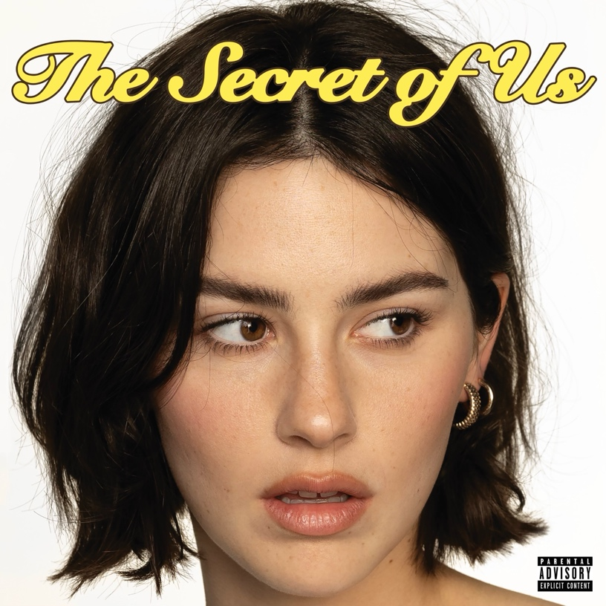

Today, GRAMMY®-nominated singer-songwriter, Gracie Abrams, returns with her anxiously awaited new single, “Risk” (Interscope Records). Gracie co-wrote the bubbly yet incisive track with her longtime friend Audrey Hobert and took a hands-on role producing the new single alongside her friend and frequent collaborator Aaron Dessner. In tandem with today’s single release, Gracie has shared the official video for “Risk. ”Gracie once again enlisted her friend Audrey to direct the video which opens with Gracie on a quiet, dark suburban street chasing after her crush and follows her through an exhilarating night.

“Risk” is the lead single from Gracie’s highly anticipated sophomore album, The Secret of Us, due out June 21st. Gracie announced the new single and album earlier this week on Instagram - see the post here - and was met with an outpouring of support and excitement from fans online as well as from Rolling Stone, Billboard, Nylon and more.

Next Wednesday (May 8), Gracie will return to The Tonight Show starring Jimmy Fallon to perform “Risk.” Along with the new single’s television debut, Gracie will join Jimmy as a chat guest for the first time to talk about new music and more.

The Secret of Us will come nearly a year since her debut album, Good Riddance, which Gracie released last February. Good Riddance also earned Gracie her first ever GRAMMY® nod at the 66th Annual GRAMMY Awards® with a nomination for the highly coveted Best New Artist.

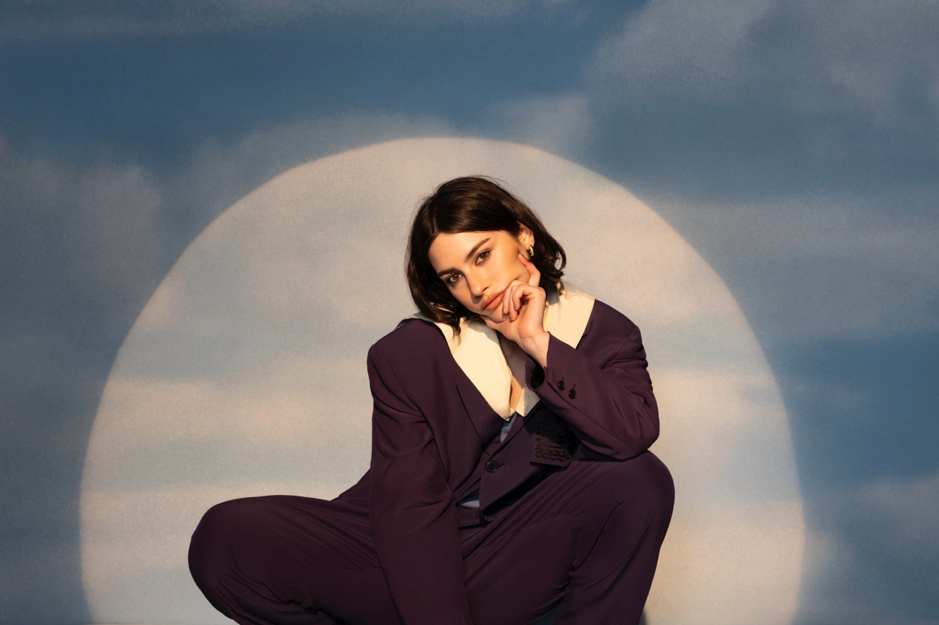
Photo Credit: Abby Waisler

ABOUT GRACIE ABRAMS
Since making her debut in 2019, Gracie Abrams has emerged as one of the most compelling singer-songwriters of her generation, earning the admiration of such like minded artists as Taylor Swift, Lorde, Billie Eilish, and Olivia Rodrigo and most recently, she earned the highly coveted nomination for Best New Artist for the 66th Annual GRAMMY Awards. A consummate songwriter who names Joni Mitchell as her most formative influence, she penned her first song at age eight, then went on to amass a devoted following on the strength of her emotionally intimate lyrics and DIY sensibilities. As her profile rose, Abrams was named an artist to watch by taste making outlets like Pigeons & Planes, Fader, and i-D, in addition to being crowned one of seven breakout female musicians by Vogue UK. With the arrival of her debut project minor in summer 2020, she received glowing reviews from the likes of NME, who praised her “painfully honest tales of heartbreak draped in delicate melodies that carry much more intrigue than the usual run-of-the-mill singer-songwriter.” Executive-produced by Blake Slatkin — and also made with leading producers like Joel Little and benny blanco – the seven-song effort features her beloved singles “21,” “I miss you, I’m sorry,” and “Long Sleeves.” In November 2021, Abrams returned with This Is What It Feels Like, a 12-track project exploring such complex emotional experiences as self-betrayal, insecurity, and failed attempts at connection. Soon after completing her sold-out North American headline tour for This Is What It Feels Like, she set to work on her debut album. Abrams kicked off 2022 with a headline tour of North America followed by a support slot on Olivia Rodrigo’s tour and reconnected with Dessner to release two songs “Block me out” and “Difficult.” In 2023, Abrams released her highly anticipated debut album, Good Riddance, on February 24, followed by a North American headline tour that sold out in under one hour. Gracie toured with Taylor Swift as the opening on select dates of her blockbuster Eras Tour and will continue as direct support when the Eras Tour returns to North America later this year.

For more information on Gracie Abrams, visit:

instagram
twitter
youtube

For more information and press enquiries please contact

Jenny Entwistle
Jenny@chuffmedia.com

