BRADLEY SIMPSON

DEBUT SOLO ALBUM ‘THE PANIC YEARS’
TO BE RELEASED ON FEB 28TH 2024
PRE-ORDER / PRE-SAVE HERE

FEATURING THE NEW SINGLE ‘HOLY GRAIL’ - LISTEN HERE

BIGGEST HEADLINE UK TOUR TO DATE ALSO ANNOUNCED
INCLUDES A LONDON SHOW AT THE O2 FORUM KENTISH TOWN

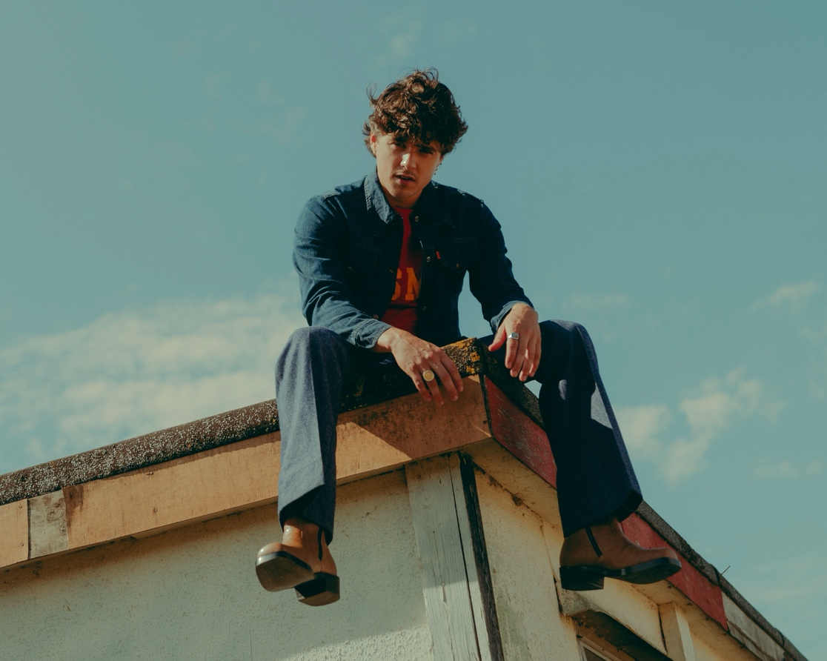

Having performed in front of millions of fans around the world and selling out headline shows, Bradley Simpson is now channelling that star power into his debut solo album, ‘The Panic Years’. Set to be released on Feb 28th 2024, the record is destined to establish him as one of the UK’s most exciting new global artists.

As we’ve heard from the singles ‘Cry At The Moon’, ‘Picasso’, ‘Daisies’ and ‘Always Like This’, the album achieves a rare blend of qualities. On ‘The Panic Years’, Bradley’s new songs take in touches of indie-rock, Americana, ‘80s synth and psychedelia but they also sparkle with pop addictiveness. Just as importantly, the songs go far deeper into his personal experiences: life, love, lust and learning - a diaristic collection of rite-of-passage moments that fans will instantly connect to.

Bradley says, “I hope these songs and stories can help them navigate those experiences. They can become the soundtrack to their lives, whether they’re dancing, crying, going out or whatever it is. It really feels like an opportunity to let them into a side of my life that I haven’t shared before.”

Despite possessing the inspiration of an artist who is just starting out, the record’s consistent accomplishment means that there’s no mistaking Bradley for a brand new artist on this record. The album’s new single ‘Holy Grail’ demonstrates his maturity, both in the songwriting and his assured vocal delivery. Sonically, it sounds timeless, a slowburner that evolves from quiet intimacy into a richer tapestry of sound. Lyrically, it celebrates the future he has with a loved one, and how he can’t wait to go through the good times and the bad, as long as it’s with them.

The song was written at Wendy House Studios in London with Ina Wroldsen (Calvin Harris) and finished in the legendary Flux Studios in New York with the two-time Grammy nominee BOOTS (Beyoncé, Run the Jewels).

Bradley adds, “‘Holy Grail’ is a song about realising that going through ups and downs with someone you love makes it worth it. I spoke about that with my friend Ina, who is an incredible songwriter, and then wrote it around an electric guitar before I recorded anything. Later, BOOTS and I tracked live drums, and I wrote the outro in the studio. It was one of the harder ones on the album to finish because it felt quite delicate and anything we added really needed to earn its place in the production.”

Authenticity is a big part of what makes ‘The Panic Years’ such an evolution of sound. The majority of its songs started in his modest home studio, and that DIY vibe didn’t really shift even as they were developed with a host of top tier collaborators. Primarily working in New York’s Flux Studios (where The Strokes’ classic ‘Is This It’ was made), Bradely would enthuse over shared influences such as Queens of the Stone Age and The Raconteurs with BOOTS, Andrew Wells (Phoebe Bridgers) and Anthony Rossomando (Liam Gallagher).

The Panic Years

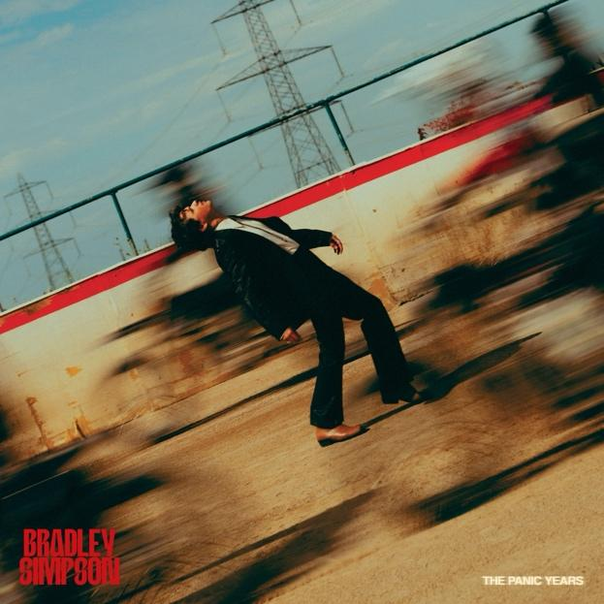

Cry At The Moon
Picasso
Carpet Burn
Daisies
Holy Grail
Getting Clear
Not Us Anymore
Almost
Favourite Band
Always Like This
The Band’s Not Breaking Up
The Panic Years

Today also brings news of Bradley’s biggest headline tour to date - a run of shows which once again scales up after his forthcoming UK and Ireland November tour sold out in just one day. He has also received rapturous reactions at this year’s summer festivals including Reading, Leeds, Latitude and the Isle of Wight.

Fans who pre-order ‘The Panic Years’ HERE before 3pm on Tuesday Nov 12th will receive access to a pre-sale for tickets. General on sale begins at 10am on Friday Nov 15th. Bradley’s official store offers a signed vinyl and CD, as well as a randomly coloured recycled vinyl and a CD with alternative artwork. Retailer exclusives include Amazon’s signed CD, a poster booklet CD from hmv, and a recycled red vinyl from select indie stores.

His newly announced 2025 tour dates are listed below, please see HERE for a list of his remaining shows this year.

MAY 2025
7th - Dublin, The Academy
10th - Newcastle, University
11th - Glasgow, SWG3 Galvanizers
13th - Sheffield, Leadmill
14th - Leeds, Beckett Student Union
16th - Manchester, O2 Ritz
17th - Birmingham, O2 Institute
19th - Cardiff, Tramshed
20th - Bristol, SWX
22nd - Southampton, Engine Rooms
23rd - London, O2 Forum Kentish Town

Follow Bradley Simpson:
Spotify | Apple Music | TikTok | Instagram

For more information, please contact
Jenny Entwistle
jenny@chuffmedia.com

