SNOW PATROL
ANNOUNCE EAGERLY AWAITED RETURN WITH BRAND NEW ALBUM
‘THE FOREST IS THE PATH’
SET FOR RELEASE SEPTEMBER 13TH 2024
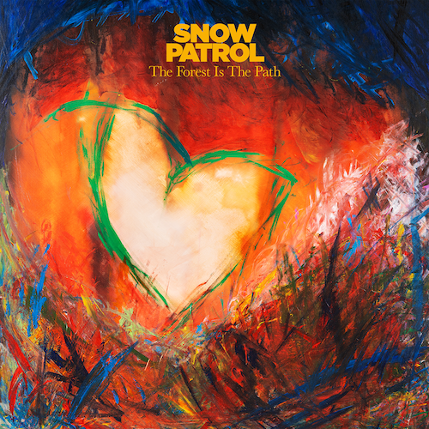
SHARE NEW SINGLE ‘THE BEGINNING’
LISTEN
ANNOUNCE ARENA TOUR IN FEBRUARY 2025
Pre-order album

SNOW PATROL have announced their eagerly awaited return with a brand new album. Titled ‘The Forest Is The Path’, the album is the Northern Irish band’s first in six years, following 2018’s ‘Wildness’, and is set for release on September 13th via Polydor Records. It is produced by Fraser T Smith (Adele/Dave/Stormzy) and the band. Now comprising the trio of Gary Lightbody, Nathan Connolly and Johnny McDaid, Snow Patrol offer the first taste of their extraordinary new album with first single ‘The Beginning’, as well as announcing details of a UK and Ireland Arena tour in 2025.

‘The Forest Is The Path’ was written by Gary Lightbody, Nathan Connolly and Johnny McDaid and features twelve tracks. Fraser T Smith, Will Reynolds, Roy Kerr and Troy Van Leeuwen (QOTSA) also contributed to the writing on some of the songs on the album. The album and single artwork features paintings by Gary Lightbody.

‘The Beginning’ is the cornerstone of the band’s eighth studio album, written on a trip to Somerset. Gary picks up the story, “The first day we wrote The Beginning, start to finish.” “And he did the vocal in one take,” says Johnny. “Straight after writing the lyrics. So it has this mind-collapsing quality to it where you feel like you’re seeing into someone’s soul.”

‘The Forest is the Path’ is an album rooted in reflection, introspection and interrogation. One of its key building blocks, says Gary, was the idea of love from the distance of time. “I haven’t been in a relationship for a very long time, 10 years or more, so love from a distance to me meant the way a relationship sits in your memory from a distance of, say, 10 years. That’s not something I’d previously thought about as away to write about love. So it’s like, when you’re in love, you’re standing in the lobby of the Empire State Building. When you’ve broken up with that person, you’re out in the street. You can still see the building, but you’re not in there anymore. And when it’s 10 years later, now you’re standing in Brooklyn looking at the Manhattan skyline.”

It’s a theme addressed unblinkingly and unflinchingly on the ‘The Beginning’. “That’s kind of a summing up of this album,” Gary continues. “It’s a way of looking at various mistakes, any pain I may have caused, from a place where nothing is hurting anymore, except the memory when you pull it back into your mind. The memory itself is full of hurt but everything around it isn’t. You’re holding in your hand this ball of fire, but now you’ve got gloves on.”

‘The Forest Is The Path’ tracklisting:
1. All
2. The Beginning
3. Everything’s Here And Nothing’s Lost
4. Your Heart Home
5. This Is The Sound Of Your Voice
6. Hold Me In The Fire
7. Years That Fall
8. Never Really Tire
9. These Lies
10. What If Nothing Breaks?
11. Talking About Hope
12. The Forest Is The Path

Snow Patrol have today announced details of an 8 date UK & Ireland Arena tour in February 2025, including The O2 in London on February 15th. Fans who pre-order The Forest Is The Path from Snow Patrol’s store will get access to tour pre-sale. Tickets go on pre-sale on Wednesday 5th June at 10am and general sale on Friday 7th June at 10am.

Dates are:
Feb 15th London O2
Feb 16th Birmingham Resorts World Arena
Feb 18th Cardiff Utilita Arena
Feb 19th Hull Connexin Live
Feb 21st Glasgow OVO Hydro
Feb 22nd Manchester Co-op Live Arena
Feb 25th Dublin 3Arena
Feb 27th Belfast SSE Arena
-
LEAD PRESS PHOTO
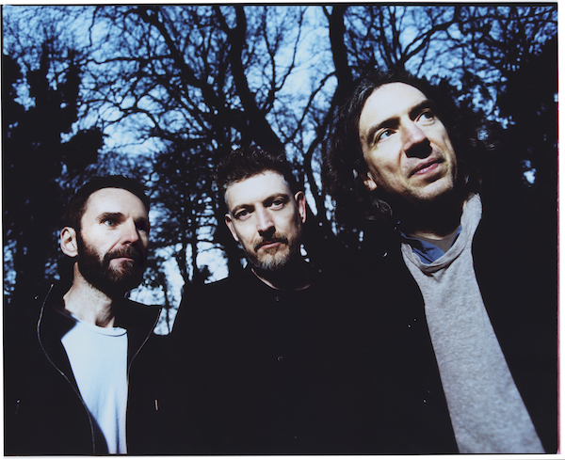
(Credit Tom Beard)
Connect with Snow Patrol
Facebook Instagram Twitter

For more on info contact warren@chuffmedia.com

