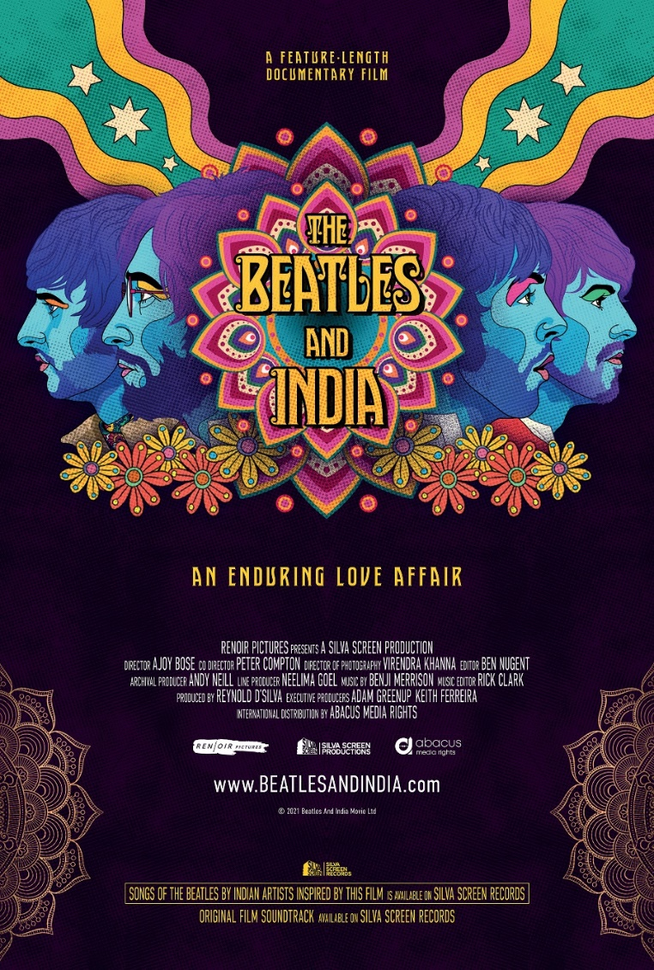
THE BEATLES AND INDIA
NEW DOCUMENTARY FILM AND COMPANION ALBUM
COMING THIS AUTUMN

- THE BEATLES AND INDIA FILM TELLS THE STORY OF THE BEATLES’ CULTURALLY GROUND-BREAKING TIME IN INDIA
- WORLD PREMIERE AT THE TONGUES ON FIRE UK ASIAN FILM FESTIVAL CLOSING GALA 6TH JUNE AT THE BFI IN LONDON
- MAJOR INDIAN RECORDING ARTISTS CONTRIBUTE BEATLES INTERPRETATIONS FOR COMPANION ALBUM INCLUDING
VISHAL DADLANI, KISSNUKA, BENNY DAYAL, DHRUV GHANEKAR, KARSH KALE, ANOUSHKA SHANKAR, SOULMATE, NIKHIL D'SOUZA
LISTEN TO FIRST SINGLE FROM THE ALBUM
INDIA, INDIA – NIKHIL D’SOUZA
LISTEN HERE

A brand new major documentary and companion album are set to be released this autumn, exploring The Beatles’ lasting legacy from their culturally ground-breaking time spent in India.

The Beatles And India is a unique historical chronicle of the enduring love affair between The Beatles and India that started more than half a century ago. Rare archival footage, recordings and photographs, eye-witness accounts and expert comments along with location shoots across India, bring alive the fascinating journey of George, John, Paul and Ringo from their high octane celebrity lives in the West to a remote Himalayan ashram in search of spiritual bliss that inspires an unprecedented burst of creative songwriting. It is the first serious exploration of how India shaped the development of the greatest ever rock band and their own pioneering role bridging two vastly different cultures.

Inspired by Ajoy Bose’s book, Across The Universe - The Beatles In India, British Indian music entrepreneur Reynold D’Silva has now taken the amazing saga of The Beatles and India further by producing Bose’s directorial debut. Bose and cultural researcher, co-director, Pete Compton, have created an audio-visual presentation that stands apart from the many documentaries on the band, delving deep into the most crucial period of their evolution from the world’s most famous pop stars into multi-faceted pioneering musical artists.

The Beatles and India will premiere on 6th June at the BFI as part of the Tongues On Fire UK Asian Film Festival ahead of a full release in autumn.

Coinciding with the full release of the film will be a companion album on Silva Screen Records, The Beatles and India: Songs Inspired by the Film, which will feature interpretations of Beatles songs that they were inspired to write from their time in India from contemporary Indian artists.

The album is evidence of the legacy of this cultural crossover, and features a diverse cast of Indian artists (Vishal Dadlani, Kissnuka, Benny Dayal, Dhruv Ghanekar, Karsh Kale, Anoushka Shankar, Soulmate and many others) all bringing their own musical styles, as well as contemporary and classical Indian influences and techniques to the record.
Between them the artists have an incredible following across India and beyond, including over 11 million combined Spotify monthly listeners, and combined YouTube views of over 3 billion.

The album features the Beatles’ songs written during their stay in Rishikesh India including Mother Nature’s Son, Revolution, Sexy Sadie, Dear Prudence, Child of Nature among others.

The first single from The Beatles and India is available now, and features Indian singer-songwriter Nikhil D’Souza poignantly performing John Lennon’s love letter to the country – India, India.

Nikhil’s rich and emotive vocals are framed by a meditative guitar and sitar drone, in a contemporary take on a track originally recorded by John Lennon in 1980, but inspired by Lennon’s memories of the time the Beatles spent studying Transcendental Meditation with Maharishi Mahesh Yogi in Rishikesh in 1968.
Nikhil is evidence in himself of the long link imbued by the Beatles between Western and Indian music, with songs such as Silver and Gold becoming a favourite and being playlisted on BBC Radio 2 in the UK, and other tracks of his achieving millions (and in the case of the song Vaaste, billions) of listens and views across the world.

The Beatles and India: Songs Inspired by the Film Tracklisting:
Tracklisting:
- Tomorrow Never Knows – Kissnuka
- Mother Nature's Son - Karsh Kale / Benny Dayal
- Gimme Some Truth – Soulmate
- Across The Universe - Tejas / Maalavika Manoj
- Everybody's Got Something To Hide (Except Me And My Monkey) - Rohan Rajadhyaksha
- I Will - Shibani Dandekar
- Julia - Dhruv Ghanekar
- Child Of Nature - Anupam Roy
- The Inner Light - Anoushka Shankar / Karsh Kale
- The Continuing Story Of Bungalow Bill - Raaga Trippin
- Back In The USSR - Karsh Kale / Farhan Ahktar
- I'm So Tired - Lisa Mishra
- Sexy Sadie - Siddharth Basrur
- Martha My Dear - Nikhil D'Souza
- Norwegian Wood (This Bird Has Flown) - Parekh & Singh
- Revolution - Vishal Dadlani
- Love You To - Dhruv Ghanekar
- Dear Prudence - Karsh Kale / Monica Dogra
- India, India - Nikhil D'Souza
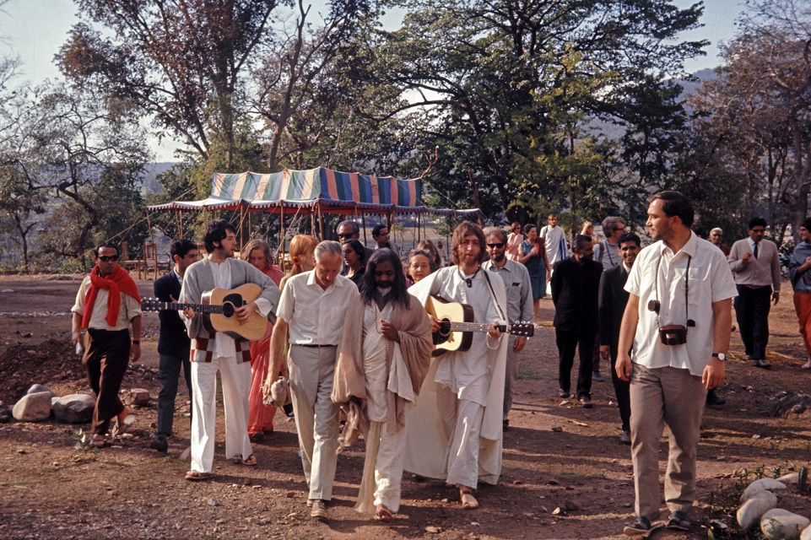
(Credit: Colin Harrison Avico Ltd)

For all media enquiries contact warren@chuffmedia.com on 07762 130510

