ANNOUNCES NEW ALBUM ‘THE THEORY OF WHATEVER’

FIRST SINGLE ‘THE OLD STYLE RAIDERS’ OUT NOW

FIFTH STUDIO ALBUM WILL BE RELEASED JULY 29TH ON POLYDOR RECORDS

PLAYS LONDON’S SUBTERANIA ON 11TH MAY

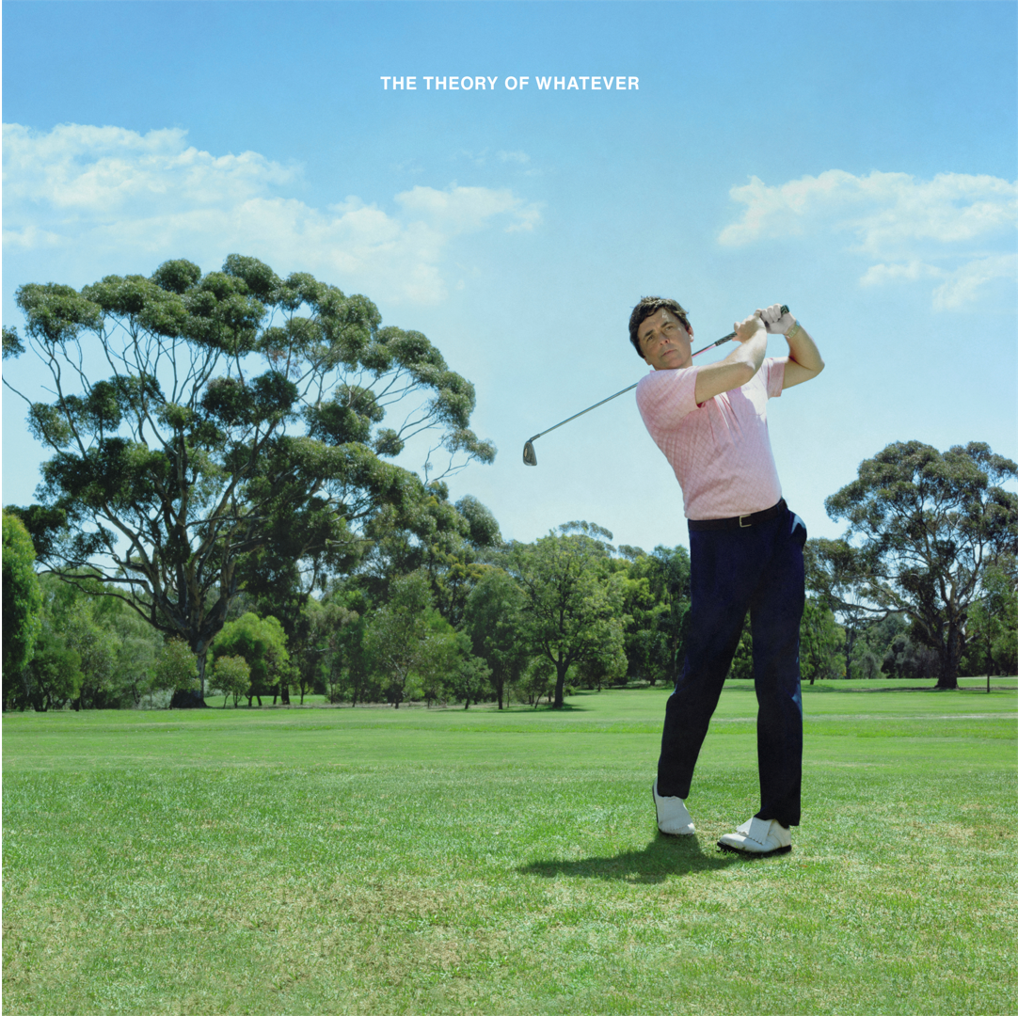
Listen to ‘The Old Style Raiders’ HERE
Watch the video HERE

Jamie T has announced details of his forthcoming new album ‘The Theory of Whatever’ and first single ‘The Old Style Raiders’ which launches today (May 4th) as Hottest Record In The World on Radio 1, alongside a video directed by Niall Trask. The singer songwriter’s fifth studio album will be released on July 29th on Polydor Records. It follows the 15-year Anniversary celebrations of ‘Panic Prevention’, Jamie T’s seminal debut album which went platinum this year.

The announcement includes details of Jamie T’s first live show in 5 years. Fans who pre-order ‘The Theory of Whatever’ from Jamie T’s official store (https://jamiet.lnk.to/officialstorepr) by 17:00 5th May can purchase tickets for an intimate show at Subterania in London on 11th May.
South Londoner Jamie T – born Jamie Treays - had some 180 songs written in the five-and-half-years since the release of 2016’s Trick. “I was struggling to find my direction with the record for a few years, really,” he admits. Bunkered in his East London home studio, he wrote and rewrote, playing all the guitar and keyboard parts himself.
“I went home one day, and I found this track that I had recorded, pretty much fully finished. And I was really upset, because I realised that I'd spent the last six months asking other people to tell me if something was good. Then I heard this track and I just immediately knew I'd kind of found my path.”
That song is ‘The Old Style Raiders’, a lean, taut indie-rock anthem with a heads-thrown-back chorus you can hang your hat on (“toe the line! / Hard to find! / Told to fight for something you love in life…”). “It's got hope in it,” answers Treays when asked what makes ‘The Old Style Raiders’ his album’s opening statement. “It's fighting to find something that means enough to you that you love. The fight to find that, and to carry on striving, to find something you love enough to hold on to.
“Rather than kid love or movie love or, gushy love or lust love, whatever you have when you're younger – it’s actually trying to fight for something that means more than that. It's the struggle to find that.”
Produced by Hugo White, the song was a pathfinder, a direction forward for a boundlessly productive artist who will freely admit that, for a minute there, he lost his way creatively. From there, he drilled down and focused on 13 vital, pin-sharp, melody-rich, spikily provocative, visually vivid and narratively expansive tunes that make up ‘The Theory of Whatever’.
Jamie T has been away, and done a lot, but now he’s back. And he has a lot to say.
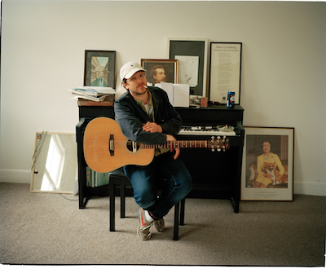

Lead press photo (Credit Will Robson-Scott) HERE
Album Artwork HERE

For more information and press enquiries please contact

Jenny Entwistle
Jenny@chuffmedia.com

