NATHAN CONNOLLY
'The Strange Order Of Things'
Debut Solo Album Released On April 21st

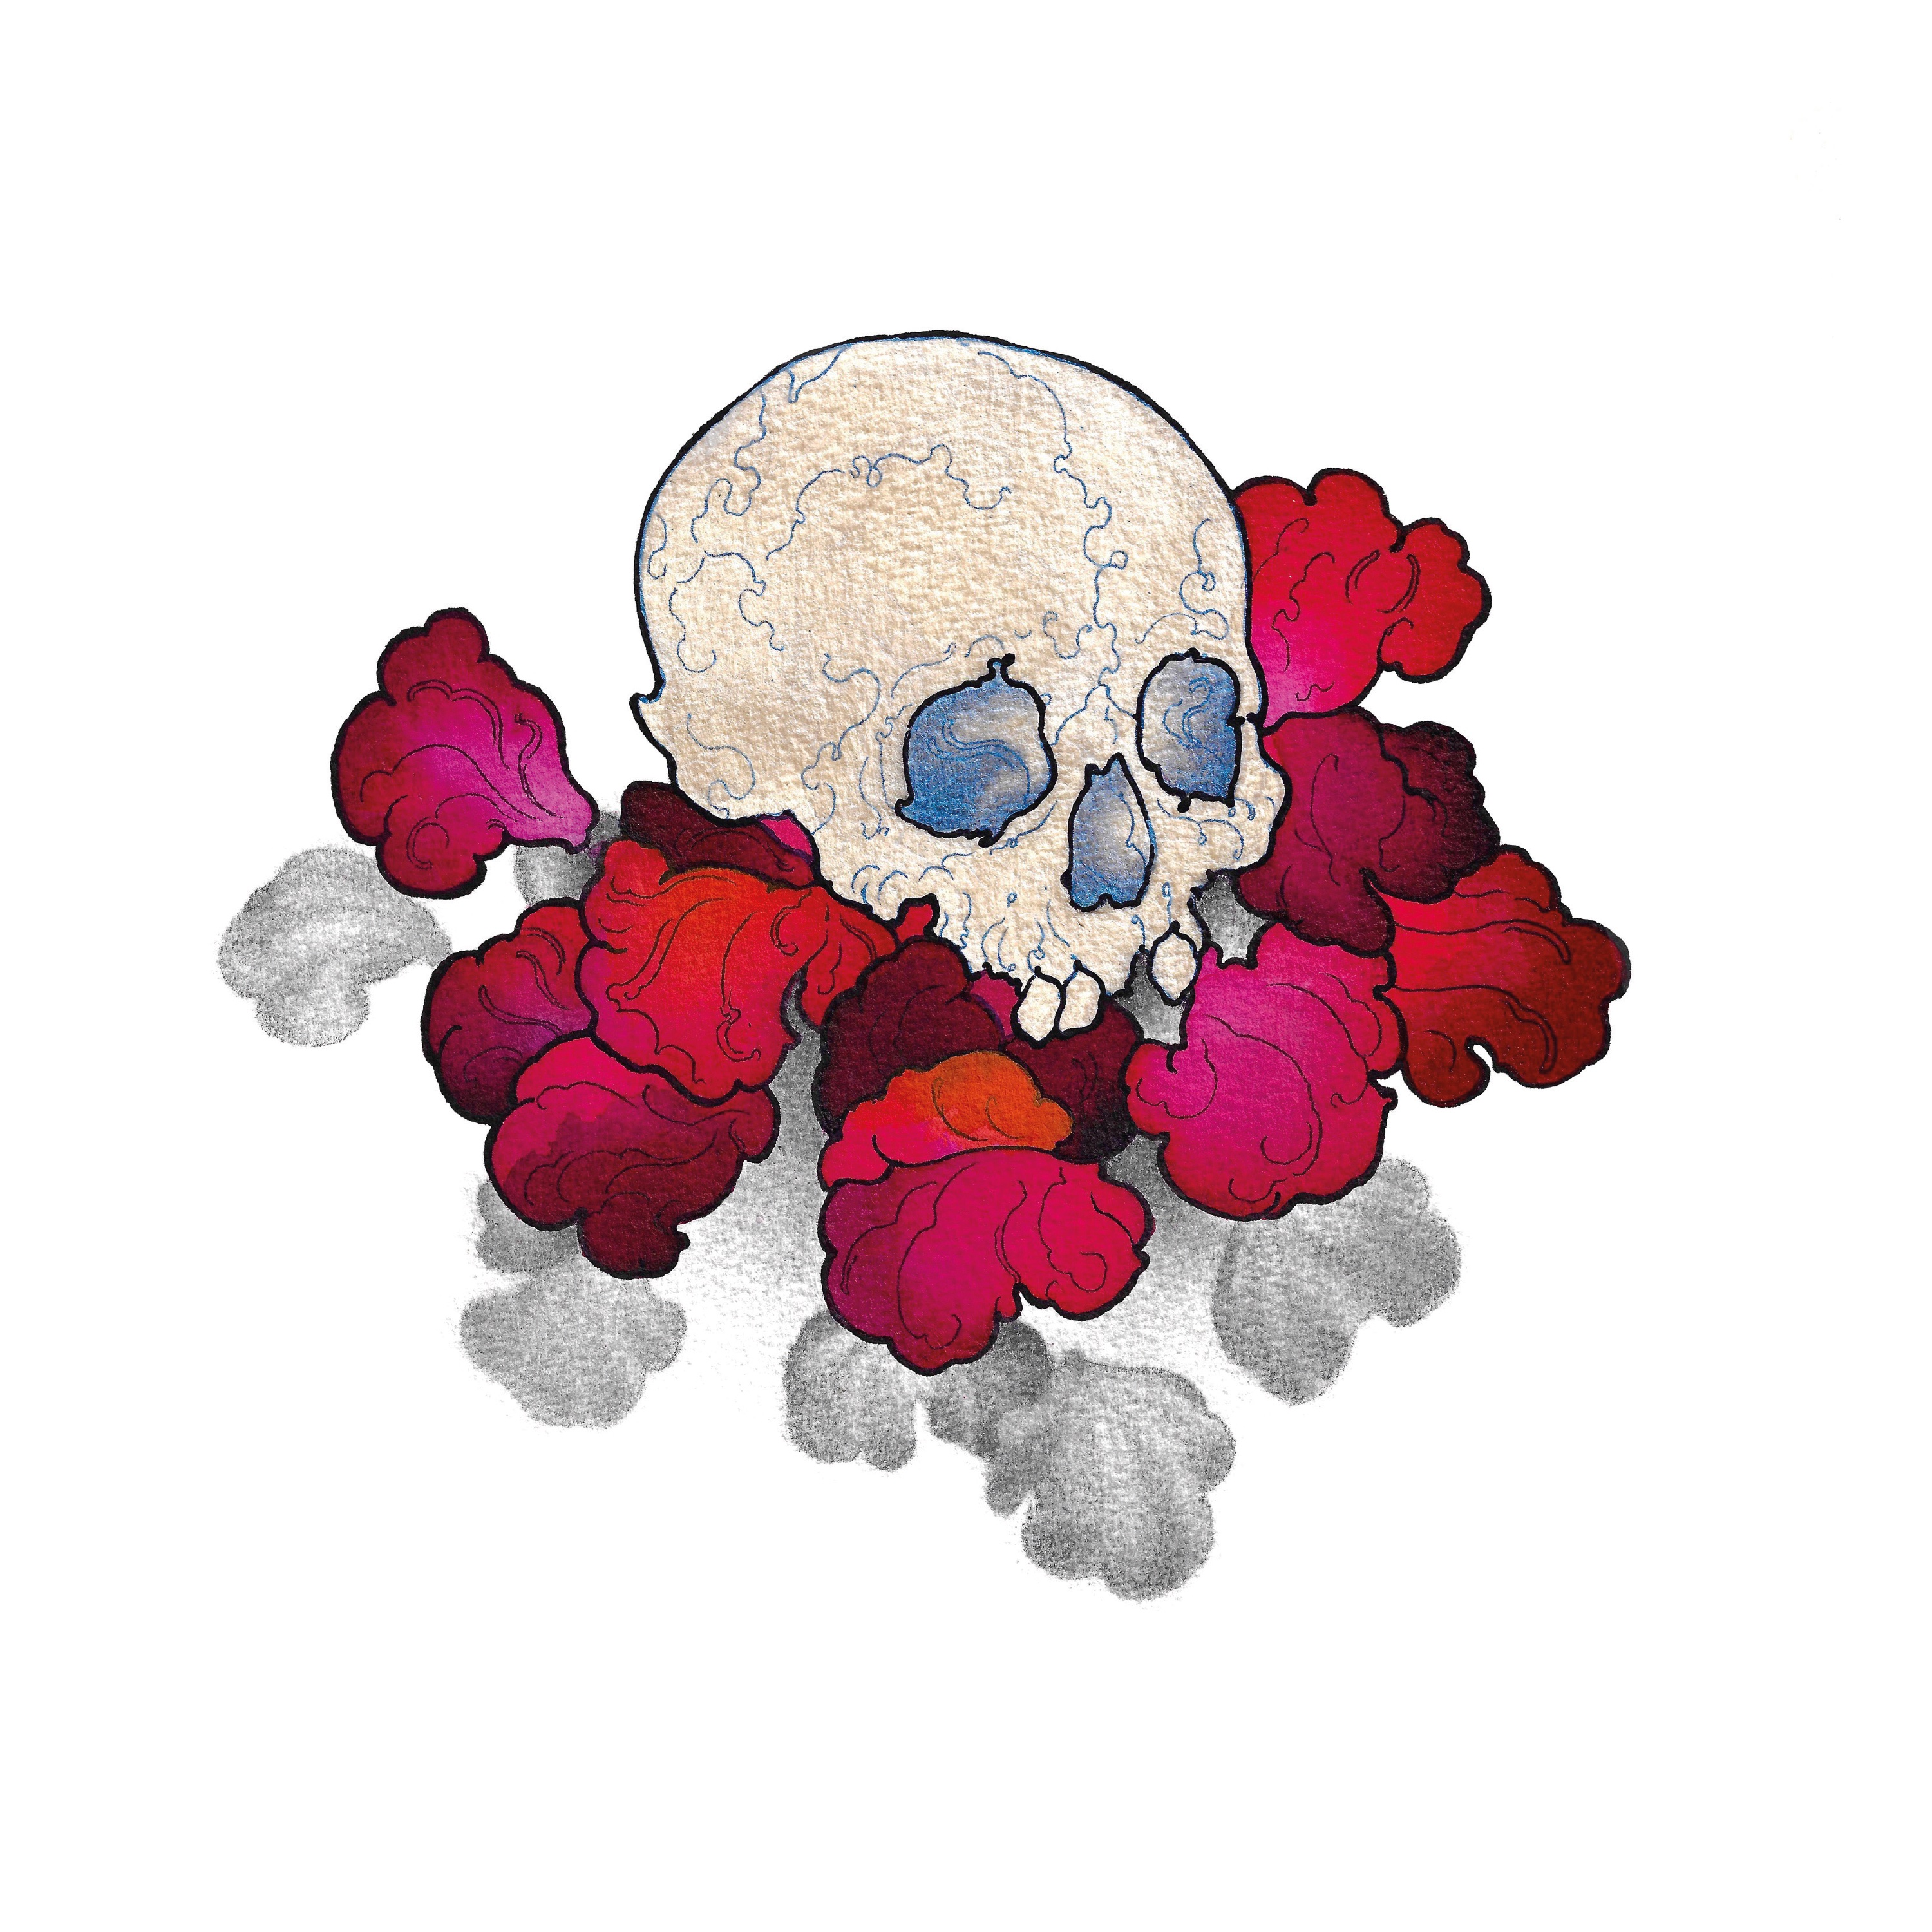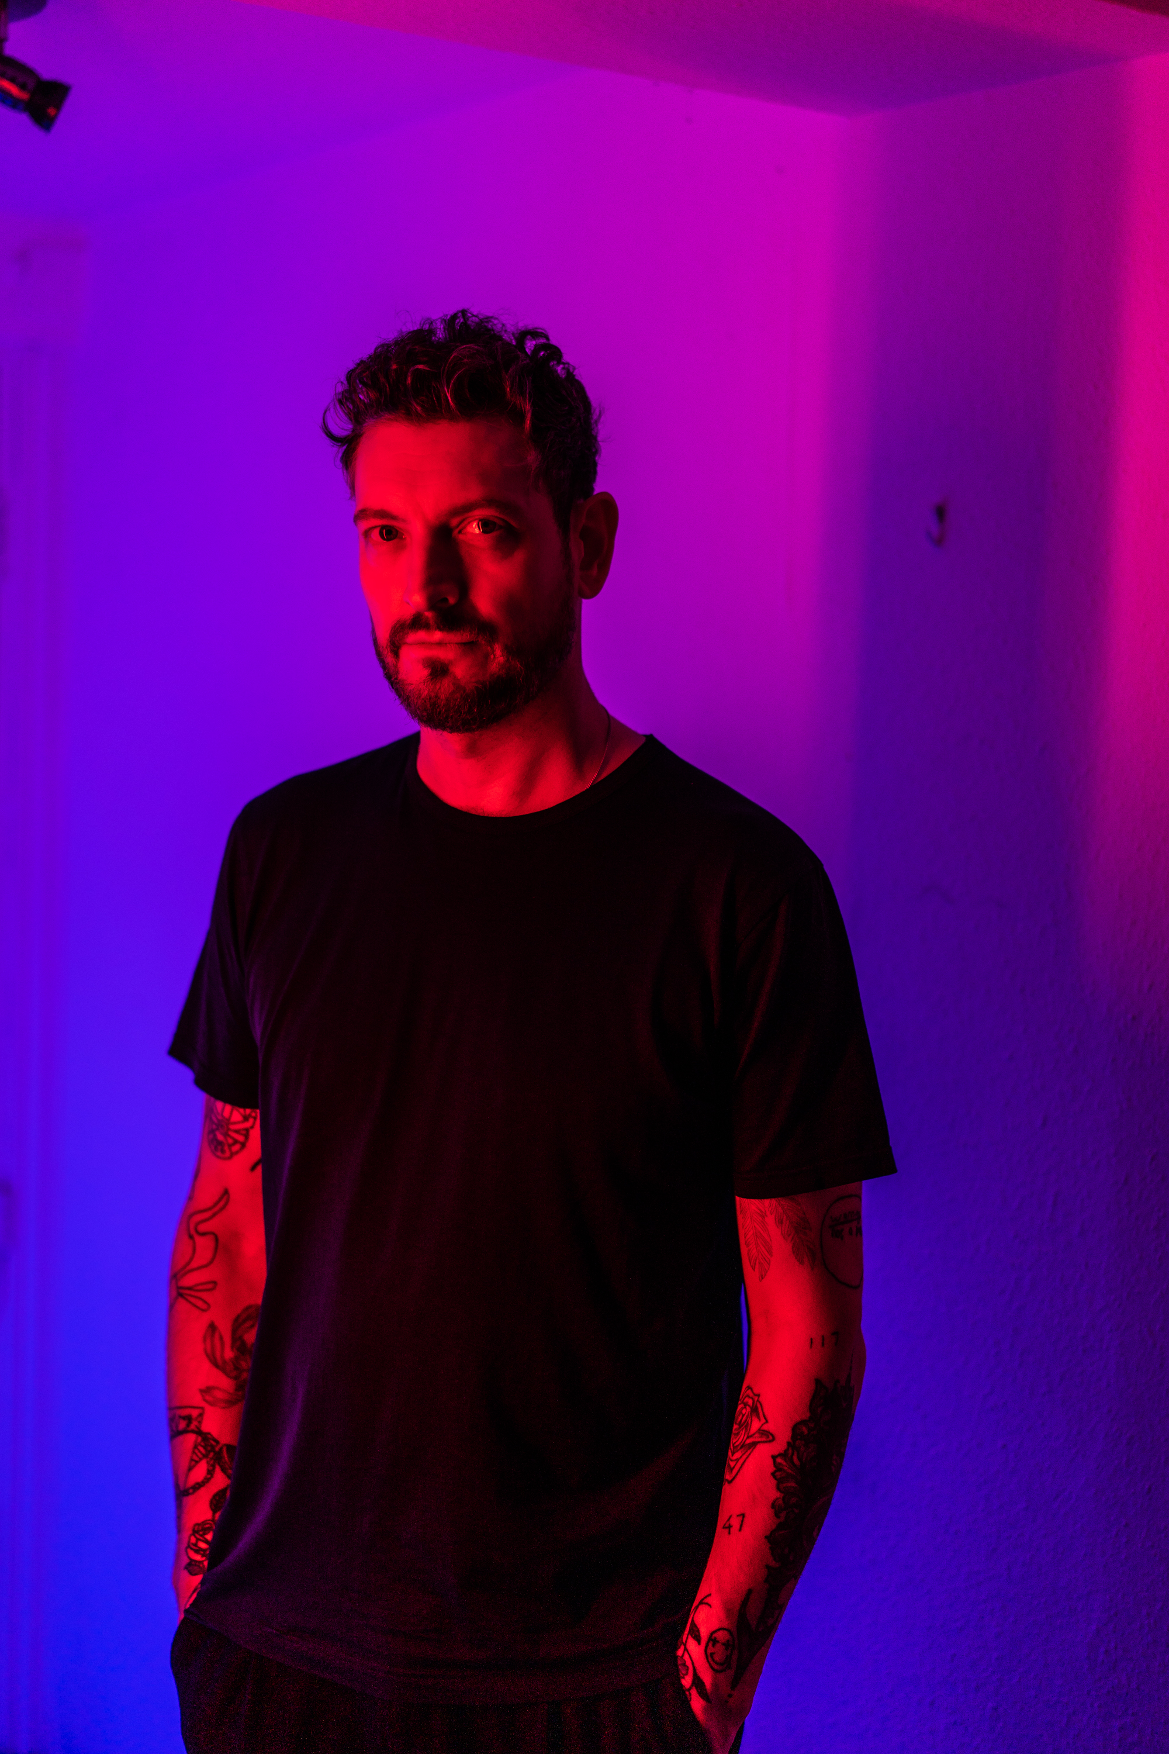

Nathan Connolly has been the guitarist with acclaimed Northern Irish rock band Snow Patrol since 2002. Since then, they have gone on to sell 17 million albums, headline festivals, achieve five UK platinum albums, an Ivor Novello award and Grammy and Mercury Music Prize nominations.

In 2013, Connolly founded Little Matador with drummer Paul 'Binzer' Brennan, bassist Gavin Fox and guitarists Troy Stewart and Dave Magee. They released their self-titled album the following year, produced by Sam Bell in London's Metropolis Studios.

Connolly began working on a solo album with producer Rocky O'Reilly in Belfast in 2017. A lockdown-imposed hiatus from Snow Patrol touring allowed him to finish the project in early 2021. "Although the album is not about home," says Connolly, "I felt compelled to make it there."

Connolly's debut solo album, 'The Strange Order Of Things' features vocals from Simon Neil of Biffy Clyro, and Irish artist Ailbhe Reddy. Long-time collaborators Dave and Herb Magee (LaFaro, Little Matador, Arvo Party), Stephen Leacock (General Fiasco) and Gavin Fox (Turn, Idlewild, Little Matador) provide a backdrop of guitars and drums on the ten-track album.

"I have known Simon Neil since back in my early days with Snow Patrol. The first show I remember playing together was a Zane Lowe MTV Gonzo show in Glasgow in 2003. Over the years we occasionally mentioned doing something together at some point. Finally, the opportunity came in the form of 'Fires'. He is extraordinary and came at the song from somewhere I don’t think I would or could have," says Connolly. "'Fires' was also co-written by Dave Magee. As was 'Love Like Wildfire'. Without Dave's seemingly effortless gift for the riff there would be no 'Fires'."

"I always had the idea that 'Ghost' could possibly be a duet but I was struggling to emotionally connect with it until Ailbhe Reddy did her thing on it. I was listening to Ailbhe’s record 'Between Your Teeth' at the time and loved her voice. I thought I would reach out to her and invite her to be part of it and wonderfully she said yes. She completed the track for me."

Connolly describes the album as "trying to understand, make sense and work through events that have led to who I am now: heartache, regret, emotional cost, fatherhood".

Nathan Connolly's album, 'The Strange Order of Things' will be released on April 21st, with pre-order available now. Live show schedule to be announced.

For all media enquiries please contact Warren@chuffmedia.com on 07762 130510

