ART SCHOOL GIRLFRIEND
ANNOUNCES SECOND ALBUM SOFT LANDING
OUT AUGUST 4 VIA FICTION

RELEASES NEW TRACK “CLOSE TO THE CLOUDS”

SOLD OUT SHOWCASE AT THIRD MAN RECORDS, LONDON ON MARCH 30
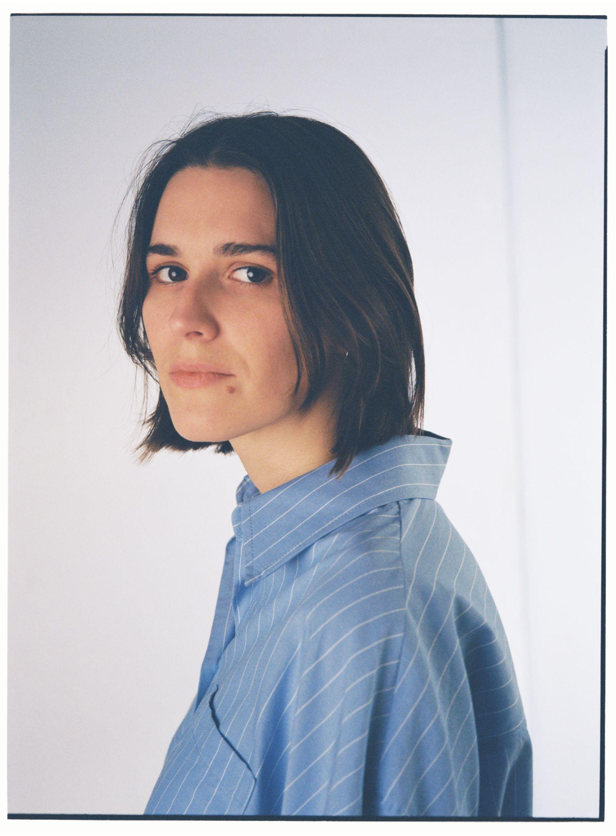
(download hi-res here, please credit Isak Berglund)

Today, Art School Girlfriend, Aka Polly Mackey, has announced that her forthcoming second album Soft Landing, is set to be released via Fiction Records on August 4, 2023. The album is self-described as a series of “small euphorias”, it is an album that finds Mackey shifting her sound towards tactile electronics whilst retaining the floating melodies of her debut.

Listen

With the announcement, Mackey has released one of her strongest tracks to date, titled “Close To The Clouds”. The song is an integral part of Soft Landing, with the central refrain providing the album with its title, and the song unfurling into climbing, arpeggiated synths amidst acid-house indebted drums. The track premiered this morning on BBC Radio 6 courtesy of Lauren Laverne.

Going deeper on the track, Mackey says, “Close To The Clouds is about looking back on my twenties with some kind of wistful hindsight. I wanted it to embody the energy of the music I spent a lot of my teenage years and early twenties listening to. It’s about reflecting on the winding path to contentment, having finally figured out how to find it.

“The album title Soft Landing is taken from these lyrics, and this track represents a lot of the record’s themes: reflection, joy, coming of age.”

Soft Landing follows Mackey’s 2020 debut album, Is It Light Where You Are? an album made in the wake of a tumultuous time and released during one. Soft Landing feels like Mackey’s true debut, a record of curiosity and playfulness with songs that sound like they are falling effortlessly into place. Stay tuned for more news

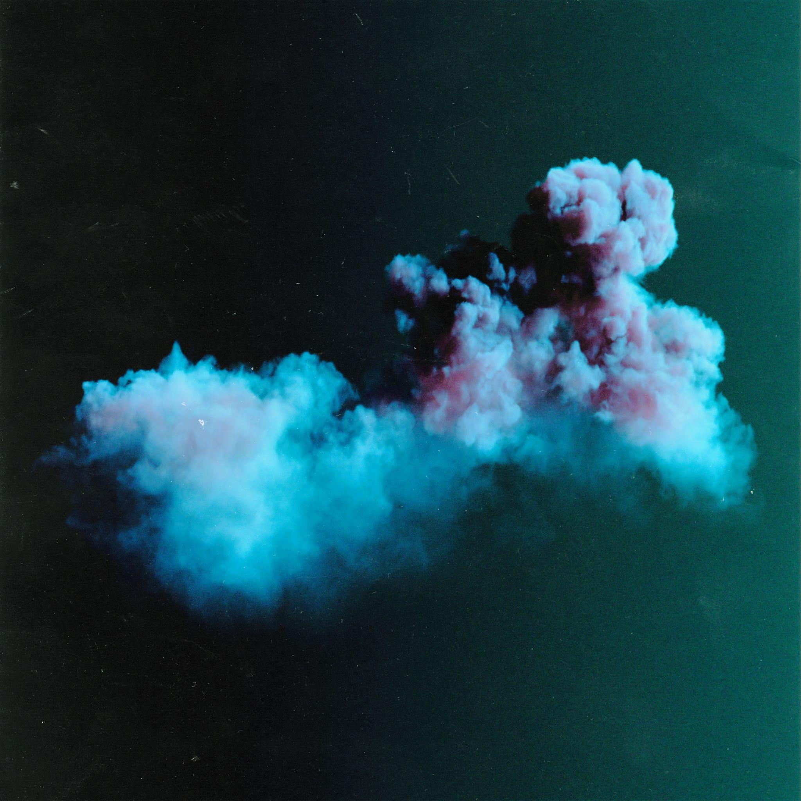
Tracklist
- A Place To Lie
- Close To The Clouds
- Real Life
- Waves
- Blue Sky feat. Tony Njoku
- The Weeks
- Laugh My Head Off
- Out There
- Heaven Hanging Low
- How Do You Do It
- Too Bright
When Polly Mackey – AKA Art School Girlfriend – released her first album Is It Light Where You Are in 2021, what was a shimmering debut felt to her more like a sublime denouement. The Welsh producer and multi-instrumentalist’s record revelled in expansive dreamscape sounds and diaristic writing that stretched deep into the emotional peripheries of a then very recent heartbreak. A protracted two years later, Polly was able to tour the record – then, embarking on a new relationship, and reconsidering her creative mode. While the album garnered critical celebration for its visceral aural textures and lucid themes, for Polly, it was inflected with alienation. “By the time it was out in the world, I felt unattached to it,” she shares. “This new record truly feels like my debut.”

Soft Landing is the culmination of Art School Girlfriend’s contemporary artistic testament. It represents a tonal shift and tenure in a much more contented and philosophical state of being. The title presented itself to her through the frequency illusion: a turn of phrase thrown up in overheard conversation, and mentioned on the news. “‘Soft landing’ showed up to strike me when things were falling into place,” Polly says. “I was at that typical moment where you’re leaving your 20s and realising you don’t have to work toward this concept of future happiness. Going to the pub with your mates can be the ultimate. Lying beside the person you love, watching the sun come in, can be it.”

This album percolates in these “small euphorias”; elations of life you don’t have to reach far for. “It captures what a lot of people coming out of COVID have felt, looking for joy closer to home, in your immediate surroundings,” Polly says. “I am much more interested in capturing a time and feeling, than getting it perfectly right.” Polly decided in April 2022 that she’d have a record by the end of summer: she booked in sessions and mixing before she started, and wrote a creative manifesto. “I really wanted to commit to a new energy,” she says. “Before, I was so worried about fixing things as I went along. That doesn’t allow for being instinctive, or staying true to how I feel in the moment. I wanted this to feel pure, energetic, instant.”

The manifesto for Soft Landing outlined a divergent style for recording and decision-making. It meant resisting the “infinite space” of the first album, which led to agonising re-records and rewrites. Plug-ins and perfectly programmed drums were shirked for instrumental improvisation, tape machines and effects performed live, and stream of consciousness writing. "How Do You Do It..." was totally improvised, played on a keyboard and sung into a tape machine in Polly’s bedroom. "It’s very different from how I worked previously. I’d have spent the year trying to find the right snare,” she says. It’s about being more curious, playful, and “getting back to the reason I started making music as a kid in my bedroom”.

The sonic palette combines Polly’s more leftfield, lo-fi electronic influences (that you’ll hear resplendent on her ambient Foundation FM radio show) with the music that first inspired her, like Pixies, early Caribou, and Warpaint: artists with electrifying energy that elegantly oscillate from electronic to instrument. “Out There” – an homage to LCD Soundsystem’s “All My Friends”, written the day after she saw them live last summer in Brixton – propels itself with the dark atmospherics of Burial, and “Heaven Hanging Low” has the sun-breaking-through-the-clouds clarity of a trance anthem. “Waves” undulates with the sinewy avant-rock turns of PJ Harvey.
Most of the album was recorded at home, the rest at Crouch End’s Church Studios with friend and co-producer Riley MacIntyre, where Polly has recorded since 2016. Six of 11 tracks were written within two weeks, after she wrote “A Place To Lie”. “One track will pin the butterfly of what the record is going to be,” she says. “‘A Place To Lie’ was that. Everything flowed through it.” The track reflects Polly’s technical skills and a prowess for creating processed sounding sonics by organic means: “I didn’t want to look at a computer much.” Synths are replaced by manipulated nylon string guitars; live drums, guitars, and strings are played throughout the record; “Real Life” features birdsong and church bells from a memorable camping trip. Throughout, Polly deftly traces dance music’s spinal nodules, its crescendos and euphoria sweeps, and the shoegaze influence of her youth with gauzy, pensive tendrils of drones.

The sound design parallels deeply poetic and visual lyrics, a skill that was lauded on her previous record and EPs. “I tell people this is my joyful album, and they laugh – it still feels pretty fucking moody,” she says. “I like the light and shade, the joy can’t come without the melancholic – the queer trope of crying on the dancefloor.” Simple concepts and experiences are made sumptuous: “A Place To Lie” swells with the contentedness of waking up next to a lover, while “The Weeks” takes place in the summer lockdown at her girlfriend’s parent’s house in Devon, delicately threading the undercurrent of worldwide threat with the lush, hushed local surroundings. Folk and shoegaze arise again in lyrics with hazy, yet precise finality – ”I understand, I understand”, a willowy alto refrain on “Close to the Clouds”.

With crystallised focus, Polly’s favourite place has become the studio. In 2020, she scored for friend and visual collaborator Tom Dream’s film Shy Radicals. “In the last few years I’ve seen some changes for women in the studio space. I’m now engineering for myself and others,” she says. Polly intends to experiment beyond her ASG moniker, by producing for people outside of genres she works within, playing in bands again, finishing her Creative Practice MA, and scoring more films.

The words of poet Lucien Stryk, describing the work of Japanese haiku master Basho, resonate deeply with Polly and the record’s themes: “The poet presents an observation of a natural, often commonplace event, in plainest diction, without verbal trickery. The effect is one of spareness, yet the reader is aware of a microcosm related to transcendental unity. A moment, crystallised, distilled, snatched from time’s flow, and that is enough.”

An artist that once made music from the serrated edges of her wounds, Art School Girlfriend now sutures them with her small, intimate joys: Soft Landing yields soft power. “I had such a nice time making the record,” Polly says. “I’m at the age now that I know it doesn’t have to be loved or heard by everyone. I just want someone out there to find their personal euphorias with it.”

Follow Art School Girlfriend for more news
Instagram // Twitter // Facebook

ASSETS
For more on info contact warren@chuffmedia.com & jenny@chuffmedia.com

