RENEÉ RAPP DROPS SOARING BALLAD ‘SNOW ANGEL’
FIRST SINGLE FROM FORTHCOMING DEBUT ALBUM OUT 18TH AUGUST 2023

LISTEN HERE

HUGE UK TOUR ANNOUNCED FOR 2024

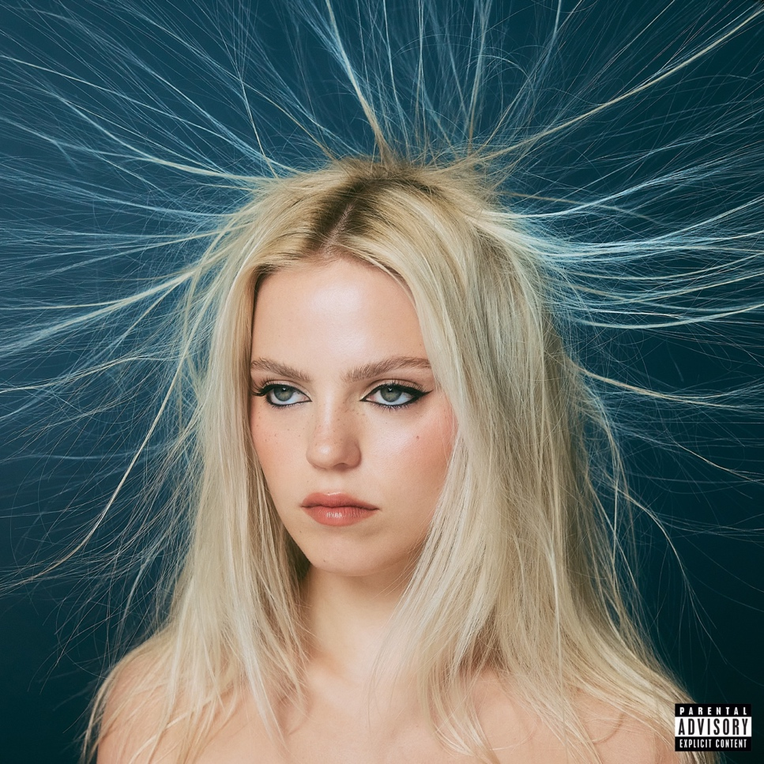

Acclaimed singer-songwriter Reneé Rapp kicks off her new era of music with the stunning song ‘Snow Angel’, the first single from her forthcoming debut album of the same name. Snow Angel the album will release on 18th August, with the evocative ballad serving as the lead single. ‘Snow Angel’ the song captures Rapp’s poignant ability to spin painful memories into songs meant to soundtrack her journey toward inner strength — the thread that holds her impressive discography together.
A delicately played piano immediately draws listeners in and lays the foundation for Rapp’s gripping vocals. “First to arrive, last to leave / What’s misery without company?” she sings in the opening verse, describing the difficulty in keeping up appearances when she’s hurting internally. “I’ll make it through the winter if it kills me / I can make it faster if I hurry / An angel in the snow until I’m worthy / But if it kills me, I tried.” Rapp’s vulnerable admissions are punctuated by swelling instrumentals as the song progresses. Finally, the track reaches an impressive crescendo mimicking the contrast of emotional highs and lows via musical composition.
‘Snow Angel’ was produced with Alexander 23 (Olivia Rodrigo, Tate McRae), who also helmed much of Rapp's forthcoming album. As the first single from the debut project, ‘Snow Angel’ showcases Rapp’s growth as a songwriter as she continues to round out her already-multidimensional artistry. Alexander 23 and Rapp first developed their undeniable rapport during their collaboration on ‘Bruises,’ a track similarly centered on the cost of putting on a brave face for everyone else’s benefit.
‘Bruises’ arrived in February on the deluxe edition of Rapp’s debut EP, Everything To Everyone — the culmination of a breakout 2022 that included selling out all of her headlining shows, netting over 200 million global streams, and earning MTV Global PUSH Artist honours. Rapp is in position to finish this year even stronger as she gears up to make her film-acting debut in Paramount+’s Mean Girls Musical (produced by Tina Fey and Lorne Michaels). The latter will find her reprising her Broadway role of Regina George.
While Rapp has made people fall in love with her characters for years, she’s ready to share a more vulnerable side of herself in her music. She’s an artist who unabashedly speaks her truth in all her songs, whether it’s through emotional ballads or infectious pop hits. ‘Snow Angel’ does exactly what you would expect from a title track: provide a window into Rapp’s most personal body of work yet.

UK TOUR DATES
On sale now via reneerapp.com/tour

23-Feb-24 Manchester O2 Apollo

25-Feb-24 Glasgow O2 Academy

28-Feb-24 Birmingham O2 Academy

1-Mar-24 London Eventim Apollo

ABOUT RENEÉ RAPP:

Reneé Rapp knew she was born to perform ever since she was a child. Even in her earliest memories, her love of music was always present. “I couldn't sit still in the car unless there was music,” she says. “Otherwise, I would cry the entire time.” The North Carolina native began harnessing her natural creativity by writing and recording songs when she was just a teenager. Eventually, her career took off when she landed the coveted role of Regina George in the Tony-nominated Mean Girls musical on Broadway. Shortly after, she found widespread recognition and praise—from the likes of W, Harper’s Bazaar, and The Hollywood Reporter for her performance as Leighton on the HBO Max/ ITV series The Sex Lives of College Girls written by Mindy Kaling. Rapp then turned her attention back to music, sharing her threadbare insecurities on debut single ‘Tattoos.’ Since then, her songs have caught on like wildfire with listeners. The multi-hyphenate's entire debut headline US tour sold out in a matter of minutes, her inspiring single ‘Too Well’ has impacted the Top 40, and her discography has amassed over 200 million streams and counting. Not only that, she will be reprising the role of Regina George in the forthcoming Paramount+ feature adaptation of the Broadway musical Mean Girls. Rapp's 2022 debut EP Everything to Everyone, as well as its deluxe edition, firmly established her pop-staying power, while her forthcoming debut LP, Snow Angel, is primed to fully showcase the hitmaker's vulnerable approach to songwriting and stunning vocal range.

INSTAGRAM | TIKTOK | TWITTER

For more information and press enquiries please contact

Jenny Entwistle
Jenny@chuffmedia.com

