PALACE
ANNOUNCE NEW ALBUM ‘SHOALS’ OUT JANUARY 21ST VIA FICTION
RELEASE NEW SINGLE ‘LOVER (DON’T LET ME DOWN)’
2022 UK TOUR - PLAY O2 ACADEMY BRIXTON FEBRUARY 11TH

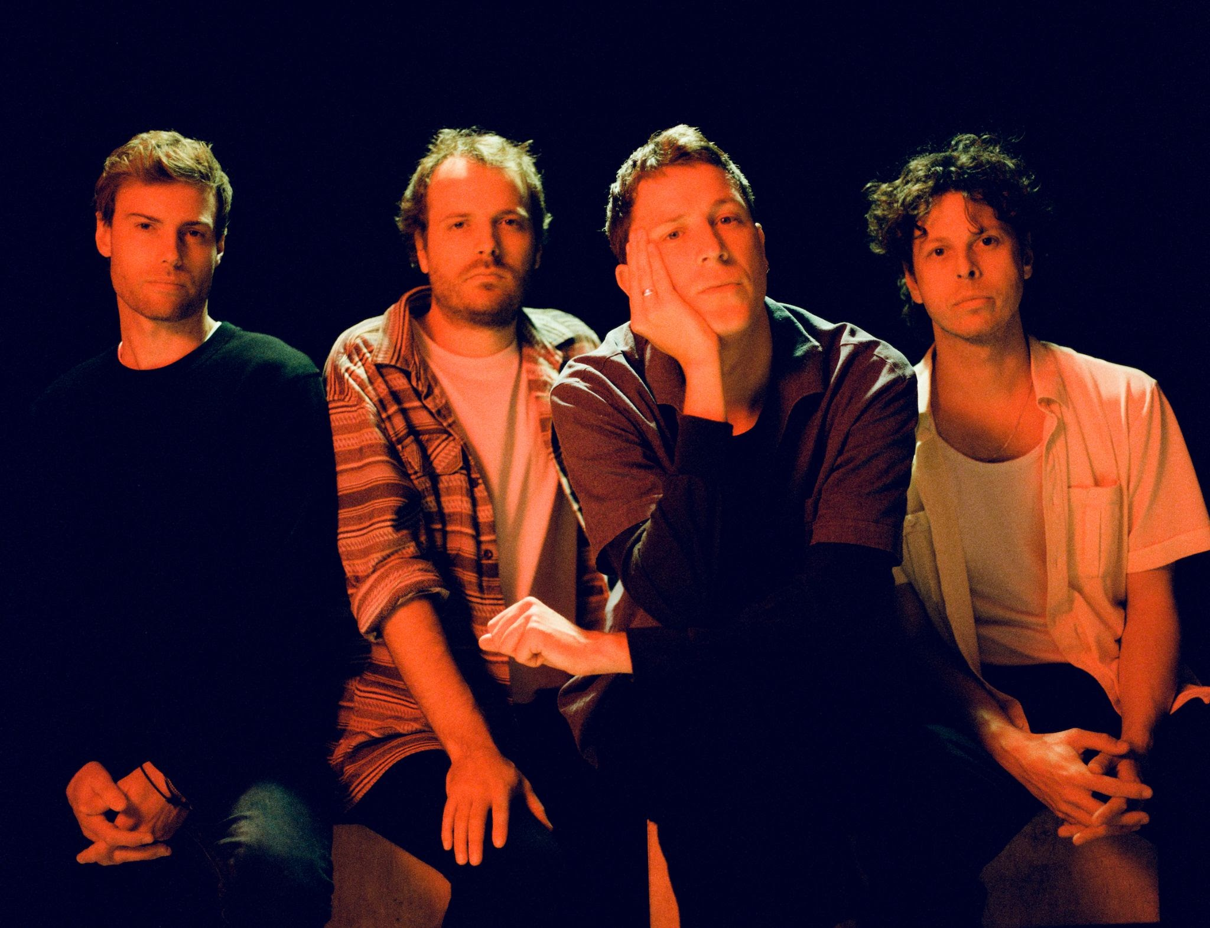
Credit: Daniel Harris

London-based Palace have announced their third album ‘Shoals’, due for release on January 21st via Fiction. The album announcement is accompanied by a new single and video ‘Lover (Don’t Let Me Down)’. The band will also play their biggest UK, European and US tours to date next spring, including a date at the O2 Academy Brixton on February 11th.

WATCH THE OFFICIAL VIDEO FOR ‘LOVER (DON’T LET ME DOWN)’ HERE

‘Shoals’ is a profound and pensive album, boldly exploring some of life’s greatest questions over its 12 mesmerising tracks. The album deftly explores the interplay of three central existential dilemmas against a broader backdrop of wonder at the vastness and power of the ocean, concluding its arc with the stunning opus ‘Where Sky Becomes Sea’. Through diving into themes of the subconscious, dreams and existentialism, ‘Shoals’ is broadly a record about living with and processing fear. As frontman Leo Wyndham explains:

“‘Shoals’ is a record about confronting our own fears and anxieties. Through the pandemic we were confronted more than ever with ourselves with little distraction, suddenly seeing who we are in the rawest of forms. It held a mirror up to our flaws and imperfections and forced us to see the real 'us'.

The record symbolises how our minds can have beautiful yet dangerous depths, like the ocean, and how our fears and thoughts are like shoals of fish that move and shift constantly from place to place; chaotic, often untameable and unpredictable.”

2019’s sophomore album ‘Life After’ is a stunning record with a clear message; hope. Its eleven tracks, that include the heart-wrenching ‘Heaven Up There’, are full of the melodic warmth and rich textures that have come to define Palace’s sound. It is an album in equal parts about loss as well as a manual to moving on, stronger than before.

Having built a dedicated live following through mesmerising shows at some of the country’s finest venues, Palace played some of the world’s biggest festivals in 2019 including main stage slots at Mad Cool, Latitude and Glastonbury’s Park Stage before an autumn tour culminating at their biggest show ever at a sold-out Camden Roundhouse. The band kicked off 2020 by selling out their debut USA tour ahead of returning to the studio to start work on their third album. With a host of new 2022 tour dates confirmed and an incredible 1.4 million monthly listeners on Spotify, Palace are set to continue their enviable trajectory upwards through the best venues the world over. See below for the full list of new tour dates.

Leo Wyndham, Matt Hodges and Rupert Turner released their acclaimed debut EP ‘Lost In The Night’ in 2014, followed by the ‘Chase The Light’ EP the following year, their debut album ‘So Long Forever’ in 2016 and sophomore album ‘Life After’ in 2019.

PRE ORDER / PRE-SAVE ‘SHOALS’ HERE

‘Shoals’ Tracklisting
1. Never Said It Was Easy
2. Shame On You
3. Fade
4. Gravity
5. Give Me The Rain
6. Friends Forever
7. Killer Whale
8. Lover (Don’t Let Me Down)
9. Sleeper
10. Salt
11. Shoals
12. Where Sky Becomes Sea

UK & IRELAND TOUR 2022
February 3rd, Glasgow, SWG3
February 4th, Manchester, O2 Ritz
February 5th, Bristol, O2 Academy
February 6th, Leeds, University Stylus
February 8th, Dublin, Vicar St
February 10th, Nottingham, Rock City
February 11th, London, O2 Academy Brixton

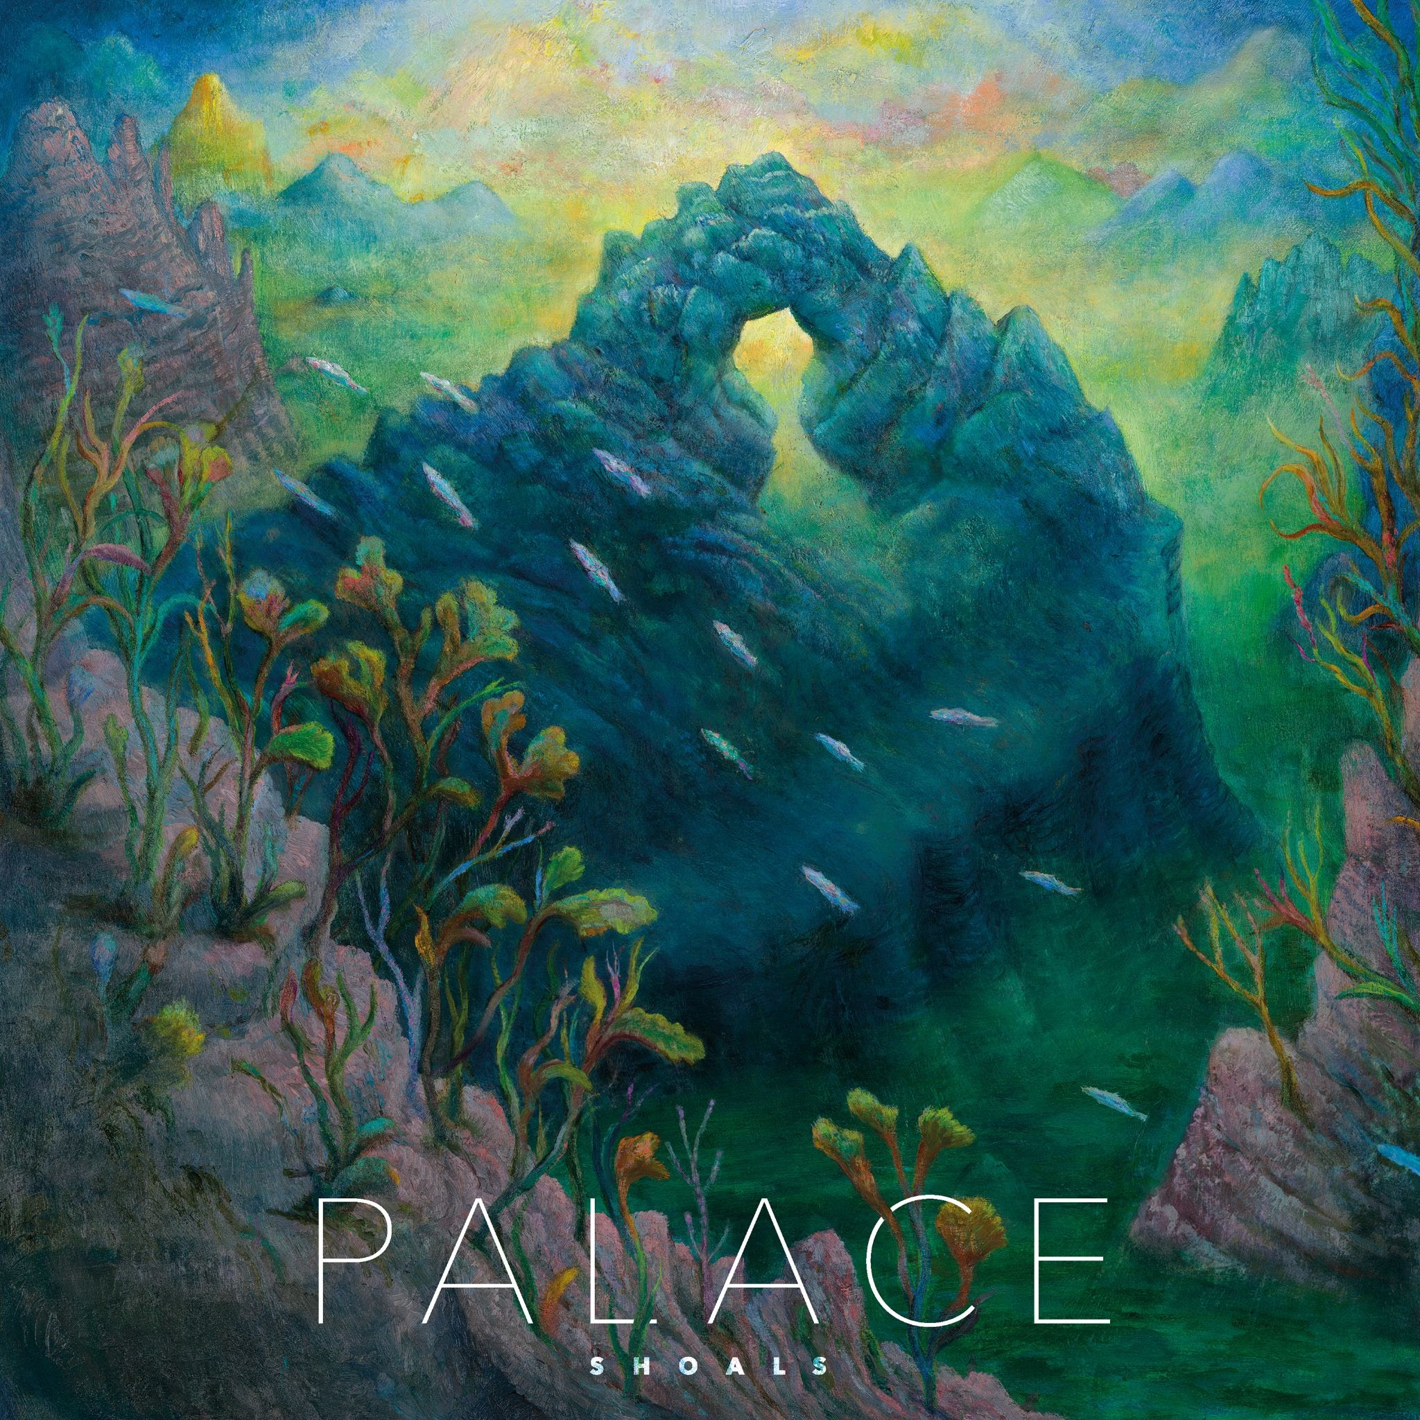
‘Shoals’ artwork

Instagram | Facebook | Twitter | Website

For more information & media enquiries, please contact Warren
warren@chuffmedia.com

