CELESTE ANNOUNCES NEW ALBUM WOMAN OF FACES
SET FOR RELEASE OCTOBER 2025
NEW SINGLE ‘ON WITH THE SHOW’ OUT NOW
LISTEN HERE
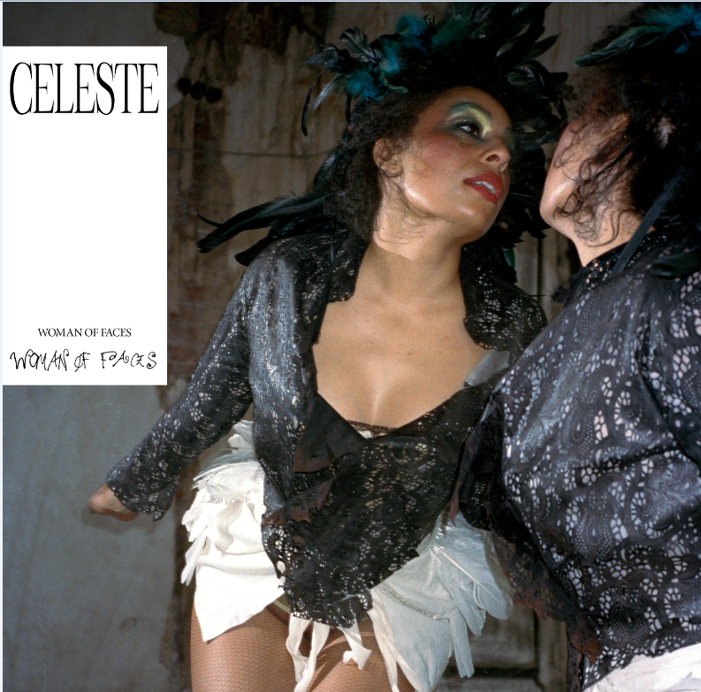
DOWNLOAD ALBUM ARTWORK
PRE-ORDER WOMAN OF FACES HERE
CELESTE has announced details of her new album Woman Of Faces which is scheduled for release in October on Polydor Records. Celeste’s highly anticipated second studio album features nine tracks including new single ‘On With The Show’, which is released today. Woman Of Faces was produced by multi-GRAMMY® award winner Jeff Bhasker. The news follows Celeste’s recent shows at London’s KOKO and LIDO Festival as she readies herself for her performance on the Pyramid Stage at Glastonbury on June 29th.

New single ‘On With The Show’ is an expansive, cinematic ballad that reckons with the battle to put on a brave face and push through anguish. Written with frequent collaborator Matt Maltese in 2022, it was the first song Celeste made specifically for the album. “I was very much in the moment of experiencing feelings of loss and needing to carry on, almost like an exaggerated hero’s journey,” she says. “This feeling of needing to trudge on through heavier feelings, knowing you have another purpose that’s attached to something bigger than yourself, so you willingly go towards it and sacrifice your sense of wellbeing.”

Stemming from the slow unravelling of a romantic relationship, and her determination to emerge from the other side triumphant, Woman Of Faces is a body of work born out of pain, but also a steadfast resilience to keep moving forward, even when everything else felt like it was falling apart. From the orchestral highs to the gut-wrenching lows, it’s a chronicle of heartbreak, recovery and reclaiming control. Unflinching and unfiltered, it’s the sound of an artist learning to trust herself.

Woman Of Faces features nine tracks, including the previously released single ‘This Is Who I Am’. The full tracklisting is:

1.⁠ ⁠On With The Show
2.⁠ ⁠Keep Smiling
3.⁠ ⁠Woman of Faces
4.⁠ ⁠Happening Again
5.⁠ ⁠Time Will Tell
6.⁠ ⁠People Always Change
7.⁠ ⁠Sometimes
8.⁠ ⁠Could Be Machine
9.⁠ ⁠This Is Who I Am

A lot has happened since Celeste’s spell-binding performance of her breakout song ‘Strange’ at the BRIT Awards placed her firmly in the global spotlight. The British-Jamaican musician, who landed the prestigious double win of both the BRITs Rising Star Award and BBC Music’s Sound of 2020, achieved a No. 1 on the UK charts with her 2021 debut album Not Your Muse. That year also saw her earn a Mercury Prize nomination alongside Academy Award and Golden Globe nominations for ‘Hear My Voice’, her lead single from The Trial of the Chicago 7.

Since then, Celeste has taken a step back from the glare of mainstage spotlights to recalibrate and reconnect with herself, figuring out how to stay true to her vision and sense of authenticity in her work. She made a striking return in November, releasing ‘This Is Who I Am’ and making her acting debut in Steve McQueen’s acclaimed film Blitz. This was followed by the release of the long-awaited track ‘Everyday’, which was initially released on vinyl for Record Store Day 2024.

CELESTE – LIVE DATES:
JUNE 29th PYRAMID STAGE GLASTONBURY FESTIVAL
JULY 4th WERCHTER BOUTIQUE -BELGIUM
JULY 10th MONTREAUX JAZZ FESTIVAL
JULY 12th NORTH SEA JAZZ FESTIVAL – THE NETHERLANDS

DOWNLOAD HERE

CONNECT WITH CELESTE
Instagram / TikTok / X

For all CELESTE inquiries please contact warren@chuffmedia.com

