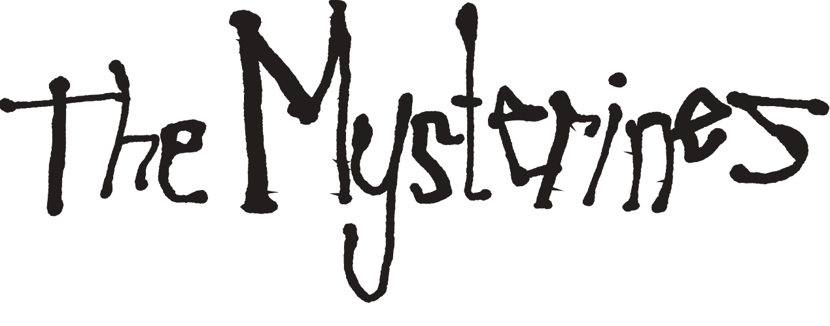
ANNOUNCE NEW ALBUM ‘AFRAID OF TOMORROWS’
OUT ON 7TH JUNE VIA FICTION RECORDS
PRE-ORDER HERE

RELEASE NEW SINGLE ‘STRAY’
LISTEN HERE | WATCH HERE

Photo Credit: Sylas Agtarap (@ShotBySig)
DOWNLOAD HI RES IMAGE HERE

Today, Merseyside alternative rock band The Mysterines announce their new album ‘Afraid of Tomorrows’, the highly-anticipated follow up to their critically-acclaimed Top 10 debut album ‘Reeling’, is set for release on 7th June via Fiction Records. Alongside the announcement, they have shared the lead single ‘Stray’, which premiered on BBC Radio 1 last night as Clara Amfo’s Hottest Record. Listen here and watch the Matilda Harding-Kemp directed video here.

Vocalist and guitarist Lia Metcalfe comments on the track: “Stray focuses on the aimless and untamed nature of the polarities of behaviour that we experience when dealing with suffering. Whether it’s guilt, paranoia or unexplained feelings of grandiosity. Often when the hands of loneliness have a firm grip over one’s eyes it can turn dangers into open doors inviting you in. We find a certain point of no return and we’re often led astray.”

Recorded and produced by Grammy Award winning producer John Congleton (St. Vincent, Angel Olsen) in LA, ‘Afraid of Tomorrows’ is a deeper and darker foray into The Mysterines’ psyche than its predecessor, and reflects the maturity and growth of the band, completed by George Favager (bass), Callum Thompson (guitar) and Paul Crilly (drums). “Afraid of Tomorrows is a mirror where you find you’re nothing more than a formless being, one made from celestial constellations - of traumas, of the old and new, mistakes, addiction, fear and happiness, loneliness, but ultimately a desire for life and the fight to keep living. It’s a collage of what’s been lost and of love unbounded”, says Lia.

The Mysterines have just wrapped up the UK leg touring as main support to Frank Carter & The Rattlesnakes, continuing this week in Europe. The band were also recently announced as special guests to Bloc Party for their huge 20th anniversary Crystal Palace Park show on 7th July, and are set to bring their electric live show to festivals all over Europe and the UK this summer, including Live at Leeds in the Park, 2000 Trees, Truck Festival and Tramlines. More live dates will be announced soon.

The Mysterines - ‘Afraid of Tomorrows’ Album Artwork
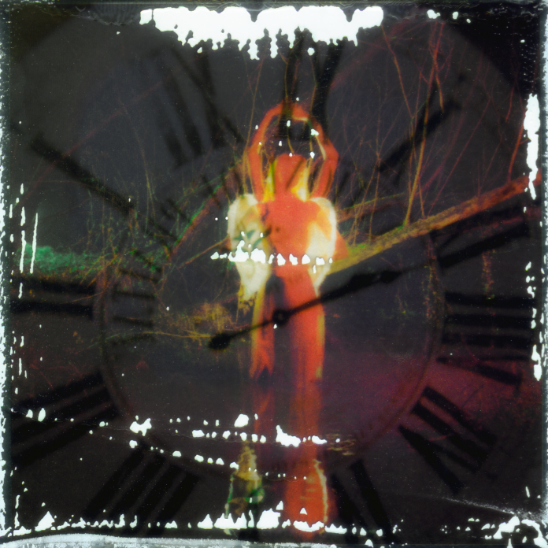
DOWNLOAD HI-RES ARTWORK HERE

The Mysterines - ‘Afraid of Tomorrows’ Track List:

1. The Last Dance
2. Stray
3. Another Another Another
4. Tired Animal
5. Jesse You're A Superstar
6. Hawkmoon
7. Sink Ya Teeth
8. Junkyard Angel
9. Goodbye Sunshine
10. Inside A Matchbox
11. So Long
12. Afraid of Tomorrows

The Mysterines 2024 Live Dates

Supporting Frank Carter & The Rattlesnakes:
22nd Feb - Metropol, Berlin, Germany
23rd Feb - Live Music Hall, Cologne, Germany
24th Feb - Le Bataclan, Paris, France
26th Feb - Ancienne Belgique, Brussels, Belgium
27th Feb - Poppodium, Tilburg, Netherlands

Summer Shows:
10th May - FOCUS Wales 2024, UK
11th May - Are You Listening? Festival, Reading, UK
17th May - London Calling, Amsterdam, Netherlands
24th May - In It Together Festival, Wales, UK
25th May - Live at Leeds in the Park, Leeds, UK
9th Jun - Best Kept Secret, Netherlands
21st Jun - Southside Festival, Germany
23rd Jun - Hurricane Festival, Germany
7th Jul - Crystal Palace Park, London (supporting Bloc Party)
11th Jul - 2000 Trees Festival, Cheltenham, UK
20th Jul - Tsunami Festival, Spain
25th Jul - Truck Festival, Steventon, UK
26th Jul - Tramlines Festival, Sheffield, UK
2nd Aug - Y Not Festival, UK
3rd Aug - Rocken Am Brocken, Germany

The Mysterines are:
Lia Metcalfe (vocals/guitar)
George Favager (bass)
Callum Thompson (guitar)
Paul Crilly (drums)

THE MYSTERINES ONLINE
INSTAGRAM | TWITTER | FACEBOOK | SPOTIFY

For more information please contact
Warren@chuffmedia.com on 07762 130 510

