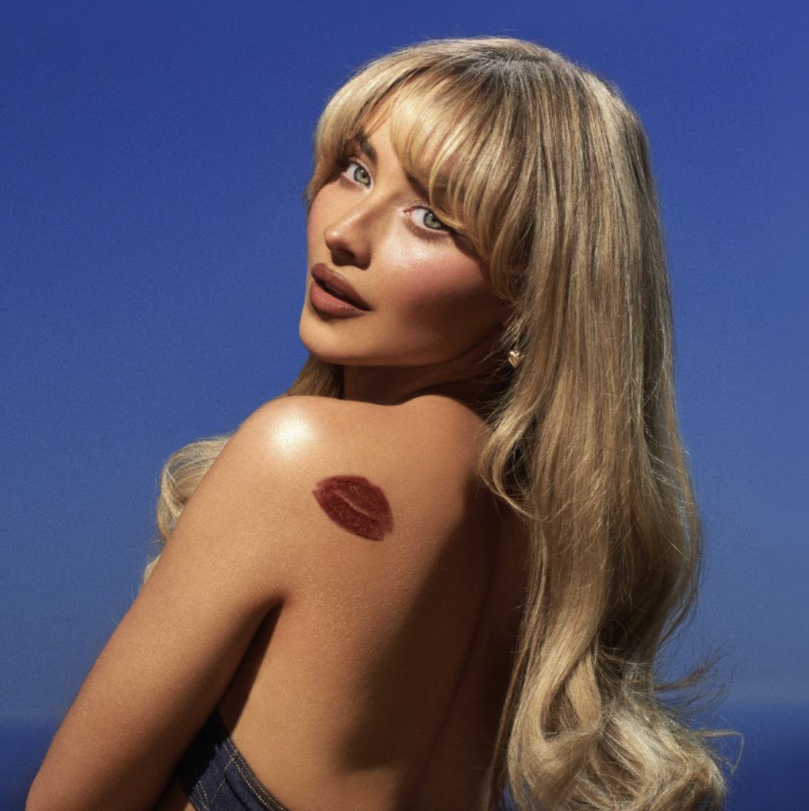

Sabrina Carpenter releases new single + music video, ‘Please Please Please’
Highly anticipated new album Short n’ Sweet out August 23rd
‘Espresso’ spends 5 consecutive weeks as UK #1 & remains #1 on Spotify Global Chart

Watch the ‘Please Please Please’ video HERE
Listen to ‘Please Please Please’ HERE
Pre-order/Pre-Save Short n’ Sweet HERE

Following her global #1 hit ‘Espresso’, debut Saturday Night Live performance, and buzzy Coachella set, Sabrina Carpenter releases her new single and music video entitled ‘Please Please Please’. The release accompanies the announcement of her highly anticipated new album, Short n’ Sweet, out on August 23, 2024 via Polydor Records.

Teaming up with GRAMMY-Award-winning collaborators Jack Antonoff and Amy Allen, ‘Please Please Please’ highlights her razor-sharp lyrics and signature conversational delivery over buoyant production as she begs, “Please Please please don’t prove I’m right. Please please please don’t bring me to tears when I just did my makeup so nice!” Directed by Bardia Zeinali and co-starring Barry Keoghan, the cinematic video seamlessly projects this vibe on screen, continuing a tradition of bold visuals by the songstress.

The song lands in the wake of her bona fide summer smash ‘Espresso’. Scaling charts worldwide, the Platinum-certified hit is her fourth to land on the Billboard Hot 100 and her first Top 5 on the chart, currently earning her a career peak at #4. It captured the #1 spot on the Spotify Global, US, and UK charts, hitting #1 on the UK Singles Chart for five consecutive weeks. The single’s success only increased the incredible momentum generated from the platinum hit ‘Feather’, which scored her first #1 at Top 40 Radio.

In addition to an acclaimed turn supporting Taylor Swift on the Era’s Tour in Mexico, South America, Australia, and Singapore, she was the talk of Coachella with a superstar-making set. Los Angeles Times cited her among “The 15 Best Things We Saw at Coachella 2024,” going on to profess, “Carpenter already had put more effort into her set than some past Coachella headliners” here. Billboard applauded her for delivering one of the “Best Moments From Coachella 2024 Day 1,” attesting, “Carpenter was resplendent during her Coachella debut” here.

Already generating over half a billion streams, ‘Espresso’ has received unanimous critical applause. Pitchfork declared, ‘‘Espresso’ is currently in pole position to be this year’s song of the summer,” and Rolling Stone hailed it as a “sugary-sweet, intensely caffeinated new single.” The New York Times predicted, “‘Espresso’ is a cheeky, summary tune that just might propel her to the next level.”

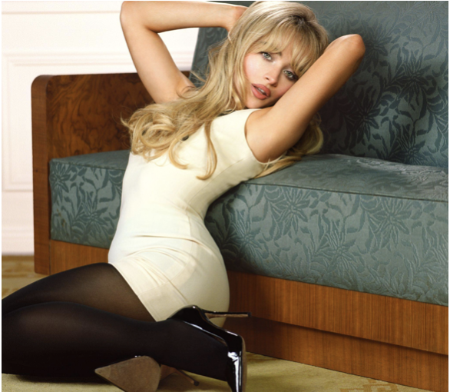
Download Hi-res image HERE

ABOUT SABRINA CARPENTER:
Sabrina Carpenter has enchanted an audience of millions as a singer, songwriter, actress and style icon. With her music, she has delivered one anthem after another on stage and in the studio, earning multiple gold and platinum certifications, and performing to sold out crowds around the world. On-screen, she has generated mega-fandom through starring roles on television and film. She is signed to Island Records, where she has released a multitude of hit singles: ‘Because I Liked A Boy,’ ‘Nonsense,’ ‘Feather’ & her most recent single ‘Espresso’. Sabrina debuted her acclaimed Gold-certified fifth studio album, emails i can’t send, which appeared on many “Best Of 2022” lists including Rolling Stone and Billboard. The album features her hit single ‘Feather’ which went #1 at Top 40 Radio, earning Sabrina her first #1. The platinum hit single also peaked at #26 on the Billboard Hot 100 and has amassed over 600M global streams to date. In addition to her growing list of acting and music credits, she was selected for Forbes’ prestigious “30 Under 30” list. Her sold out emails i can't send tour took her to North America, Europe, Asia and Brazil, and she recently served as direct support for Taylor Swift in Latin America, Australia and Singapore on the Era's Tour. In April, Sabrina made her Coachella debut and was one of the most talked about artists of the festival. Ahead of her Coachella debut, she released her new single ‘Espresso,’ which has quickly climbed the charts and became Sabrina’s most successful single launch to date. Upon release, Pitchfork declared Espresso "in pole position to be this year’s song of the summer,” and The New York Times heralded the single as the song ready to “propel her to the next level”. Since its release, ‘Espresso’ has gone on to reach #1 on the UK & Australian singles charts, Top 5 in the US, and #1 on Spotify, globally where it has also reached over 200M streams within its first month. Sabrina made her Saturday Night Live debut in May on the season finale where she performed ‘Espresso’ and ‘Feather/Nonsense’. She will release her highly anticipated sixth studio album, Short n’ Sweet, on August 23rd, 2024.

For more information and press enquiries please contact

Jenny Entwistle
Jenny@chuffmedia.com

