SABRINA CARPENTER SHORT N’ SWEET (DELUXE)
OUT NOW
LISTEN HERE

RELEASES ‘PLEASE PLEASE PLEASE’ VIDEO WITH DOLLY PARTON
WATCH HERE

RETURNING TO SATURDAY NIGHT LIVE THIS WEEKEND FOR 50TH ANNIVERSARY SPECIAL

EUROPEAN LEG OF SOLD-OUT SHORT N’ SWEET TOUR
KICKS OFF IN DUBLIN MARCH 3RD

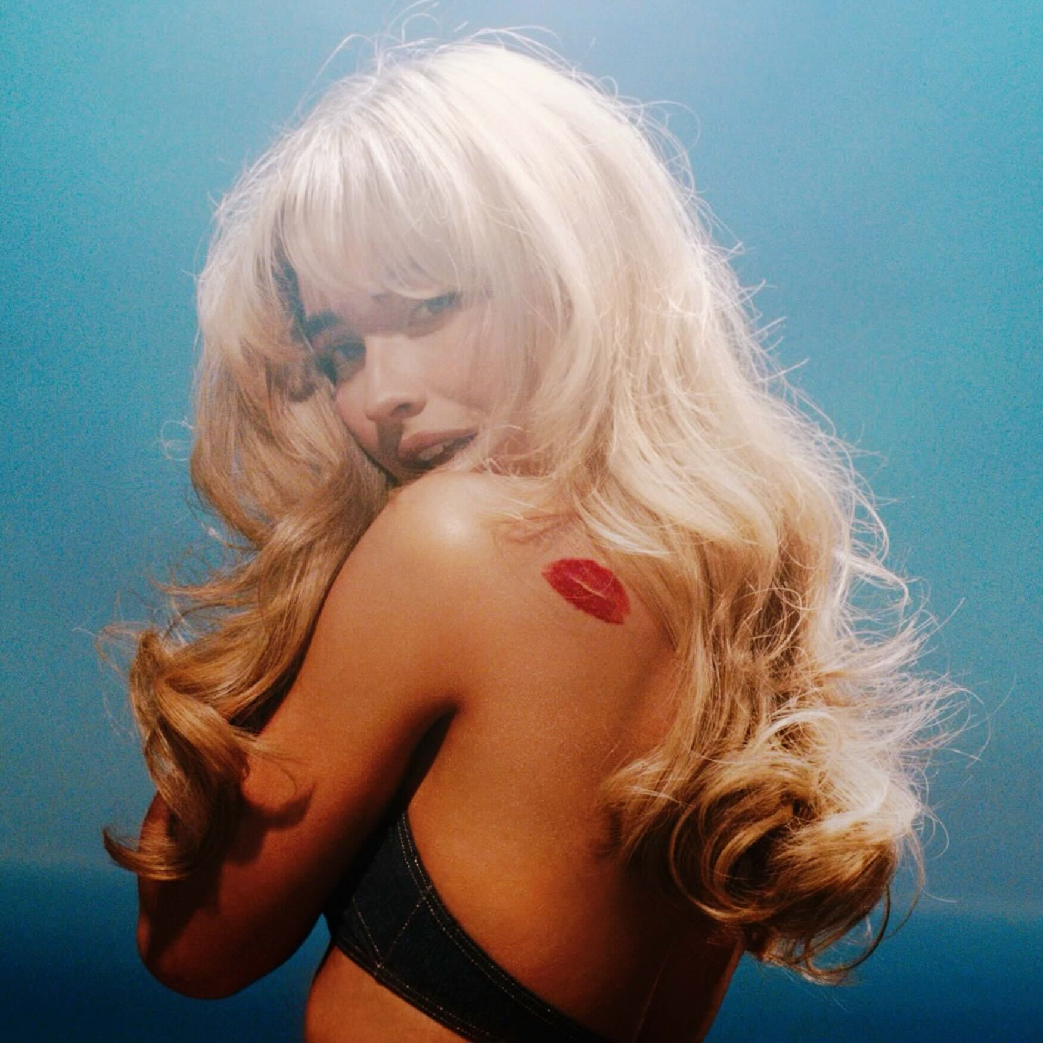
Download High-Res Asset Here

February 14, 2024 - Today, two-time GRAMMY Award winning global superstar, Sabrina Carpenter, releases the deluxe version of her chart topping album, Short n’ Sweet - listen HERE. Short n’ Sweet (Deluxe) features five additional songs including a duet with global icon, Dolly Parton, on “Please Please Please” and “Busy Woman” which Sabrina debuted live on her sold-out headlining arena tour. Alongside the deluxe, Sabrina released a video with Dolly for “Please Please Please.” The video was shot in Nashville and co-directed by Sabrina and Sean Price Williams - watch HERE.
Originally released last August, Short n’ Sweet topped the charts worldwide and had one of the biggest global debuts of 2024. Upon release, Short n’ Sweet skyrocketed to the top for three consecutive weeks at No. 1 on the Billboard 200, becoming only the second album in 2024 to spend its first three weeks atop the list. The album’s opening track, “Taste,” captured #1 on Spotify’s US chart, dethroning Sabrina’s own “Please Please Please” and making it the 3rd song off her album to hit #1.
The album earned Sabrina six GRAMMY nods as a first time GRAMMY nominee. Sabrina took home the coveted “Best Pop Vocal Album” award for Short n’ Sweet along with “Best Pop Solo Performance” for the album’s lead single, “Espresso.” She also made her debut on the GRAMMY’s stage with a medley of “Espresso/Please Please Please” to which Harper’s Bazaar said “if Carpenter was already a rising pop princess before tonight, then her Grammys debut has cemented her status as pop royalty.”
Earlier this week, The BRIT Awards announced Sabrina will be joining the lineup as both a performer and honoree. In addition to being nominated twice for international artist of the year and international song of the year for “Espresso,” she will be receiving the Global Success, becoming the first international artist to receive it.
Next month, Sabrina also kicks off the sold-out European leg of her highly acclaimed Short n’ Sweet Tour in Dublin and will hit arenas across Europe and the UK including London, Paris, Amsterdam, Berlin and more. Due to demand, additional shows were added in Zurich, Oslo, Copenhagen and Stockholm. This run follows the incredibly successful 33 date sold-out North American leg which wrapped last November with a 3 night run in Los Angeles.
Sabrina will be returning to Saturday Night Live this weekend to make a guest appearance for their 50th Anniversary Special. She made her debut as the musical guest on the season finale of Saturday Night Live last May. Sabrina also just graced the cover of Vogue US for the first time - see the cover/read the feature here.

Short n’ Sweet (Deluxe) Tracklist
- Taste
- Please Please Please
- Good Graces
- Sharpest Tool
- Coincidence
- Bed Chem
- Espresso
- Dumb & Poetic
- Slim Pickins
- Juno
- Lie to Girls
- Don't Smile
- 15 Minutes
- Please Please Please (feat. Dolly Parton)
- Couldn't Make It Any Harder
- Busy Woman
- Bad Reviews

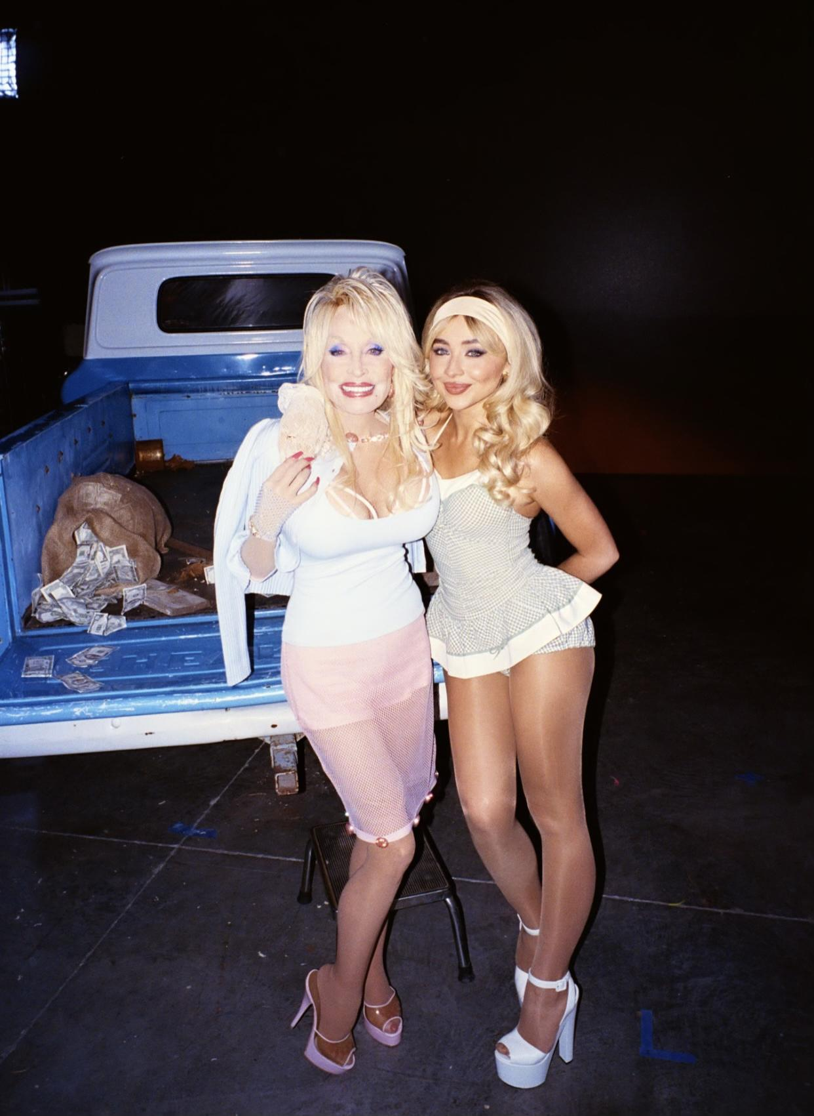
Photo Credit: Aiden Magarian
Download hi-res image Here

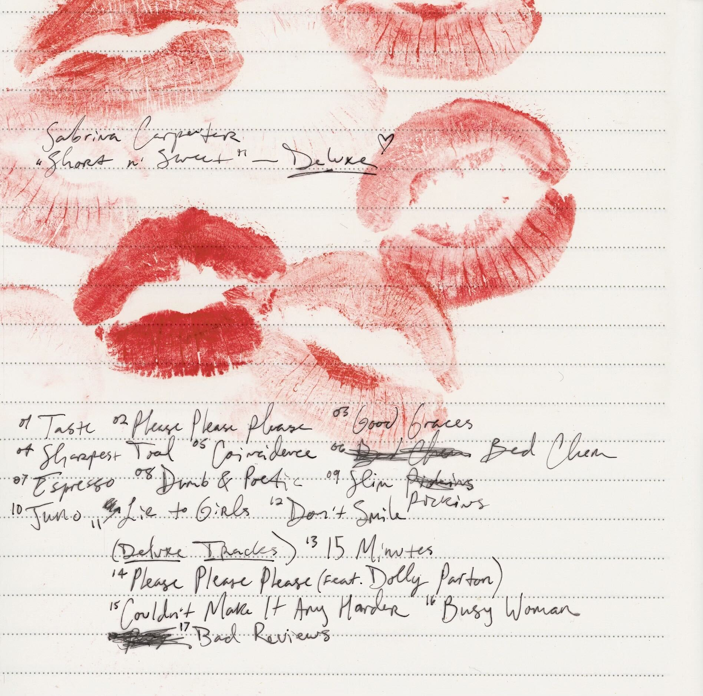
Download High-Res Asset Here

ABOUT SABRINA CARPENTER:
Two time GRAMMY® award winner, Sabrina Carpenter, has enchanted an audience of millions as a singer, songwriter, actress and style icon. With her music, she has delivered one anthem after another on stage and in the studio, earning multiple gold and multi-platinum certifications, and performing to sold out crowds around the world. On-screen, she has generated mega-fandom through starring roles on television and film. She is signed to Island Records, where she debuted her acclaimed Gold-certified fifth studio album, emails i can’t send, which appeared on many “Best Of 2022” lists including Rolling Stone and Billboard. The album features her hit single “Feather” which went #1 at Top 40 Radio, earning Sabrina her first #1. Her sold out emails i can't send tour took her to North America, Europe, Asia and Brazil, and she recently served as direct support for Taylor Swift in Latin America, Australia and Singapore on the Eras Tour. In April, Sabrina made her Coachella debut and was one of the most talked about artists of the festival. Ahead of her Coachella debut, she released her single “Espresso” which quickly climbed the charts. Upon release, Pitchfork declared “Espresso” as "in pole position to be this year’s song of the summer,” and The New York Times heralded the single as the song ready to “propel her to the next level”. Since its release, “Espresso” has gone on to reach #1 on the UK & Australian singles charts, Top 5 in the US, and #1 on Spotify globally, where it reached over 200M streams within its first month. Her second single, “Please Please Please,” was released in June and shot straight up to the top of the charts. The single hit #1 on Spotify’s Global and US charts, #1 on Apple Music and debuted at #2 on the Billboard Hot 100 before claiming the #1 spot a week later and went #1 at US Pop Radio. Sabrina made her Saturday Night Live debut in May on the season finale where she performed “Espresso” and “Feather/Nonsense.” In August, she released her highly anticipated sixth studio album, Short n’ Sweet. The album was instantly met with an outpouring of critical acclaim from the likes of the New York Times, Rolling Stone, Pitchfork, Variety, and many more. The album debuted at #1 on the Billboard 200, making it the 3rd biggest first week debut in the US in 2024 and became only the second album that year to spend its first three weeks atop the list. Short n' Sweet also topped the charts around the world, reaching #1 in UK, Canada, Australia, Spain, and France. The album earned Sabrina an impressive six GRAMMY® nominations as a first time nominee. Short n’ Sweet took home the GRAMMY® Award for Best Pop Vocal Album and Sabrina also won the “Best Pop Solo Performance” GRAMMY® Award for the album’s lead single “Espresso.” She made her debut at the 67th GRAMMY® Awards with a captivating performance of “Espresso/Please Please Please.” Last Fall, Sabrina wrapped the 33 date North American leg of her monumental sold-out Short n’ Sweet Tour and will be embarking on the sold-out European leg on March 3rd.

For more information and press enquiries please contact

Jenny Entwistle
Jenny@chuffmedia.com

