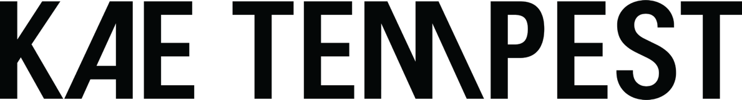

ANNOUNCES FIFTH ALBUM
‘SELF TITLED’
04.07.25

Featuring Neil Tennant, Connie Constance,
Young Fathers and more

Co-produced by Fraser T Smith and Kae Tempest

New single ‘Know Yourself’ out today – listen here

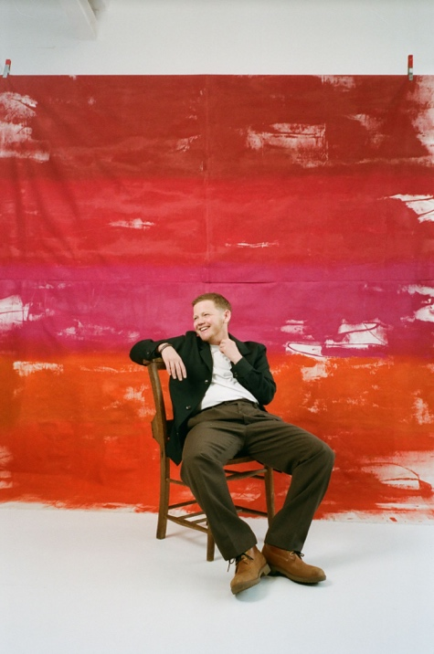

Acclaimed musician, poet and author Kae Tempest returns with his fifth studio album, ‘Self Titled’, set for release July 4 via Island Records.

The 12-track album is Kae’s most intimate and revealing project to date. ‘Self Titled’ not only explores who Kae is as an artist, it reaches into the essence of Kae as a person. It’s bold, witty, and, at times, profoundly moving, in ways that surprise and linger.

Working with the Grammy-winning producer behind Adele and Stormzy for the first time on an album, sparked a union that saw a flood of new ideas and unexpected directions. Fraser encouraged Kae to be both an active participant in production and guided him to write in the first person, to tell his own story. The result is a body of work that sees Kae reconnect with his Hip Hop roots while paying a gentle homage to contemporary pop — an exhilarating album from start to finish.

Kae kicked off the year with a headline appearance at BBC Radio 6 Music Festival and a handful of sold out underplay shows in March - offering an early glimpse of new material to an electrified response from both fans and critics. The album’s first single, ‘Statue In The Square’, was released in March — a raw, rhythmic track driven by Tempest’s signature fast flow and hard-hitting lyrics. Its accompanying video, filmed in Deptford, features a powerful lineup of influential community voices, including Princess Julia, Joelle Taylor, Sweatmother, Debbie Smith, and Dr Ronx, capturing the track’s urgent energy in celebratory fashion.

At its core, ‘Self Titled’ is a love letter to Tempest’s younger self — a conversation across time, shaped by the people, places, and experiences that define him. Guest appearances include Neil Tennant, Young Fathers, Connie Constance, and Tawiah. The album is both a bold new chapter and a deep reflection, positioning Kae Tempest at the forefront of contemporary music and storytelling.

A new single, ‘Know Yourself’ has also been revealed today, watch here. Kae adds “I love this song. It samples a lyric I wrote years ago, where my younger self is talking to their younger self. A dialogue between selves across time, in real time. Or maybe I could put that simpler – When I was young I sought help from my older self. I came into my head, I told me know yourself.”

‘SELF TITLED’
I Stand On The Line
Statue In The Square
Know Yourself
Sunshine On Catford
Bless The Bold Future
Everything All Together
Prayers To Whisper
Diagnoses
Hyperdistillation
Forever
Breathe
Till Morning

Kae Tempest has released four critically acclaimed studio albums, as well as numerous books, plays and poetry collections, including Brand New Ancients, which saw him become the first person under 40 to receive the Ted Hughes Award in 2013. For his music, Kae won the Ivor Novello Award for Best Contemporary Song in 2024, following two previous Ivor Novello nominations in 2020 and a BRIT Award nomination in 2018. Kae has been shortlisted for the Mercury Prize twice (For Let Them Eat Chaos in 2017 and Everybody Down in 2014). In 2023 he was the subject of a BBC Arena documentary ‘Being Kae Tempest’, a captivating insight into his musical and creative journey throughout a period of profound artistic and personal change. With this impressive list of accolades, it’s clear that Kae Tempest has firmly established himself as one of the most unique, thought-provoking, and critically acclaimed voices of their generation."

For more information please contact – louise@wecarealotpr.com

