OLIVIA RODRIGO RELEASES HIGHLY ANTICIPATED
DEBUT ALBUM, SOUR – OUT NOW VIA GEFFEN RECORDS
STREAM OR DOWNLOAD SOUR HERE
RODRIGO MADE HER MUSICAL GUEST DEBUT ON SNL ON MAY 15
WATCH THE PERFORMANCE OF “drivers license” HERE AND “good 4 u” HERE
“All of pop music is Olivia Rodrigo’s playground… She’s a whole new pop-queen paradigm, ripping up the old playbook and starting again.” – ROLLING STONE

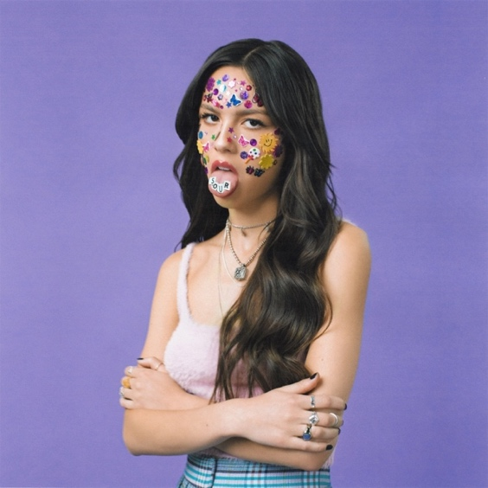
Download Hi-Res Album Artwork HERE

May 21, 2021 – Santa Monica, CA – Multi-platinum, critically acclaimed singer/songwriter, Olivia Rodrigo, today released her highly anticipated debut album, SOUR, via Geffen Records. All throughout the LP, the 18-year-old musician displays her incredible talent for capturing complex emotions in high-impact, dynamic pop songs. The album, entirely co-written by Rodrigo, embodies a minimalist yet mesmerizing form of alt-pop, each song centered on the L.A.-based artist’s beautifully detailed storytelling, unforgettably original narrative voice, and undeniable boldness. SOUR is available to stream or download HERE.

For Rodrigo, one of the greatest joys in life comes from deliberately tapping into her deepest heartache. “There’s nothing like sitting at the piano in my bedroom and writing a really sad song,” she says. “It’s truly my favorite thing in the world; it’s so inspiring to see my music affect people and maybe help them to feel less alone too.”

“I’m also fascinated by the idea of a relationship going sour—how a person you loved so much and told all your secrets to can become the person you can’t stand,” Rodrigo explains about the album’s title. “For me, the goal of all music is to take these complicated feelings and externalize them in a way that makes people feel seen.”

On January 8, 2021, the arrival of Rodrigo’s record-breaking, triple-platinum, debut single, “drivers license,” revealed the tremendous power of her raw self-expression—and ultimately cemented her status as the most promising young artist to emerge this year. The song premiered at No. 1 on the Billboard Hot 100, holding the top spot for eight consecutive weeks and becoming the first in 2021 to hit one billion total global streams. “drivers license” is also the first this year to be RIAA certified at Gold, Platinum, double and triple-Platinum, not to mention scoring the No. 1 spot at Top 40 radio for five consecutive weeks and having the quickest trip to the top spot for a first-time charting female artist.

On April 1, 2021, Rodrigo made music industry history again with the release of her incredible sophomore single, “deja vu” – becoming the first artist to debut her first two proper singles in the top ten of the Billboard Hot 100. On May 14, 2021, Rodrigo also shared the third-released track from SOUR, “good 4 u,” which has already amassed 70 million global audio streams and 40 million global video streams in its first week. She also performed the new song during her musical guest debut on Saturday Night Live on May 15, which Billboard praised, saying “Olivia Rodrigo crushed it during her SNL debut.”

Critical Acclaim for Olivia Rodrigo

"After such a tremendous debut, Rodrigo’s next move would determine if she would be deemed a one-hit wonder or pop music’s next heavyweight. ‘deja vu' firmly suggests the latter."
– PITCHFORK

“it is safe to say that [Rodrigo] knocked her two-song performance [on SNL] out of the park on Saturday night. If this performance and these two songs, which balance anger and sadness with joyful release are any indication, she could be our next superstar.” – VARIETY

“[‘drivers license’] is a disarmingly honest pop song that feels like the first step in a long career.”
– VOGUE
“[‘drivers license’] has pulled away as the defining runaway pop hit of the year so far.”
– THE NEW YORK TIMES
“…[“good 4 u” reminds] fans just how lethal the 18-year-old musician is with a pen.”
– COMPLEX

SOUR Track Listing
1. brutal
2. traitor
3. drivers license
4. 1 step forward, 3 steps back
5. deja vu
6. good 4 u
7. enough for you
8. happier
9. jealousy, jealousy
10. favorite crime
11. hope ur ok

Olivia Rodrigo SOUR
Retail: https://OliviaRodrigo.lnk.to/SOUR
Amazon: https://OliviaRodrigo.lnk.to/SOUR/amazonmusic
Apple Music: https://OliviaRodrigo.lnk.to/SOUR/applemusic
Deezer: https://OliviaRodrigo.lnk.to/SOUR/deezer
iTunes: https://OliviaRodrigo.lnk.to/SOUR/itunes
Pandora: https://OliviaRodrigo.lnk.to/SOUR/pandora
Spotify: https://OliviaRodrigo.lnk.to/SOUR/spotify
Tidal: https://OliviaRodrigo.lnk.to/SOUR/tidal
YouTube Music: https://OliviaRodrigo.lnk.to/SOUR/youtubemusic

Follow Olivia Rodrigo
Website | Twitter | Instagram | YouTube

For more information and press enquiries please contact

Jenny Entwistle
Jenny@chuffmedia.com

