ROLE MODEL ANNOUNCES DEBUT ALBUM ‘Rx’ AND WORLD TOUR SHARES NEW SINGLE ‘IF JESUS SAVES, SHE’S MY TYPE’

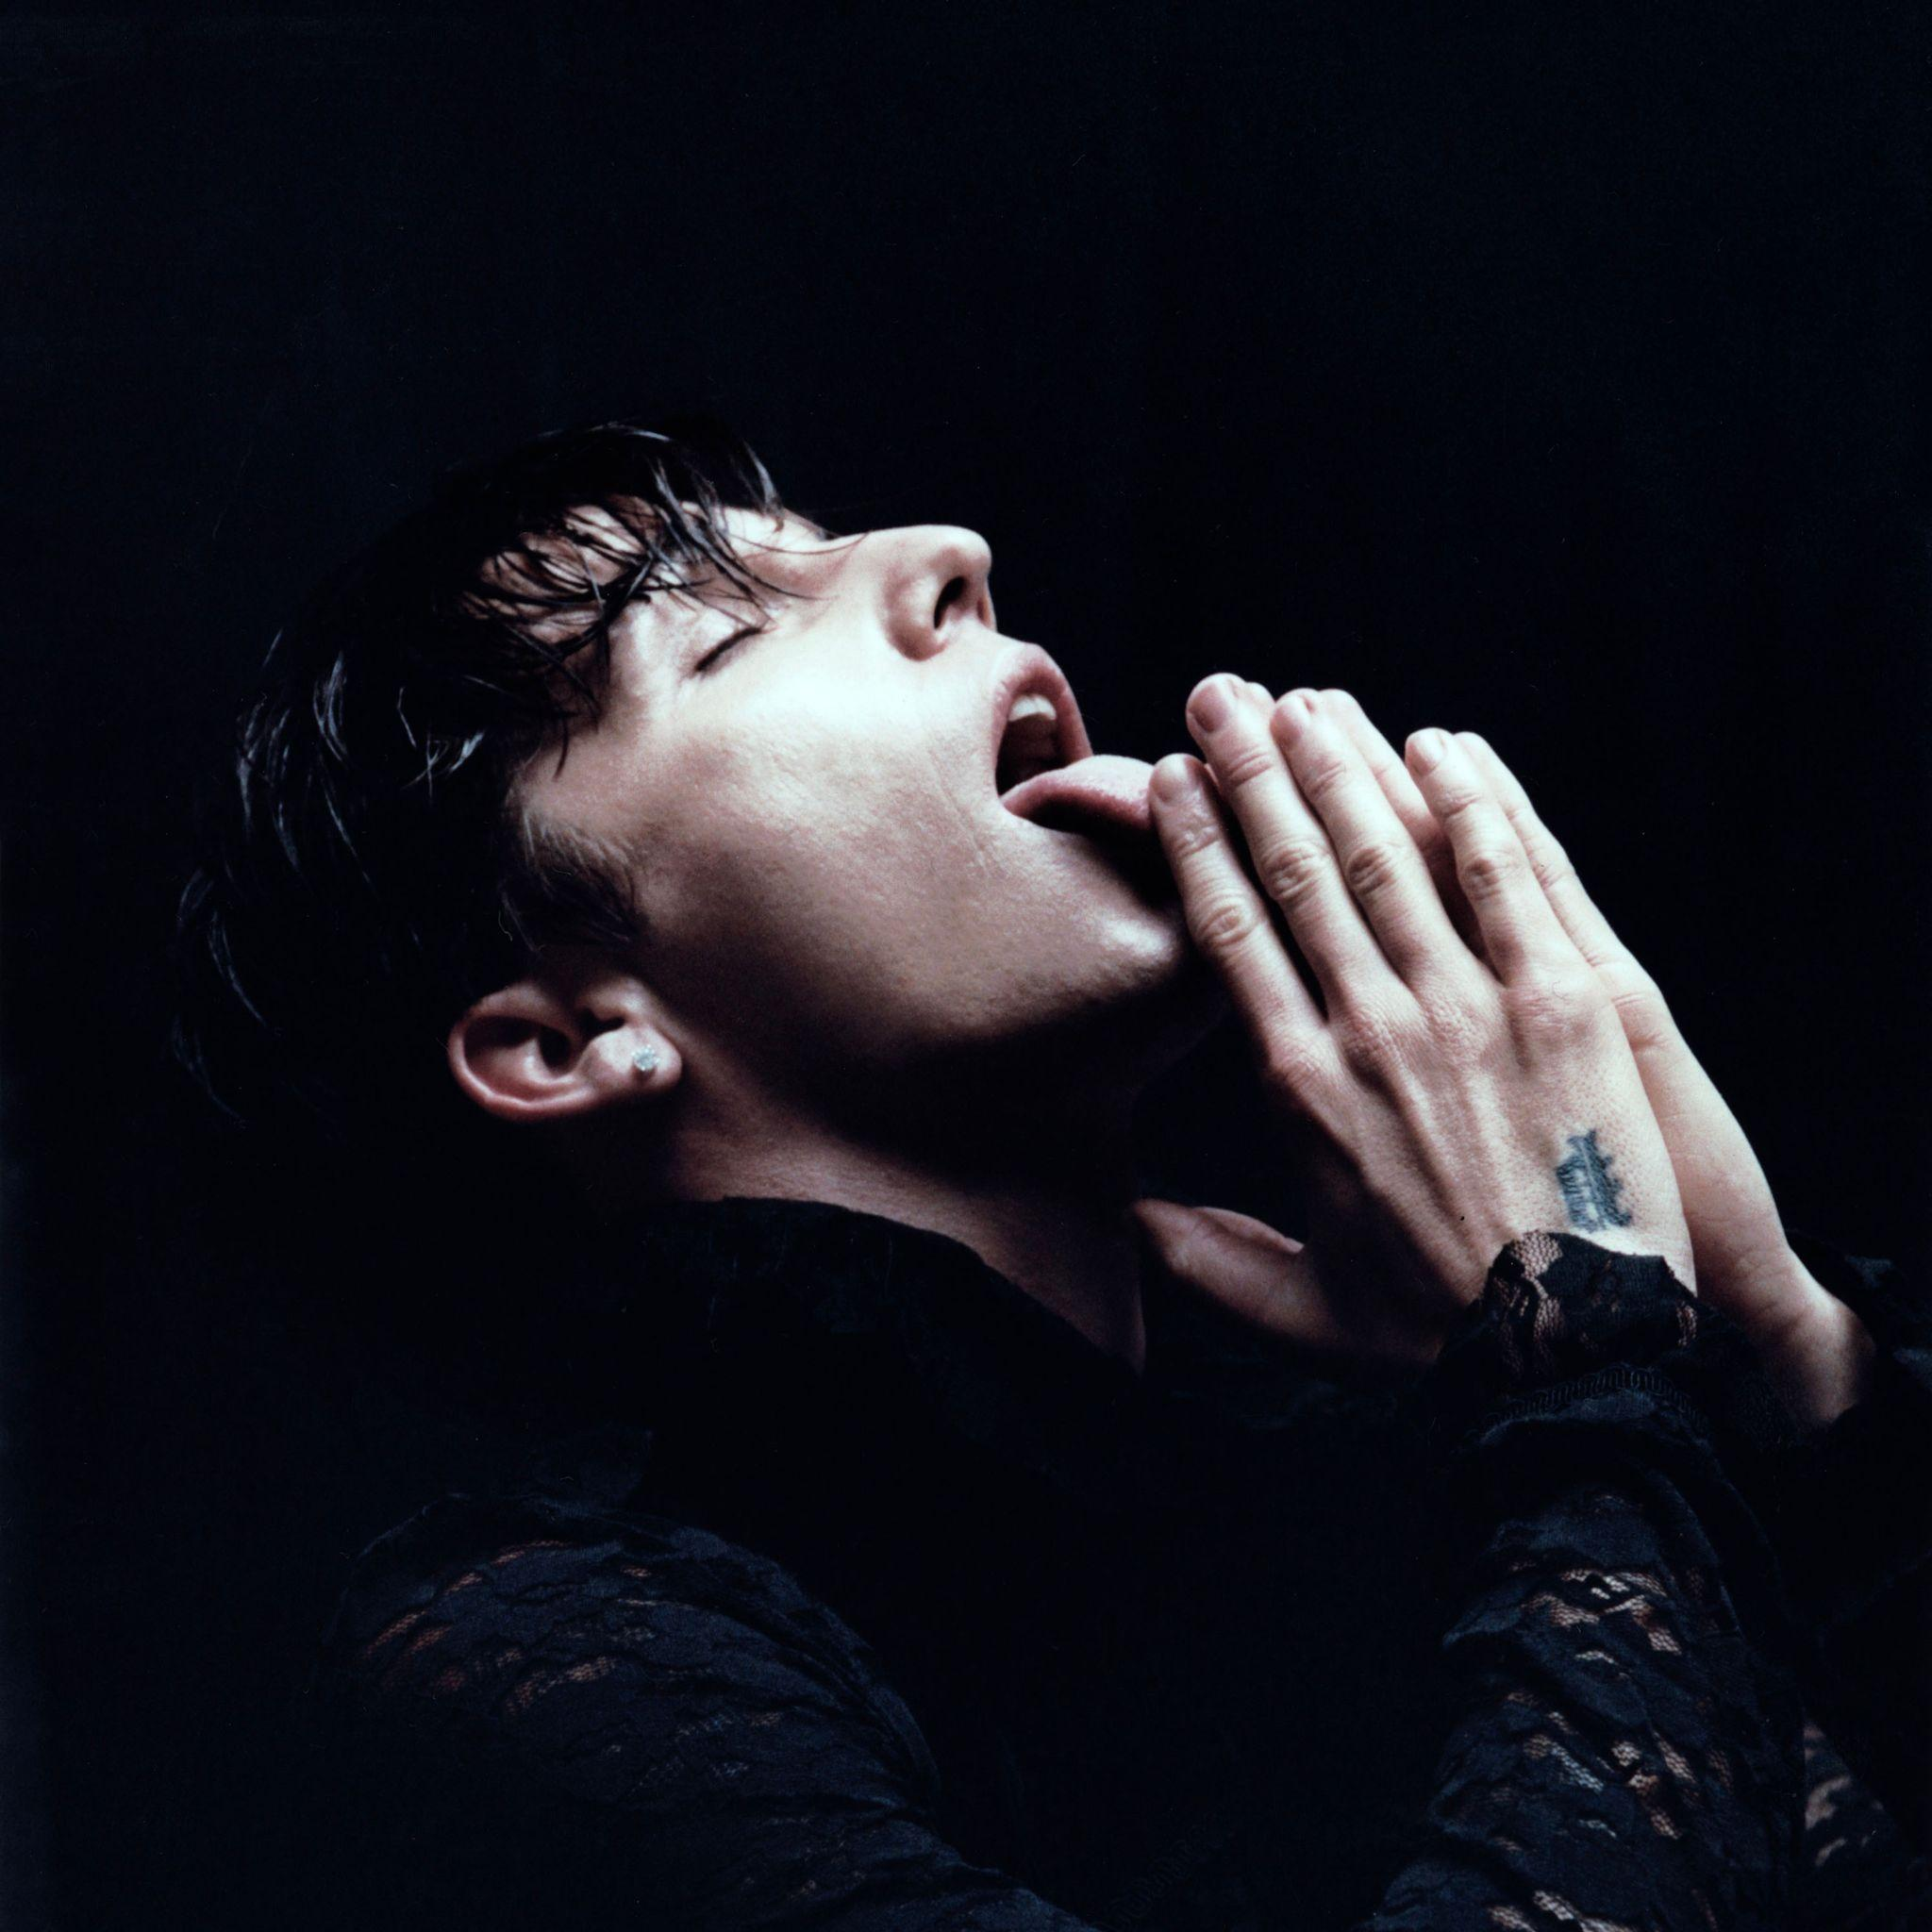

LISTEN

“Pillsbury’s music is barefaced, the production sunkissed with hints of melancholia, like a Californian suburb” — I-D MAGAZINE

“Role Model is moving into fresh, uncharted spaces” — CLASH

“...his lightness of touch means these shimmering guitar lines and live percussion also amount to great understated pop songs” — NME

“Sounds like sunshine” — DIY MAGAZINE (CLASS OF 2022)

Maine-born songwriter and musician ROLE MODEL — AKA Tucker Pillsbury — has announced his debut album ‘Rx’, out April 8th via Interscope/Polydor. Alongside the announcement, he shares his latest single ‘if jesus saves, she’s my type’, available to buy and stream now on all platforms, and further details of a world tour including UK and European dates throughout August and September.

Drawing on Pillsbury’s trademark dark-but-sweet lyricism, his latest single serves as a thematic intro to his debut album. Themes of love, healing and the transformative power of relationships fill ‘Rx’ while Pillsbury’s playful use of religious iconography gives his bittersweet pop a unique depth. Of his new single, Pillsbury writes: “As much as I love being alone, I think even the strongest people have a breaking point. I spent years completely alone and got to a point where I needed help, which later came in the form of a girl, who I fell in love with. This song is that stage of desperation that I felt could be compared to the way some people find God. When you're on your knees just begging for something or someONE. It sets up the album perfectly.”

The now 25-year-old songwriter has spent recent years building an increasingly familial fan base, with regular streamers and followers in their multi-millions. Across multiple EP releases, including 2020’s ‘our little angel’ EP and his most recent 2021 single ‘death wish’, Pillsbury has piqued critical interest from titles including i-D, NME, The Line of Best Fit, Highsnobiety and DIY Magazine, who highlighted his forthcoming album in their ‘Class of 2022’ tips issue. ROLE MODEL has also enjoyed heavy support from BBC Radio 1, with ‘death wish’ receiving an exceptional review on Jack Saunders’ ‘Future Artists’ show.

For more information on tickets and pre-sales, head to Role Model's website and sign up to his mailing list here.

UK TOUR DATES

26/8 Reading, UK Reading Festival
27/8 Leeds, UK Leeds Festival
29/8 London, UK O2 Forum Kentish Town
31/8 Manchester, UK O2 Ritz
1/9 Birmingham, UK O2 Institute 2
2/9 London, UK O2 Forum Kentish Town
4/9 Bristol, UK O2 Academy Bristol

‘Rx’ TRACKLIST

1. die for my bitch
2. who hurt you
3. forever&more
4. save a seat
5. if jesus saves, she’s my type
6. masturbation song
7. neverletyougo
8. stripclub music
9. life is funny
10. can you say the same
11. Rx

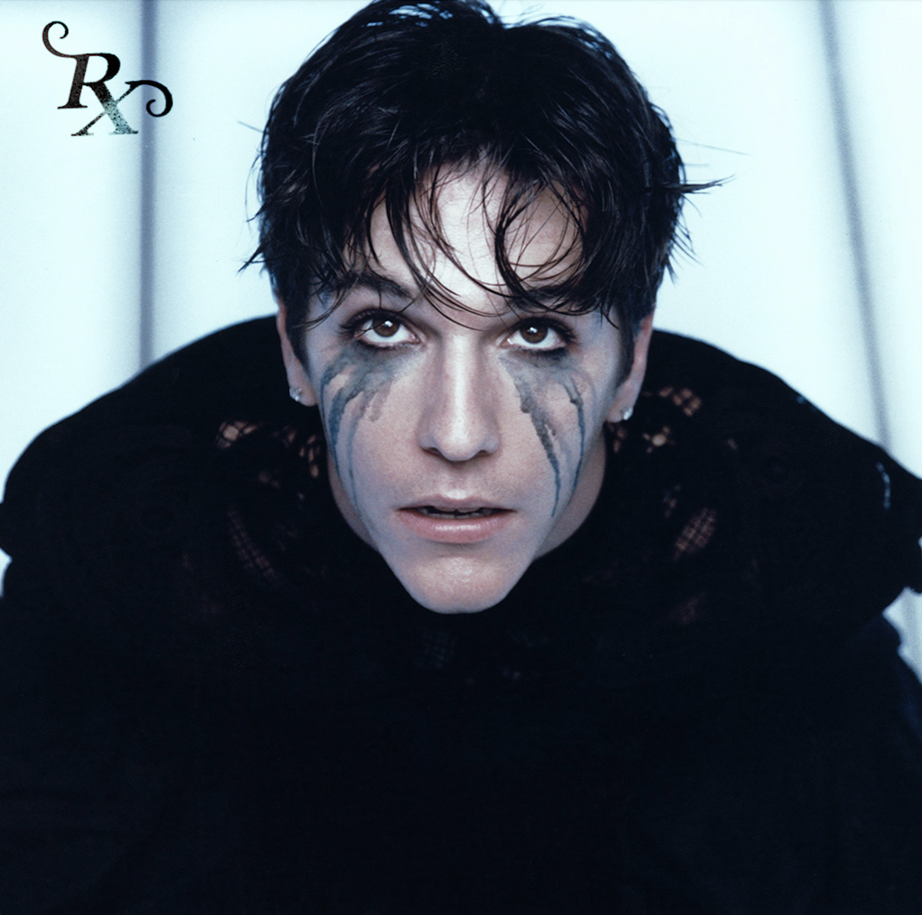

For more information and press enquiries please contact

Jenny Entwistle
Jenny@chuffmedia.com

