**Lily Lyons Announces Debut Album ‘Re-Open The World’**

**Released 31st October by Fiction**

**New Single ‘Can’t Be The One’ Out Now**

**Headlines London’s Omeara on 20th February 2026**

*“An ensnaring combination of ethereal melodies, precise enunciation and haunting, up-close vocals.***” - Sunday Times Culture**



**credit: Sequoia Ziff**

‘Re-Open The World’ is the debut album from Lily Lyons, due to be released by Fiction on 31st October. Produced with Joel Pott (Athlete, George Ezra, London Grammar), ‘Re-Open The World’ is a collection of 10 immaculately crafted songs. Lily’s songwriting across the album captures beautiful vignettes of her experiences in life so far. Perceptive lyrics, delivered in a voice for the ages, examine the multiplicities of self, giving space to it all whilst believing in the power of music to soothe and to heal.

The first track to be revealed from the album was the BBC 6Music supported ‘Look At You’, released earlier this year. Her new single ‘Can’t Be The One’ provides the follow up and arrives alongside the album announcement.. A joyful finger-picking tune, it finds Lily reveling in *“allowing the stroppy, pissed off version of myself”* to be voiced, whilst simultaneously acknowledging the devastation of having to let someone go. She explains “*It’s the story of walking away from someone and also kind of being aware that you love that person, that you can still love them and need to not have them in your life. Allowing opposites to be true at the same time. Anger, giving up and dissatisfaction are embraced in this track but they coexist with love and lightness. A more two dimensional version of the song would have picked one or the other. The truest depiction of the feeling was to hold both the fury and the love.”*

For Lily, music feels like hope - or perhaps, possibility. Growing up split between London and Somerset, making weekly eight hour drives across the country between the base she knew with her mother and the faraway town her father had left for, she remembers the comfort of the car stereo on the open road. As she grew older, struggling to fully realise herself in the world, music was the thing that offered a window to an alternative. She cites Simon and Garfunkel, Nick Drake and Joni Mitchell as formative influences, whilst for her debut album, Lisa Marchiano’s feminist text *The Vital Spark* provided huge inspiration. The book celebrates Lilith, the woman said to have come before Eve, who refused to be of Adam and was thus labelled the “anti-mother”.

“*The book is about celebrating when it’s quite good to let your inner Lilith come out: to say, ‘No, I’m not gonna take care of you and take on your crap because I also have dreams and things I want to do in the world’,”* she says. *“I’m not seeing my life as a vehicle for someone else. It’s its own thing, and it’s for me.”*

**Lily Lyons will headline London’s Omeara on 20th February 2026. ‘Re-Open The World’ will be released by Fiction on 31st October.**

**The tracklist for ‘Re-Open The World’ is:**

1. Cover The Trails
2. Can’t Be The One
3. 57
4. Weightless
5. Reaching
6. Re-Open The World
7. Trip My Step Up
8. Look At You
9. Only Lonely Person
10. Here With You, Jo

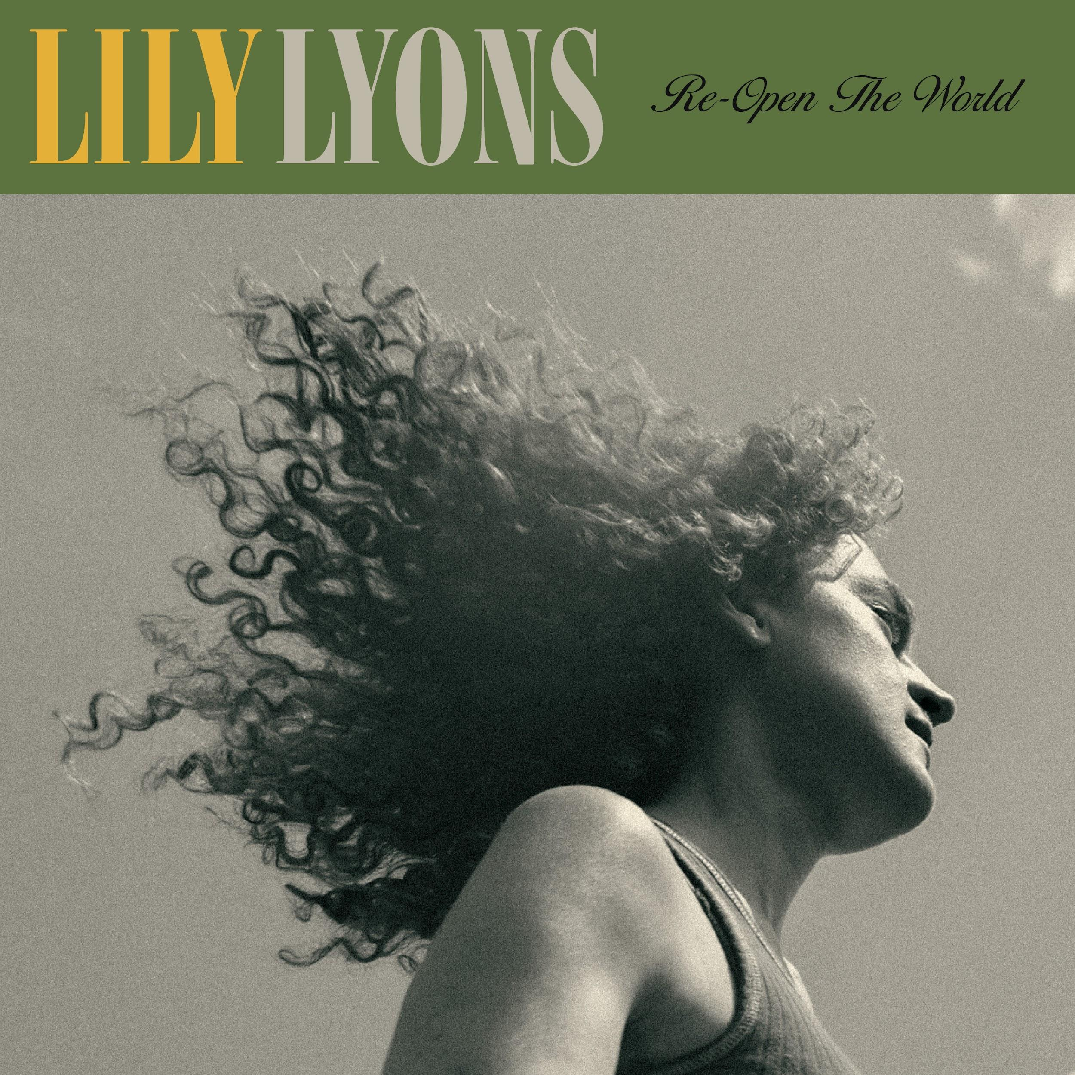

**‘Re-Open The World’ artwork**

**LILY LYONS PLAYS:**

**2025**

**AUGUST**

**28th** St Peters Church, **POOLE** (supporting The Staves)

**SEPTEMBER**  
 **4th** St Pancras Old Church, **LONDON** (supporting Gemma Hayes)

**5th** St Pancras Old Church, **LONDON** (supporting Gemma Hayes)

**OCTOBER**

**30th** Global Connections Festival, **GUERNSEY**

**2026**

**FEBRUARY**

**20th** Omeara, LONDON

**Keep Up To Date With Lily Lyons**

[**INSTAGRAM**](https://www.instagram.com/lilylyonsmusic/?hl=en) **//** [**YOUTUBE**](https://youtube.com/@lilylyons2413?si=HRfkrZmIx21Bzviz) **//** [**SPOTIFY**](https://open.spotify.com/artist/5YKAGYFz84gLEI7rAFpIpX?si=A-OG-Z2ETtmphrk4aY61Dw)

**For more info contact Warren** [**warren@chuffmedia.com**](mailto:warren@chuffmedia.com)