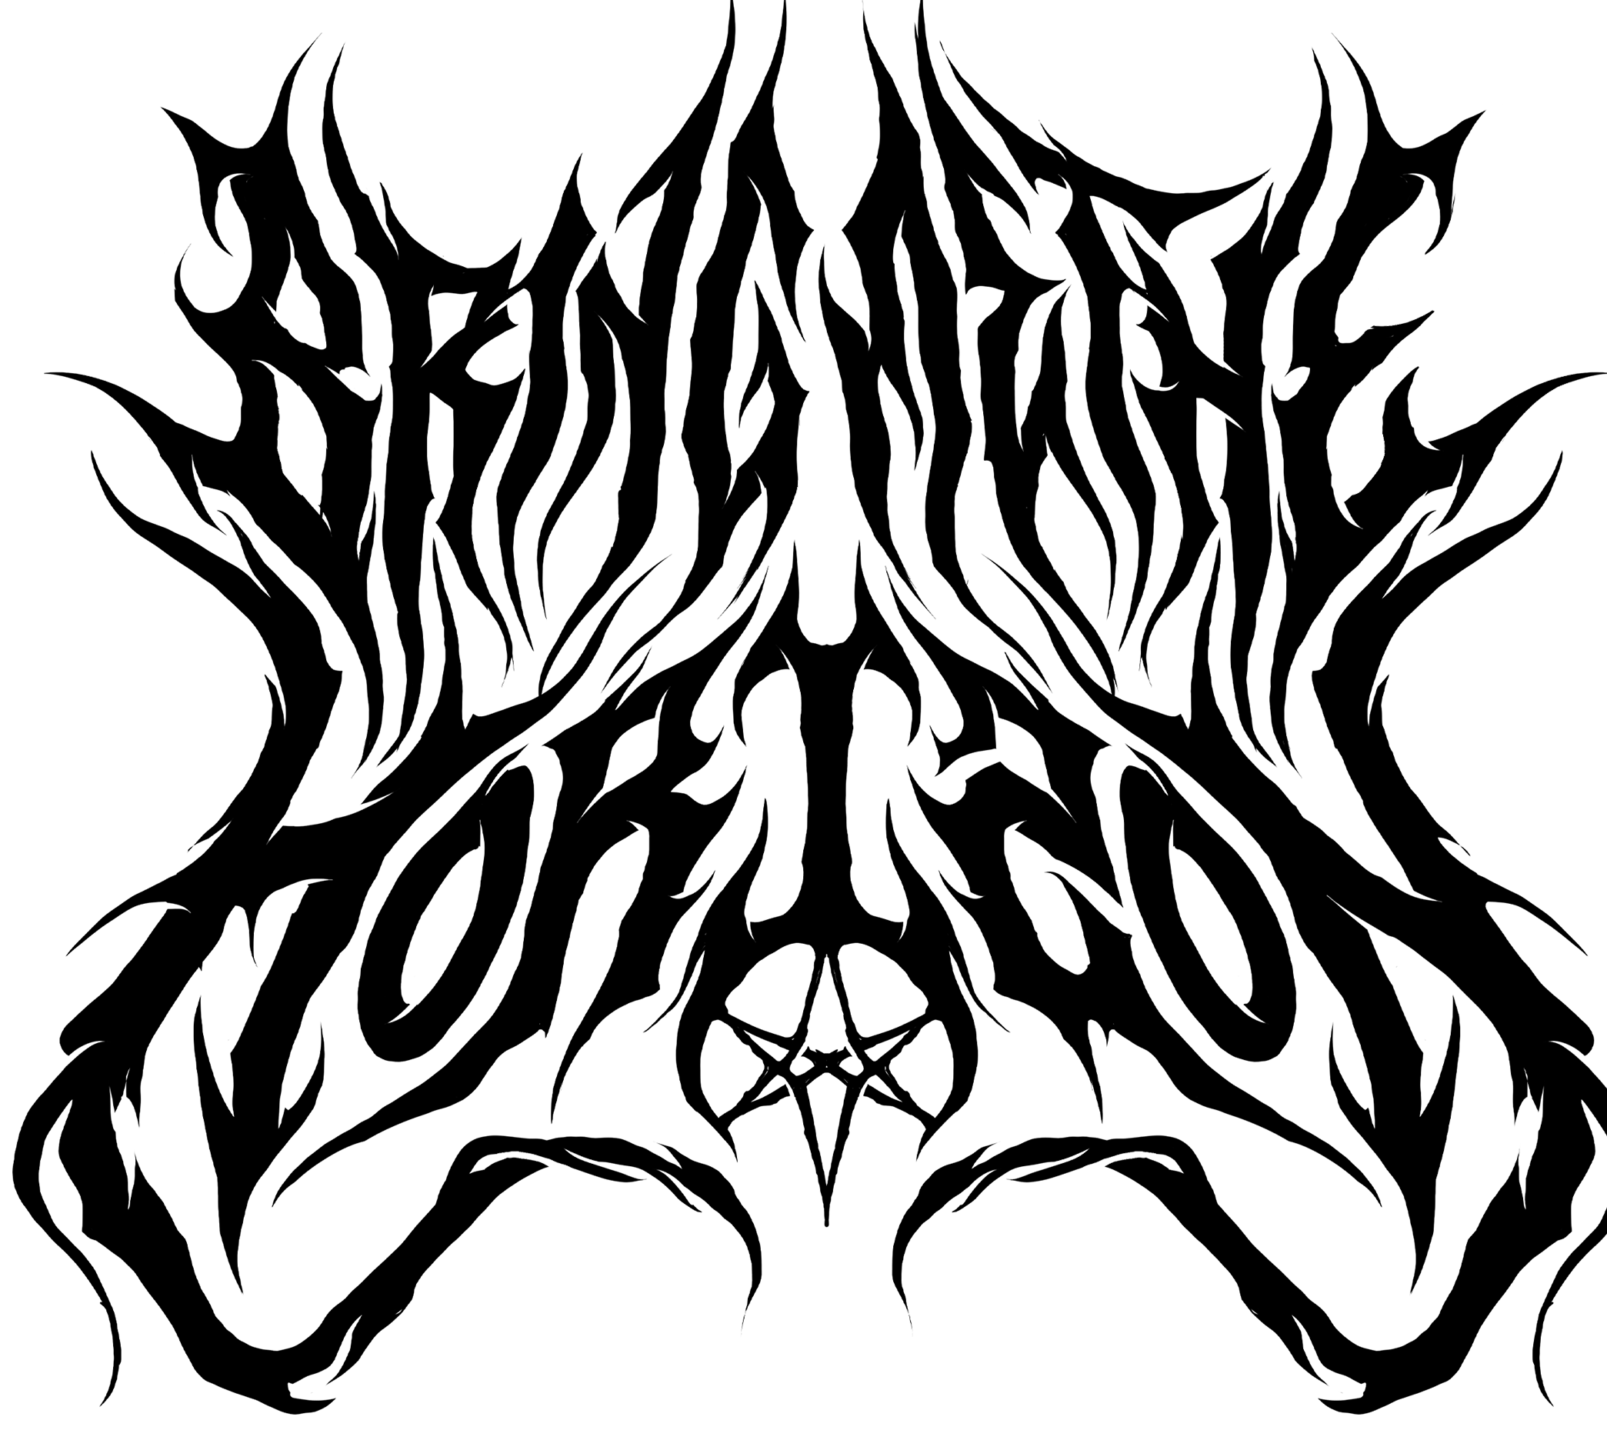
BRING ME THE HORIZON
POST HUMAN: NeX GEn
**ALBUM OUT NOW**
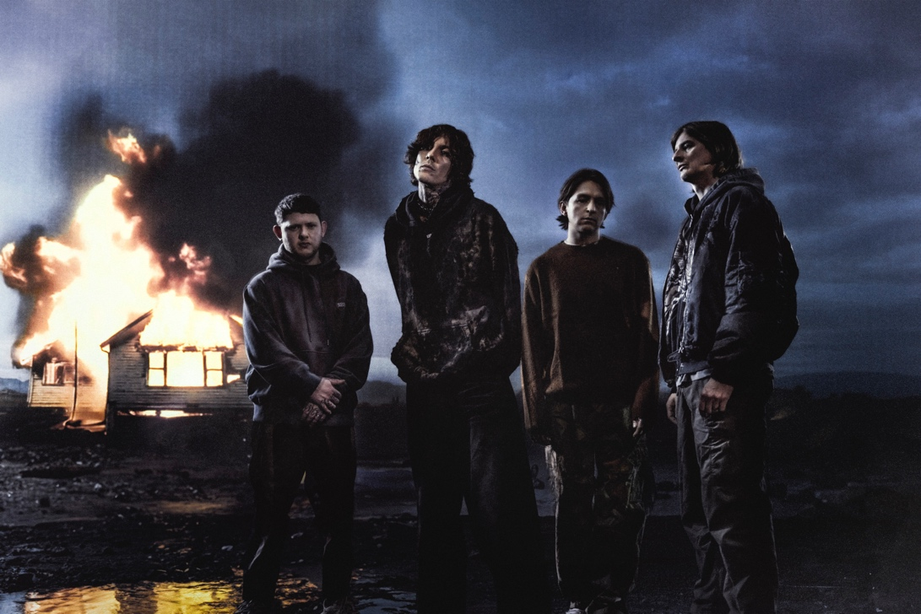

Welcome to NeX GEn…the wait is finally over. Today the hottest British rock band on the planet release their highly anticipated new album NeX GEn via Sony/RCA.
NeX GEn is the latest chapter in the series to be revealed and sees the band expanding both musically and conceptually. Following on from 2020’s POST HUMAN: Survival Horror – which featured collaborations with YUNGBLUD, Nova Twins, BABYMETAL and Evanescence’s Amy Lee, and includes the huge hit singles Teardrops and Obey. Sonically the album hits heavy, whilst frontman Oli’s vocals are his most melodic to date.
Bring Me The Horizon entered 2024 with an explosive start having played to over 140,000 fans in the UK & Ireland on their biggest UK arena tour to date, winning the BRIT Award for Best Alternative/Rock Act, announcing their first stadium show in São Paulo, Brazil and now the surprise release of their new album, which has already caused a global frenzy since appearing online last night.
The first part of the POST-HUMAN Series, Survival Horror was recorded during the first COVID lockdowns, almost entirely remotely, and leaned into the band’s heavy side to express its feelings of anger, fear, emptiness and despair. Of NeX GEn, singer Oli Sykes says that it’s searching for something more hopeful, if not entirely positive in and of itself. Fittingly, the music this time – already previewed in huge singles Kool Aid, DiE4u , AmEN! and DArkSide – has an even more euphonic, post-hardcore-inflected stripe, while still bursting with the band’s unique, forward-thinking creativity.
Oli adds the album took “ages to write”. Partly, this is down to the band thinking that lockdown would last much longer than it did. When it lifted, they quickly found their schedules full with touring the world and headlining festivals such as Reading & Leeds (where they were joined by Ed Sheeran for their collaborative hit Bad Habits), hosting and headlining NEX FEST in Japan, Download Festival in the UK, Good Things in Australia and When We Were Young and Sick New World in Las Vegas.
But it’s also down to the concept quickly growing into something bigger than its creators originally imagined. POST-HUMAN: Survival Horror became far more of an event than the band had envisioned upon release, and crafting its follow-up required much bigger thinking than first anticipated.
There is so much to unwrap under the surface of the album for those who can spot it. “It's a real concept album, with a full narrative that connects to the first record, but the concept is hidden and buried,” he says. “Some people aren’t going to be interested, but for some people it could be like a self-help book. There’s a lot of things in there, some of it’s quite clear, but a lot of it cryptic and hidden. People are gonna have to work it out.”
Not that Bring Me The Horizon are looking backward. As ever, NeX GEn is the work of a band unafraid to challenge both themselves and the musical world in which they have become leaders.
Once again, others will follow. Prepare for the evolution.
POST HUMAN: NeX GEn
- [ost] dreamseeker
- YOUtopia
- Kool-Aid
- Top 10 staTues tHat CriEd bloOd
- liMOusIne ft AURORA
- DArkSide
- a bulleT w/ my namE On ft Underoath
- [ost] (spi)ritual
- n/A
- LosT
- sTraNgeRs
- R.i.p. (duskCOre RemIx)
- AmEN! ft Lil Uzi Vert & Daryl Palumbo of Glassjaw)
- [ost] p.u.s.s.-e
- DiE4u
- DIg It

About Bring Me The Horizon
BRIT award winning, Grammy-nominated, multi-platinum-selling group Bring Me The Horizon are one of the most successful rock bands on the planet, selling over 5 million albums globally to date. They have toured the world multiple times, playing sold-out shows in over 50 countries and in 2024 alone, played to over 300k fans to date. They are revered festival headliners across the globe, in 2023 they played Download Festival to over 100k fans, hosted and headlined NEX FEST in Japan, Good Things in Australia and most recently When We Were Young and Sick New World in Las Vegas. They kicked off their POST HUMAN era in 2020 with the release of the first of four EPs aptly titled ‘POST HUMAN: Survival Horror’. The critically acclaimed release debuted at Number 1 on the UK Album chart. 2022 saw them appear at the BRIT Awards where they joined Grammy award winning singer-songwriter Ed Sheeran for an electrifying performance of ‘Bad Habits’ and they released their gold-certified sixth studio album, ‘amo’, in 2019, which debuted at Number 1 in 17 markets and was named “one of the most anticipated albums of 2019” by Billboard, it also garnered the band their second Grammy nomination for Best Rock Album, after the LP’s first single ‘MANTRA’ earned them a nod for Best Rock Song in 2018. They also received their first BRIT Award nomination for Best Group in 2021 and a BRIT win in 2024 for ‘Best Alt/Rock Act’, beating the Rolling Stones and Blur. They have now also amassed over 1 billion video views on YouTube and are in the top 500 most streamed artists globally. Ahead of NeX Gen’s release, singles from the POST HUMAN series have been streamed over a massive 500M times. Bring Me The Horizon are vocalist Oli Sykes, guitarist Lee Malia, bassist Matt Kean and drummer Mat Nicholls.
INSTAGRAM |FACEBOOK | WEBSITE |YOUTUBE | SPOTIFY

For more information and press enquiries please contact

Jenny Entwistle
Jenny@chuffmedia.com

