
NEW ALBUM ‘EVERYWHERE I WENT LED ME TO WHERE I DIDN’T WANT TO BE’
OUT NOW!
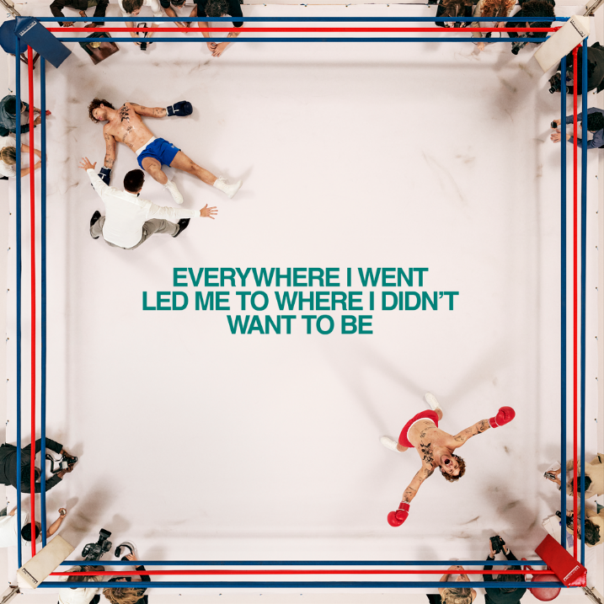
DOWNLOAD ALBUM ARTWORK
TOM GRENNAN has released his eagerly awaited new album, ‘Everywhere I Went Led Me To Where I Didn't Want To Be’. The 15-track album is the multi-platinum-selling artist’s fourth and is released today via Insanity Records. Tom teamed up with producer Justin Tranter for the album, creating a state-of-the-art pop record that further showcases the thrilling evolution of one of UK’s most exciting talents at his creative best. Tom will embark on his biggest UK & Ireland arena tour next month with the GRENNAN '25 tour taking in 11 cities including London’s O2 on September 6th.
'Everywhere I Went Led Me To Where I Didn't Want To Be' is the follow up to Tom Grennan’s No.1 album from 2023, 'What Ifs & Maybes', and includes the singles 'Full Attention', 'Higher', 'Shadowboxing', 'Boys Don’t Cry', and 'I Won’t Miss A Thing'. The album arrives at a time of peak success for Tom, whose recent achievements include receiving the BRIT Billion Award for surpassing one billion UK streams, headlining Gunnersbury Park and Radio 1's Big Weekend, launching his popular new podcast 'You About?' alongside Roman Kemp and landing his highest ever singles chart for a solo release with Top 3 festive smash ‘It Can’t Be Christmas (Amazon Music Original)’
With two number one albums under his belt alongside multiple Brit and Ivor Novello nominations, countless airplay smashes, sold-out arena tours and an MTV Award for Best UK Act, Tom Grennan is already one of the country’s biggest artists. Keen to explore a new sound, Tom enlisted the songwriter and producer behind hits for Dua Lipa and Chappell Roan and found in Tranter a collaborator who understood exactly what he wanted to say and what he wanted to sound like: George Michael, Prince, Freddie Mercury. “So much of the new music is uplifting — it makes you dance, makes you sing,” Tom says.
“It's about my fight with a side of me I have a lot of trouble with. It’s still a daily battle. But I’ve learned how to fight all these demons and I’m mentally and physically prepared now. I’m in athlete mode.”
While the title alludes to a time when Tom faced challenges with his mental health, ‘Everywhere I Went Led Me To Where I Didn't Want To Be’ is a positive album about self-belief and having the confidence to take risks. “This album is about me, revived. Now I'm at a place where I DO want to be. And I'm ready to blow people's heads off.”
It is a stunning addition to Tom Grennan’s already-impressive discography, which has seen him accumulate over 1.5 million album sales and 2.5 billion streams across his gold-selling debut Lighting Matches (2018), his first UK Number One album Evering Road (2021) and What Ifs & Maybes (2023), another Number One and Tom’s third gold-selling album in a row. Tom Grennan’s recent Top 3 festive smash ‘It Can’t Be Christmas (Amazon Music Original)’ immediately gained silver certification in its first run at the Christmas title and was only narrowly held off the top spot by Christmas titans Wham! and Mariah Carey.
The album tracklisting is:
- Full Attention
- Cool With That
- Shadowboxing
- Boys Don’t Cry
- Somewhere Only We Go
- Shadows on the Ceiling
- Celebrate
- Higher
- Certified
- Diamond
- Dirty Dishes
- Cinnamon
- Drama Queen
- I Won’t Miss A Thing
- Lonely Dancer
Final Night Of Tour Rehearsals Show
29-Aug-25 Coventry Exhibition Hall, Coventry Building Society Arena

GRENNAN ’25 UK Arena Tour
3-Sep-25 Bournemouth BIC
4-Sep-25 Birmingham Utilita Arena
6-Sep-25 London O2 Arena
9-Sep-25 Cardiff Utilita Arena
10-Sep-25 Nottingham Motorpoint Arena
11-Sep-25 Glasgow OVO Hydro
15-Sep-25 Aberdeen P&J Arena
16-Sep-25 Newcastle Utilita Arena
18-Sep-25 Leeds First Direct Arena
19-Sep-25 Manchester Co-Op Live

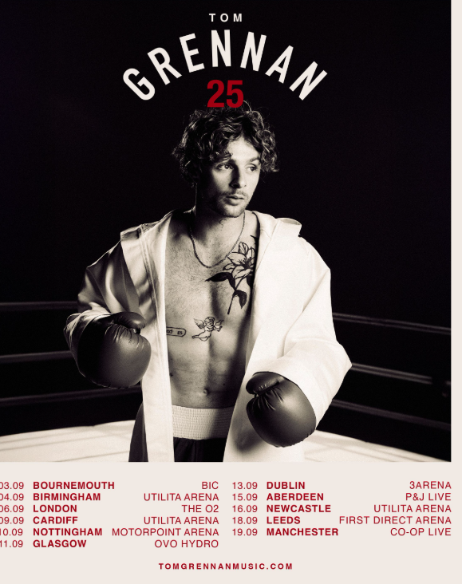

Connect with TOM GRENNAN

INSTAGRAM
TIK TOK
YOUTUBE
FACEBOOK
X

For more information and press enquiries for TOM GRENNAN please contact

Jenny Entwistle
Jenny@chuffmedia.com

